Parsnip River Watershed – Fish Habitat Confirmations (PEA-F20-F-2967) - DRAFT

July 02, 2020

Table of Contents

# 

**Executive Summary**

The health and viability of freshwater fish populations depends on access to tributary and off channel areas which provide refuge during high flows, opportunities for foraging as well as overwintering, spawning and summer rearing habitats. In addition, open migration corridors are can facilitate adaptation to the impacts of climate change such as rising water temperatures and changing flow regimes. Culverts can present barriers to fish migration due to increased water velocity, turbulence, a vertical drop at the culvert outlet and/or maintenance issues. There are hundreds of culverts presenting barriers to fish passage in the Parsnip River watershed with some of these structures obstructing fish movement to valuable fish habitat.

In the spring and summer of 2019, the Society for Ecosystem Restoration Northern BC (in collaboration with New Graph Environment, Hillcrest Geographics and the McLeod Lake Indian Band) conducted fish habitat confirmation assessments throughout the Parsnip River watershed. Prior to the field surveys a literature and Provincial Stream Crossing Inventory Summary System (PSCIS) database review was conducted and a community scoping exercise within the McLeod Lake Indian Band was undertaken to focus the work on fish passage restoration candidates with the highest potential benefits for salmonid populations in the watershed. Crossings prioritized for habitat confirmation field assessments were those identified as having potentially high fisheries value as well as likely large quantities of habitat upstream. The project aligns with the Fish and Wildlife Compensation Program Streams Action Plan (Fish and ildlife Compensation Program 2014) objective of conserving or enhancing high priority species and habitats by implementing actions to both identify restoration opportunities and restore fish passage in streams.

Review of the PSCIS database indicated that within the Parsnip River watershed, since 2001, 574 assessments for fish passage (Phase 1) have been conducted at crossing structures. Locations of 99 crossing structure assessments were selected for a detailed office review and ranked for follow up based on upstream wetland, lake, and instream habitat quantity, and quality; fish species present, or suspected, near the crossing; stream order, previously recorded channel size and recommendations of past fish passage assessments.

Habitat confirmation assessments were conducted between August 30, 2019 and September 8, 2019 at 17 crossings ranked as high or moderate priority for follow up. During the habitat confirmations a total of approximately 15 km of stream was assessed with 9 crossings rated as high priorities for rehabilitation, Four crossings rated as moderate priorities and Four crossings rated as low priorities.

At the time of reporting, communications were underway with Ministry of Forests, Lands, Natural Resource Operations & Rural Development representatives, forest licensees and engineering consultants to commission an engineering site plan and design for a fish passable structure to replace one of the barrier culverts identified as a high priority for replacement. It is expected that funding for the design will be provided through this project.

**Acknowledgements**

The Society For Ecosystem Restoration Northern BC gratefully acknowledges the financial support of the Fish and Wildlife Compensation Program for its contribution to this project. The FWCP is partnership between BC Hydro, the Province of B.C., Fisheries and Oceans Canada, First Nations and public stakeholders to conserve and enhance fish and wildlife in watersheds impacted by BC Hydro dams.

## Introduction

The health and viability of freshwater fish populations depends on access to tributary and off channel areas which provide refuge during high flows, opportunities for foraging as well as overwintering, spawning and summer rearing habitats (Swales and Levings 1989; Bramblett et al. 2002). Culverts can present barriers to fish migration due to increased water velocity, turbulence, a vertical drop at the culvert outlet and/or maintenance issues (Whyte et al. 1997). In addition, open migration corridors are essential for adapting to the impacts of climate change such as rising water temperatures and changing flow regimes (Seliger and Zeiringer 2018). There are hundreds of culverts presenting barriers to fish passage in the Parsnip River watershed with some of these structures obstructing fish movement to valuable fish habitat (Gollner, Cain, and Russell 2013; Hooft 2014).

In the spring and summer of 2019, the Society for Ecosystem Restoration Northern BC (in collaboration with New Graph Environment, Hillcrest Geographics and the McLeod Lake Indian Band) conducted fish habitat confirmation assessments throughout the Parsnip River watershed. Prior to the field surveys a literature and database review was conducted and a community scoping exercise within the McLeod Lake Indian Band was undertaken to focus the work on fish passage restoration candidates with the highest potential benefits for salmonid populations in the watershed. Crossings prioritized for habitat confirmation field assessments were those identified as having potentially high fisheries value as well as likely large quantities of habitat upstream. Prioritization rankings were assigned based on upstream wetland, lake, and instream habitat quantity, and quality; fish species present, or suspected, near the crossing; stream order, previously recorded channel size and recommendations of past fish passage assessments (Gollner, Cain, and Russell 2013).

Although there currently are no plans for long-term maintenance of the site, the interactive version of this report was made available at <https://newgraphenvironment.github.io/Parsnip_Fish_Passage/>.

## Background

As a result of high-level direction from the provincial government of British Columbia, a Fish Passage Strategic Approach protocol has been developed for British Columbia to ensure that the greatest opportunities for restoration of fish passage are pursued. A Fish Passage Technical Working Group has been formed to coordinate the protocol and data is continuously amalgamated within the Provincial Stream Crossing Inventory System (PSCIS) which has been built to house all culvert related data. Historically, British Columbia Timber Sales has administered most of the fish passage assessment, design and remediation contracts in the province with the majority of funding typically provided by the Land Based Investment Strategy (LBIS). The strategic approach protocol for fish passage restoration involves a four-phase process as described in (Fish Passage Technical Working Group 2014):

* Phase 1: Fish Passage Assessment – Fish stream crossings within watersheds with high fish values are assessed to determine barrier status of structures and document a general assessment of adjacent habitat quality and quantity.
* Phase 2: Habitat Confirmation – Assessments of crossings prioritized for follow up in Phase 1 studies are conducted to confirm quality and quantity of habitat upstream and down as well as to scope for other potential nearby barriers that could affect the practicality of remediation.
* Phase 3: Design – Site plans and designs are drawn for priority crossings where high value fish habitat has been confirmed.
* Phase 4: Remediation – Implementation of re-connection of isolated habitats through replacement, rehabilitation or removal of prioritized crossing structure barriers.

The scope of this project included planning and implementation for Phase 2 of the strategic approach protocol in the Parsnip River watershed. The Parsnip River watershed was chosen for habitat confirmation actions due to its high fisheries values, because it is a watershed impacted by dam operations and because there has been significant investment in Phase 1 assessments since 2001 with 574 assessments for fish passage already completed.

### Study Area

The Parsnip River watershed is located within the south-eastern portion of the 108,000 km2 traditional territory of the Tse’khene from the [McLeod Lake Indian Band](https://www.mlib.ca/about/History). The Tse’khene *“People of the Rocks”* are a south westerly extension of the Athabascan speaking people of northern Canada. They were a nomadic hunting people who’s language belongs to the Beaver-Sarcee-Tse’khene branch of Athapaskan (“History - Who We Are,” n.d.).

The continental divide separates watersheds flowing north into the Arctic Ocean via the Mackenzie River and south and west into the Pacific Ocean via the Fraser River (Figure 1). The Parsnip River is a 6th order stream with a watershed that drains an area of 5597 km2. The mainstem of the river flows within the Rocky Mountain Trench in a north direction into Williston Reservoir starting from the continental divide adjacent to Arctic Lakes. Major tributaries include the Misinchinka, Colbourne, Reynolds, Anzac, Table, Hominka and Missinka sub-basins which drain the western slopes of the Hart Ranges of the Rocky Mountains. The Parsnip River has a mean annual discharge of 147.6 m3/s with flow patterns typical of high elevation watersheds on the west side of the northern Rocky Mountains which receive large amounts of precipitation as snow leading to peak levels of discharge during snowmelt, typically from May to July (Figures 2 - 3).

Construction of the 183 m high and 2134 m long W.A.C. Bennett Dam was completed in 1967 at Hudson’s Hope, BC, creating Williston Reservoir (Hirst 1991). Filling of the 375 km2 reservoir was complete in 1972 and flooded a substantial portion of the Parsnip River and major tributary valleys forming what is now known as the Peace and Parsnip reaches. The replacement of riverine habitat with an inundated reservoir environment resulted in profound changes to the ecology, resource use and human settlement patterns in these systems (Hagen et al. 2015; Stamford, Hagen, and Williamson 2017; Pearce 2019). Prior to the filling of the reservoir, the Pack River, into which McLeod Lake flows, was a major tributary to the Parsnip River. It now enters the Williston Reservoir directly as the historic location of the confluence of the two rivers lies within the reservoir’s footprint.

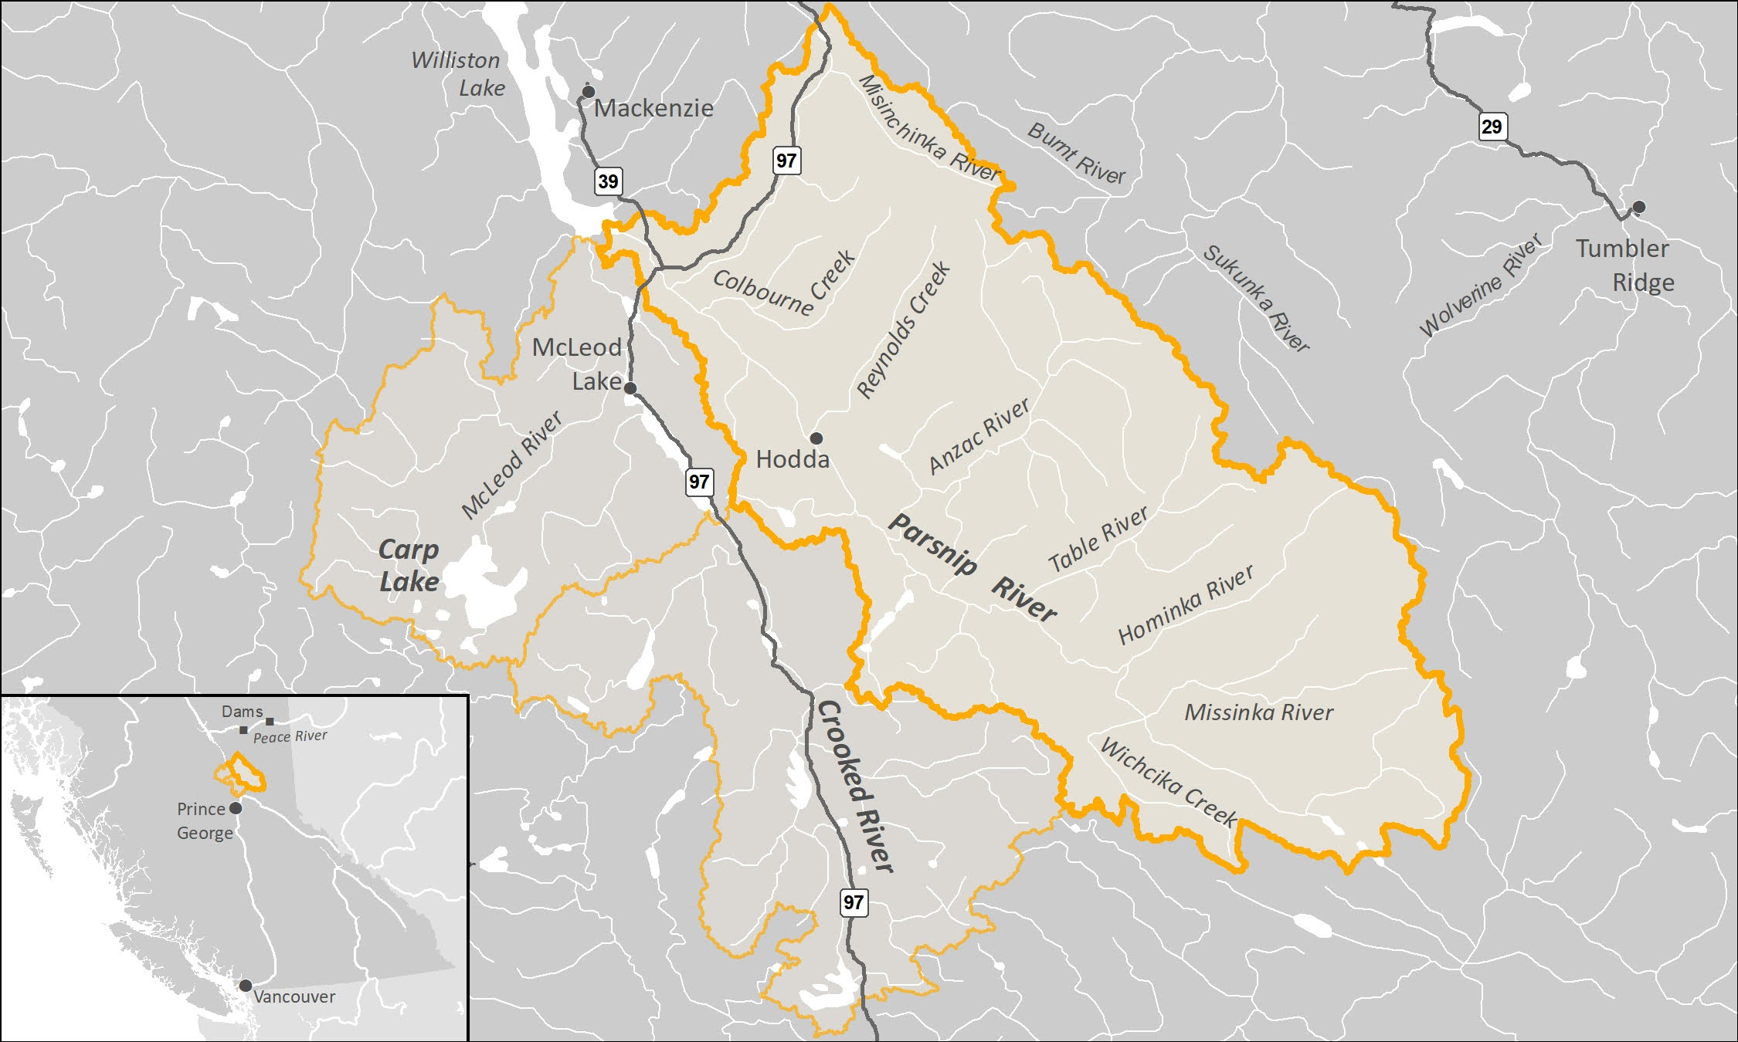

Figure 1: Overview Map

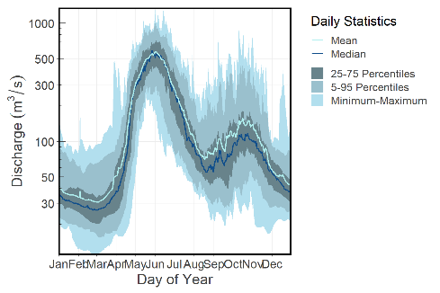

Figure 2: Parsnip River Above Misinchinka River (Station #07EE007 - Lat 55.08194 Lon -122.913063). Available daily discharge data from 1967 to 2015.

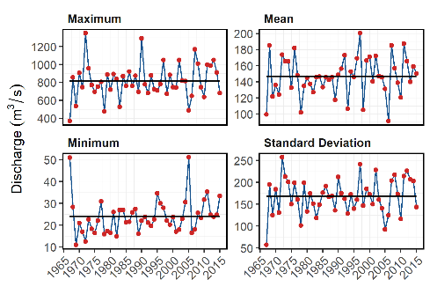

Figure 3: Summary discharge statistics (annual maximum, minimum, mean and standard deviation) for Parsnip River at hyrometric station #07EE007. Solid line is long term mean.

### Fisheries

Fish species recorded in the Parsnip River watershed are detailed in Table 1 (MoE 2019b). In addition to flooding related to the formation of the Williston Reservoir, transmission lines, gas pipelines, rail, road networks, forestry, elevated water temperatures, interrupted connectivity, invasion from non-native species and insect infestations affecting forested areas pose threats to fisheries values in the Parsnip River watershed (Hagen et al. 2015; Stamford, Hagen, and Williamson 2017; Hagen and Weber 2019; Comittee on the Status of Endangered Wildlife in Canada 2012). A brief summary of trends and knowledge status related to Arctic Grayling, Bull Trout, Kokanee, Mountain Whitefish and Rainbow Trout in Williston Watershed streams is provided in Fish and ildlife Compensation Program (2014) with a more detailed review of the state of knowledge for Parsnip River watershed populations of Arctic Grayling and Bull Trout provided below.

Table 1: Fish species recorded in the Parsnip River watershed.

| Scientific Name | Species Name | Species Code |
| --- | --- | --- |
| Catostomus catostomus | Longnose Sucker | LSU |
| Catostomus commersoni | White Sucker | WSU |
| Catostomus macrocheilus | Largescale Sucker | CSU |
| Coregonus clupeaformis | Lake Whitefish | LW |
| Cottus asper | Prickly Sculpin | CAS |
| Cottus cognatus | Slimy Sculpin | CCG |
| Couesius plumbeus | Lake Chub | LKC |
| Lota lota | Burbot | BB |
| Mylocheilus caurinus | Peamouth Chub | PCC |
| Oncorhynchus mykiss | Rainbow Trout | RB |
| Oncorhynchus nerka | Kokanee | KO |
| Prosopium coulteri | Pygmy Whitefish | PW |
| Prosopium williamsoni | Mountain Whitefish | MW |
| Ptychocheilus oregonensis | Northern Pikeminnow | NSC |
| Rhynichthys cataractae | Longnose Dace | LNC |
| Richardsonius balteatus | Redside Shiner | RSC |
| Salvelinus confluentus | Bull Trout | BT |
| Salvelinus fontinalis | Brook Trout | EB |
| Salvelinus namaycush | Lake Trout | LT |
| Thymallus arcticus | Arctic Grayling | GR |
|  | Coarse or non-game fish | OS |
|  | Fish Unidentified Species | SP |

#### Bull Trout

Bull Trout populations of the Williston Reservoir watershed are included within the Western Arctic population ‘Designatable Unit 10’, which, in 2012, received a ranking of ‘Special Concern’ by the Committee on the Status of Endangered Wildlife in Canada (Comittee on the Status of Endangered Wildlife in Canada 2012). They were added to Schedule 1 under the Species of Risk Act in 2019 (Species Registry Canada 2020) and are also considered of special concern (blue-listed) provincially (BC Species & Ecosystem Explorer 2020).

A study of Bull Trout critical habitats in the Parsnip River was conducted in 2014 with the Misinchinka and Anzac systems identified as the most important systems for large bodied bull trout spawners accounting for a combined total of 65% of spawners counted. The Table River was also highlighted as an important spawning destination accounting for an estimated 15% of the spawners. Other watersheds identified as containing runs of large bodied Bull Trout spawners included the Colbourne, Reynolds, Hominka and Missinka River with potentially less than 50 spawners utilizing each sub-basin (Hagen et al. 2015). Hagen and Weber (2019) have synthesized a large body of information regarding limiting factors, enhancement potential, critical habitats and conservation status for Bull Trout of the Williston Reservoir and the reader is encouraged to review this work for context. They have recommended experimental enhancements within a monitoring framework for Williston Reservoir Bull Trout (some spawning and rearing in Parsnip River mainstem and tributaries) which include stream fertilization, side channel development, riparian restoration and fish access improvement.

In 2018, sub-basins of the Anzac River watershed, Homininka River, Missinki River and Table River watersheds were designated as fisheries sensitive watersheds under the authority of the *Forest and Range Practices Act* due to significant downstream fisheries values and significant watershed sensitivity (Beaudry 2013a, 2014a, 2014b, 2013b). Special management is required in these watersheds to protect habitat for fish species including Bull Trout and Arctic Grayling including measures (among others) to limit equivalent clearcut area, reduce impacts to natural stream channel morphology, retain old growth attributes and maintain fish habitat/movement (Forest and Range Practices Act 2018).

Tse’khene Elders from the McLeod Lake Indian Band report that sa’ba (Bull Trout) size and abundance has decreased in all rivers and tributaries from the reservoir with more injured and diseased fish captured in recent history than was common in the past (Pearce 2019).

#### Arctic Grayling

A detailed review of Arctic Grayling life history can be referenced in Stamford, Hagen, and Williamson (2017). Since impoundment of the Williston Reservoir, it appears that physical habitat and ecological changes have been the most significant factors limiting Arctic Grayling productivity. Although these changes are not well understood they have likely resulted in the inundation of key low gradient juvenile rearing and overwintering habitats, isolation of previously connected populations and increases in abundance of predators such as Bull Trout (Shrimpton, Roberts, and Clarke 2012; Hagen, Pillipow, and Gantner 2018).

Migration of mature adult Arctic Grayling occurs in the spring with arrival at known spawning locations coinciding with water temperatures of 4 $​^{∘}$ C. Spawning in the Parsnip watershed appears to occur between late-May and late-June within sites located primarily within the lower reaches of the Anzac and Table rivers as well as within the Parsnip River mainstem. Side-channel and multiple-channel locations containing small gravels appear to be selected for spawning. Currently, the primary distribution of Williston Arctic Grayling appears to be among fourth order and larger streams (Williamson and Zimmerman 2005; Stamford, Hagen, and Williamson 2017). Stewart et al. (2007) report that Arctic Grayling spawn in large and small tributaries to rivers and lakes, intermittent streams, within mainstem rivers as well as lakes, most commonly at tributary mouths. Although past study results indicate that 0+ grayling appeared to overwinter in lower reaches of larger tributaries (i.e. Table, Anzac rivers) as well as the Parsnip River and that few age-1+ grayling have been sampled in tributaries, habitat use in small tributaries and the extent they are connected with the mainstem habitats of all core areas is not well understood. Between 1995 and 2019, Arctic Grayling population monitoring has been conducted in the Table River in nine out of 25 years (8 years for the Anzac) using snorkel surveys. Results from 2018 are 2019 are intended to contributing to assessment of the conservation status of the species in the Parsnip Core area (Hagen, Pillipow, and Gantner 2018).

Tse’khene Elders from the McLeod Lake Indian Band report that Arctic Grayling numbers have declined dramatically since the flooding of the reservoir and that few dusk’ihje (Arctic Grayling) have been caught in the territory in the past 30 years (Pearce 2019).

## Goals and Objectives

The overall goal of our project was to build capacity, awareness and momentum for fish passage restoration in the Parsnip Watershed. To realize this goal we created a short list of high priority culverts for fish passage restoration in the Parsnip River watershed through a data analysis exercise, scoping for First Nations input, fish passage assessments (BC Ministry of Environment 2011), habitat confirmation assessments (Fish Passage Technical Working Group 2011) and procurement of design specifications for a prioritized crossing.

## Methods

To identify priorities for crossing structure rehabilitation in Parsnip River watershed streams, background literature and the PSCIS database was reviewed with potential fish habitat associated with barrier and potential barrier culverts analyzed within the context of outputs from the Fish Habitat Model (Norris and Mount 2016) and associated watershed/fisheries information. The Fish Habitat Model was developed by the BC Ministry of Environment to provide estimates of the amount of fish habitat potentially accessible to fish upstream of crossing locations. The model calculates the average gradient of BC Freshwater Atlas [stream network lines](https://catalogue.data.gov.bc.ca/dataset/freshwater-atlas-stream-network) at minimum 100m long intervals starting from the downstream end and working upstream. The network lines are broken into max gradient categories with new segments created when the average gradient of the stream lines exceeds user provided gradient thresholds. For our purposes, stream network line segments were grouped into areas upstream of sections not exceeding 5% (0 - 5%), 5 - 15%, 15 - 22% and >22%. Stream areas upstream of gradients estimated at >22% for more than 100m were considered non-fish habitat if no fish observations had been documented upstream.

Following delineation of “non-fish habitat”, the *average* gradient of each stream segment created by the Fish Habitat Model was also calculated and used to quantify upstream habitat and symbolize stream lines based on stream morphology. We summarized average gradients within six categories (0 - 3%, 3 - 5%, 5 - 8%, 8 - 15%, 15 - 22%) and symbolized mapped stream lines in three categories. Categories symbolized are associated with riffle/cascade (0 - 5%), step-pool (5 - 15%), and step-pool very steep (15 -22%) stream habitats (Table 2). For each crossing location, the linear length of stream habitat upstream of crossings and <22% was summarized by average gradient and the area of lake and wetland habitat upstream was collated and reviewed to give an indication of the potential quantity and quality of habitat potentially gained should fish passage be restored.

Table 2: Stream gradient categories (threshold and average) and associated channel type.

| Gradient | Channel Type |
| --- | --- |
| 0 - 5% | Riffle and cascade pool |
| 5 - 15% | Step pool |
| 15 - 22% | Step pool - very steep |
| >22% | Non fish habitat |

Past fish passage assessment reports for the Parsnip River watershed were first reviewed to identify crossing structure barriers previously ranked as priorities for rehabilitation in Gollner, Cain, and Russell (2013). All crossings prioritized in Gollner, Cain, and Russell (2013) underwent a detailed office review and ranking for follow up in the field. Of note, Hooft (2014) also contains prioritization information for the Parsnip River watershed however it was not publicly available at the time of field planning due to technical issues with provincial databases and an inability to contact the report author. However, this report was obtained in the spring of 2020 and included prioritizations have been cross referenced with 2019 habitat confirmations in the results of this document. During planning for field surveys, to identify crossing structure barriers located on potentially high value streams not prioritized in Gollner, Cain, and Russell (2013), road crossing structures that met the following criteria in the Fish Habitat Model and/or PSCIS database also underwent a detailed review to rank crossings for Phase 2 - Habitat Confirmations.

* Stream crossing barriers and potential barriers on streams with confirmed fish presence upstream of the structure.
* Stream crossing barriers and potential barriers on streams documented as ≥ 1.5m wide with linear lengths of modeled upstream habitat <22% gradient for ≥500 m.
* Stream crossing barriers and potential barriers located on streams classified as 3rd order or higher.
* Stream crossing barriers and potential barriers located on streams with >5 ha of modeled wetland and/or lake habitat upstream of the structure.
* Stream crossing barriers and potential barriers on streams with habitat value rated as “medium” or “high” in past fish passage assessment data.

A Google Earth (.kml) file with crossing locations and rational for prioritizing for habitat confirmations was forwarded to provincial fish habitat biologists, McLeod Lake Indian Band staff, representatives from CN Rail, BC Timber Sales and Canfor Forest Products to provide an opportunity for review and scope for feedback. Additionally, Arlene Salonas (Land and Resource Consultation Coordinator from McLeod Lake) issued a mailout document to scope for feedback from the community on potential fish passage restoration candidates as well as to inquire about fisheries information in traditional territory watersheds potentially relevant to fish passage restoration activities.

In the field, PSCIS crossings ranked as high priorities for follow-up were first assessed for fish passage following the procedures outlined in “Field Assessment for Determining Fish Passage Status of Closed Bottomed Structures” (MoE 2011) to confirm that the crossings were still barriers to fish passage. The following criteria, which act as hydraulic indices, were utilized to determine if a crossing was a barrier to fish passage: depth and degree of embedment, outlet drop, slope of culvert, stream width ratio (ratio of average downstream channel width to culvert width), and length of the culvert.

Following fish passage assessments, habitat confirmations were completed in accordance with procedures outlined in the document “A Checklist for Fish Habitat Confirmation Prior to the Rehabilitation of a Stream Crossing” (FPTWG 2011). The main objective of the field surveys was to document upstream habitat quantity and quality and to determine if any other obstructions exist above or below the crossing. Habitat value was assessed based on channel morphology, flow characteristics (perennial, intermittent, ephemeral), the presence/absence of deep pools,un-embedded boulders, substrate, woody debris, undercut banks, aquatic vegetation and overhanging riparian vegetation. Criteria used to rank habitat value is specified in Fish Passage Technical Working Group (2011) and summarized in Table 3. Data from fish habitat assessments and habitat confirmation assessments will be submitted to the PSCIS database.

During habitat confirmations, assessment of habitat was completed following procedures outlined in Resources Inventory Standards Committee (RIC) Fish and Fish Habitat Inventory Standards and Procedures (BC Fisheries Information Services Branch 2001) with data collated on [“Site Cards”](https://www2.gov.bc.ca/gov/content/environment/natural-resource-stewardship/laws-policies-standards-guidance/inventory-standards/aquatic-ecosystems) and submitted to the provincial database under scientific fish collection permit PG19-550935. The [Fish Data Submission Spreadsheet Template - V 2.0, April 16, 2019](https://www2.gov.bc.ca/gov/content/environment/plants-animals-ecosystems/fish/fish-and-fish-habitat-data-information/fish-data-submission/submit-fish-data#submitfish) was used to store field data and facilitate data input. Among others, habitat characteristics recorded included channel widths, wetted widths, residual pool depths, gradients, bankfull depths, stage, temperature, conductivity, pH, cover by type, substrate and channel morphology. When possible, the crew surveyed the stream downstream of the crossing to the point where fish presence had been previously confirmed. Any potential obstacles to fish passage were inventoried with photos, physical descriptions and locations recorded on RIC site cards. Surveyed routes were recorded with time-signatures on handheld GPS units. When sites surveyed were located in areas near to where the subsequent day’s surveys were planned, minnow-traps were set overnight to obtain fish sampling data.

This pdf report and an online interactive version were generated from Rmarkdown documents processing raw data available at [New Graph Environment Github Site](https://github.com/NewGraphEnvironment/Parsnip_Fish_Passage). Although there currently are no plans for long-term maintenance of the site, the interactive version of this report was made available at <https://newgraphenvironment.github.io/Parsnip_Fish_Passage/> . In addition to numerous spatial layers sourced through the BC Data Catalogue and along with outputs from the Fish Habitat Model, data inputs for this project included completed:

* [Fish Data Submission Spreadsheet Template - V 2.0, April 16, 2019](https://www2.gov.bc.ca/gov/content/environment/plants-animals-ecosystems/fish/fish-and-fish-habitat-data-information/fish-data-submission/submit-fish-data#submitfish)
* [pscis_assessment_template_v23.xls](https://www2.gov.bc.ca/gov/content/environment/natural-resource-stewardship/land-based-investment/investment-categories/fish-passage/assessment-projects)
* Excel spreadsheet with priority level and linear amount of mainstem habitat upstream of the crossing detailed for each of the crossings surveyed.
* GPS tracks and points from field surveys.
* Photos and photo metadata. When not available in metadata, photos were georeferenced by aligning photo metadata time with GPS track times.

Table 3: Habitat value criteria (Fish Passage Technical Working Group, 2011).

| Habitat Value | Fish Habitat Criteria |
| --- | --- |
| High | The presence of high value spawning or rearing habitat (e.g., locations with abundance of suitably sized gravels, deep pools, undercut banks, or stable debris) which are critical to the fish population. |
| Medium | Important migration corridor. Presence of suitable spawning habitat. Habitat with moderate rearing potential for the fish species present. |
| Low | No suitable spawning habitat, and habitat with low rearing potential (e.g., locations without deep pools, undercut banks, or stable debris, and with little or no suitably sized spawning gravels for the fish species present). |

## Results and Discussion

Review of the PSCIS database indicated that within the Parsnip River watershed, since 2001, 574 assessments for fish passage (Phase 1) have been conducted at crossing structures. Locations of 99 crossing structure assessments were selected for a detailed office review based on upstream wetland, lake, and instream habitat quantity, and quality; fish species present, or suspected, near the crossing; stream order, previously recorded channel size and recommendations of past fish passage assessments. Following review, 26 crossings given a high priority for field review with habitat confirmation assessments. It should be noted that 4 of the crossings prioritized as high priorities for follow up were logged twice in the PSCIS database so in actuality only 22 crossings were present in the field. Thirty-Three crossings were assessed with a moderate priority, 33 crossings were assessed with a low priority and 5 were assessed as “no fix”. Additionally, 2 crossings were noted as “fixed”. Historic PSCIS photos and details, Fish Habitat Model outputs and prioritization rank/comments related to crossings ranked for follow up with habitat confirmation assessments is available [HERE](https://newgraphenvironment.github.io/Parsnip_Fish_Passage/Parsnip_report_planning_summary.html) and a Google Earth (.kml) file with crossing locations and pre-habitat confirmation prioritization rational for crossing rated as high and moderate priority for follow up with habitat confirmations is available [HERE](https://github.com/NewGraphEnvironment/Parsnip_Fish_Passage/raw/master/data/planning_high_mod_culverts.zip). In addition to the Parsnip River watershed group, georeferenced field maps were also generated for the Carp River watershed group and the Crooked River Watershed group areas to prepare for future fish passage and habitat confirmation surveys and are available [HERE](https://hillcrestgeo.ca/outgoing/forNewGraph/parsnip/maps/) along with associated Fish Habitat Model data outputs which are available [HERE](https://hillcrestgeo.ca/outgoing/forNewGraph/parsnip/data/).

Habitat confirmation assessments were conducted between August 30, 2019 and September 8, 2019 by Allan Irvine, R.P.Bio, Jonathan St.Jean, R.P.Bio, Tyler Valle, Environmental Technician and Ken Solonas, Environmental Technician with 17 crossings ranked as high or moderate priority for follow. During the habitat confirmations a total of approximately 15 km of stream was assessed and fish sampling (primarily minnow trapping) was conducted upstream and downstream of six restoration candidate sites. Several crossings were also surveyed briefly from the road with fish passage assessments completed only (no habitat confirmation assessments completed) as conditions were assessed as passable for fish migrating upstream. Crossing 125149 was an overflow for an adjacent channel where a bridge was located, crossing 57621 had been replaced by a bridge and crossing 125261 (Fern Creek) was equipped with baffles and appeared passable to most life stages of salmonids at most flows. Additionally, fish passage assessments were conducted on all significantly sized streams on the Hodda-Lake FSR located immediately east of McLeod Lake with data to be uploaded to the PSCIS database.

Following habitat confirmation assessments, 9 crossings were rated as high priorities for rehabilitation due to the relatively high value and/or quantity of habitat gain associated with rehabilitation. Four crossings were rated as moderate priorities. Four crossings were rated as low priority since the fisheries value gains associated with crossing rehabilitation were relatively low and/or where the presence of natural barriers would nullify the potential value of crossing rehabilitation. Field maps showing crossing locations, habitat confirmation field tracks, Fish Habitat Model outputs, historic fish observations and documented barriers to fish passage are available [here](https://hillcrestgeo.ca/outgoing/forNewGraph/parsnip/maps/). Results from sites surveyed are summarized in Table 4 with detailed reporting including links to georeferenced maps also provided in site specific appendices of this document.

At the time of reporting, communications were underway with Ministry of Forests, Lands, Natural Resource Operations & Rural Development representatives, forest licensees and engineering consultants to commission an engineering site plan and design for a fish passable structure to replace one of the barrier culverts identified as a high priority for replacement. It is expected that funding for the design will be provided through this project.

Methodology and workflows for this project have evolved significantly from those of past projects and our team welcomes feedback. Please contact [al@newgraphenvironment.com](mailto:al@newgraphenvironment.com) (2507771518) with feedback and any questions regarding the project.

Table 4: Overview of stream crossing.

| Site | Stream | Road | Tenure | UTM (10N) | Fish Species | *Habitat Gain (km) | Habitat Value | Priority | Comments |
| --- | --- | --- | --- | --- | --- | --- | --- | --- | --- |
| 57681 | Trib to Parsnip River | Chuchinka-Colbourne FSR and CN Railway | FLNRORD 5506 04 and CN Rail | 533218 6067620 | BB, CC, LKC, MW, RB, RSC, SU | 49.2 | Medium | Moderate | The culvert is very long, steep and continous under the CN railway and Chuchinka-Colbourne FSR (PSCIS crossing 125353) and empties directly into margins of Parsnip River. Stream drains Goose Lake. Numerous fish observed upstream. Small woody debris, overhanging vegetation and undercut banks abundant. Some gravels present suitable for spawning. Minnowtrapping conducted upsteam and downstream. Rainbow trout captured upstream and burbot and rainbow trout captured downstream. |
| 57690 | Trib to Wichcika Creek | Chuchinka FSR | FLNRORD 5506 01 0 | 555027 6046138 | RB | 15.3 | Medium | High | Multiple drops and rock chutes beginning 350 m upstream of culvert with 1.4 m falls at top end of site (650 m upstream of culvert). Deep pools suitable for overwintering and rearing. Rainbow trout (120 mm) observed approximately 60 m upstream of culvert. Some gravels present suitable for spawning present. |
| 57695 | Trib to Wichcika Creek | Chuchinka-Wichcika FSR | FLNRORD 5506 14 0 | 563257 6038803 | - | 1.5 | Medium | Moderate | Pockets of gravels, some shallow pools and some widely spaced large woody debris. No bariers observed besides debris jams ranging from 50 - 100 cm in height. |
| 57696 | Trib to Wichcika Creek | Chuchinka-Wichcika FSR | CARRIER LUMBER LTD. R21212 D 0 | 564171 6037942 | - | 1.5 | Medium | Low | Cascade at top end of site (650 m upstream) not passable by any species or life stage. Some intermittent small paches of gravel suitable for spawning. Very limited spawning habitat. |
| 125000 | Trib to Parsnip River | Chuchinka-Arctic FSR | FLNRORD 5506 10 0 | 577534 6038205 | RB, CC | 10.5 | High | High | Undercut banks, large woody debris and overhanging vegetation througout. Pools shallow. Beaver dams start 330m upstream of crossing. Minnowtrapping conducted upstream and downstream of crossing with Rainbow Trout and Sculpin captured downstream. |
| 125098 | Trib to Parsnip River | Unnamed | WINTON GLOBAL LUMBER LTD. R01821 B | 582902 6035080 | RB | 1 | Low | Low | Small stream with low flow indicated by moss mid-channel. Very few pools but sections of gravel present. |
| 125128 | Trib to Missinka River | Unnamed | FLNRORD 5506 25 | 583454 6051827 | - | 1.9 | Low | Low | Beaver influenced extensive wetland area located upstream for as far as visible from 50 m upstream of culvert. 5 m high cascde (10 m long at 50% gradient) is located approximately 5 m below the culvert. Below this is a rock chute for 12 m (30%). Culvert is potentially accessible only to adult adfluvial bull trout however it is unlikely that they would utilize this stream due to the wetland type habitat present upstream of the culvert. |
| 125175 | Trib to Missinka River | Chuchinka-Missinka FSR | FLNRORD 5506 11 0 | 571772 6051998 | RB | 2.3 | Medium | Moderate | At approximately 300m upstream of culvert stream spilts into three tributaries. Abundant gravels but very little to no overwintering habitat. Lack of large woody debris and no deep pools. |
| 125179 | Trib to Missinka River | Chuchinka-Missinka FSR | FLNRORD 5506 11 0 | 570308 6052835 | BT, RB | 2.1 | High | High | Classified as fisheries sensitive watershed under FRPA due to downstream Bull Trout and Arctic Grayling (Beaudry 2013, FSW-TAG f-7-020). Some deep pools for overwintering and rearing. Large woody debris and undercut banks throughout. Sections of gravel suitable for spawning. Good flow. |
| 125180 | Trib to Missinka River | Chuchinka-Missinka FSR | FLNRORD 5506 11 0 | 569649 6053047 | RB | 2.1 | High | High | Classified as fisheries sensitive watershed under FRPA due to downstream Bull Trout and Arctic Grayling (Beaudry 2013, FSW-TAG f-7-020). Larger stream with good flow and high habitat complexity. Frequent pockets of gravel suitable for spawing at pool tailouts and behind large woody debris. |
| 125186 | Trib to Missinka River | Chuchinka-Missinka FSR | FLNRORD 5506 11 0 | 565417 6052678 | RB | 1.4 | High | High | Classified as fisheries sensitive watershed under FRPA due to downstream Bull Trout and Arctic Grayling (Beaudry 2013, FSW-TAG f-7-020). Large woody debris and pools throughout. Frequent pockets of gravel suitable for spawning. |
| 125231 | Trib to Table River | Chuchinka-Table FSR | FLNRORD 5506 08 0 | 549976 6065139 | RB | 2.4 | High | High | Classified as fisheries sensitive watershed under FRPA due to downstream Bull Trout and Arctic Grayling (Beaudry 2014, FSW-TAG f-7-022). Some deep pools and boulders, udercut banks, large wody debris and gravels throughout. Some debris steps from 30 - 70 cms high. Passble railway culvert located downstream (16603641). New bridge upstream. |
| 125247 | Trib to Parsnip River | Chuchinka-Table FSR and CN Railway | FLNRORD 5506 08 0 | 542959 6062815 | RB | 17.7 | Medium | High | Abundant undercut banks, overhanging vegetation, large woody debris and gravels. Historic beaver dam 700 m upstream. Railway culvert (modelled crossing 16603287) is 200 m upstream and is barrier (90 m long, unembedded and 3%). |
| 125253 | Trib to Parsnip River | Chuchinka-Table FSR | FLNRORD 5506 08 0 | 537735 6064732 | - | 11.2 | High | Moderate | Stable channel with large woody debris throughout. Railway crossing culvert (modelled ID 16603267) is located 60 m downstream of the crossing and is a barrier. Overhanging vegetation and undercut banks present for cover. Historic beaver impounded area at top of site. |
| 125345 | Trib to Parsnip River | Chuchinka-Colbourne FSR | FLNRORD 5506 04 0 | 522549 6083674 | (RB), CC | 35.6 | High | High | Culvert is under Chuchinka-Colbourne FSR but CN railway crossing (PSCIS 57687) is located 10 m upstream and also has barrier crossing. Abundant gravels throughout with deep pools suitable for overwintering. |
| 125403 | Trib to Parsnip River | Hodda Lake FSR | FLNRORD 7698 01 0 | 520140 6084908 | - | 6.1 | Low | Low | Beaver influenced wetland for first 50 m then small stream with deep polls and undercut banks, overhanging vegetation. Large wetland approximatly 200m upstream of crossing. |
| CV1 | Trib to Table River | CN Railway | CN Rail | 547303 6063955 | RB, (BT) | 6.6 | High | High | Classified as fisheries sensitive watershed under FRPA due to downstream Bull Trout and Arctic Grayling (Beaudry 2014, FSW-TAG f-7-022). CN Rail crossing. Abundant gravels, large woody debris, undercut banks, overhanging vegetation and small woody debris. Recently installed bridges downsteam and upstream on FSRs. 20 cm long bull trout (suspected) observed approximately 340 m upstream of the culvert. Minnowtrapping conducted upstream and downstream with Rainbow Trout captured downstream. 200mm Bull Trout (suspected) observed upstream near redd. |

*Habitat gain based on Fish Habitat Model estimates of linear stream length upstream of crossing with no section of modeled gradients >22% for 100m or more. Estimates currently not adjusted to indicate results from field surveys. Please see individual memos (appendices) for refined estimates of potential habitat gained based on field surveys and conservative GIS estimates of upstream habitat in mainstem of stream only.

## Recommendations

Recommended next steps for fish passage restoration in the Parsnip River Watershed include:

* Acquisition of funding to contribute towards costs for replacing the high priority structure receiving replacement designs through this 2019/2020 phase of the project.
* Acquisition of funding to procure site plans and replacement designs for structures identified as high priorities for restoration through this 2019/2020 phase of the project.
* Explore and pursue opportunities to obtain buy-in and funding for replacement of identified high priority structures.
* Drafting and implementation of a collaborative plan for assessing the impacts of fish passage restoration investments. The plan should be designed to provide data necesary to effectively monitor the outcomes of restoration efforts, inform future investments and build capacity/momentum for ecosystem restoration activities in the FWCP Peace Region.

# Appendix - Crossing 57681 - Chuchinka-Colbourne FSR and CN Railway - Trib to Parsnip River

##### Site Location

Crossing 57681 is located on an unnamed tributary to the Parsnip River under the CN Railway and Chuchinka-Colbourne FSR and CN Railway immediately upstream of the confluence with the Parsnip River and approximately 2.5 km north-east of Tacheeda Lakes (Table 5). At the time of the field surveys, the FSR had heavy traffic associated with the Gaslink Pipeline construction project. A remote camp for the pipeline project was located approximately 1.5 km up the FSR from the crossing location.

##### Background Information

At the crossing location, the stream is a 4th order stream with a watershed area upstream of the crossing of 24.6km2. The stream drains Goose Lake with Burbot, Sculpin, Lake Chub, Mountain Whitefish, Rainbow Trout, Redside Shiner and Suckers recorded upstream (MoE 2019b). Goose Lake is located on the west side of the Parsnip River, is approximately 75ha in area, sits at an elevation of approximately 800m and drains tributary watersheds with elevations reaching near 1000m. Goose Lake was stocked with Rainbow Trout on eight occasions since 1982, with the last stocking event occurring in 2002 (“Fish Inventories Data Queries” 2020). Stocking was discontinued in 2002 as the lake was thought to be more suitably managed as a wild fishery and because the risks associated with possible genetic introgressions with native stocks were assessed as outweighing the likely benefits of the stocking program (Clarke 2005). There are no other crossing barriers on the mainstem of the stream between the FSR and Goose Lake which is located 7 km upstream of the culverts. PSCIS crossing 57676 is located between Goose Lake and an upstream lake/wetland area and although it was assessed as a barrier in 2012, PSCIS data indicates low value habitat upstream with “no further action” recommended in recorded contractor comments (Gollner, Cain, and Russell 2013; Hooft 2014).

Following office review, PSCIS stream crossing 57681 was ranked as a high priority for follow up with habitat confirmation due to the potential for rehabilitation of the crossing to provide access to upstream lake (89.5ha), wetland (48ha) and instream (49.2km) habitat. Additionally, it was known as fish bearing upstream of the crossing and ranked by Gollner, Cain, and Russell (2013) as a high priority for follow up (Table 6). The habitat confirmation was completed on September 06, 2019. A map of the watershed including areas surveyed is provided in Attachment 1 – Map [093J119](https://hillcrestgeo.ca/outgoing/forNewGraph/parsnip/maps/FishPassage_093J.119.pdf).

##### Stream Characteristics at Crossing

At the time of the survey, the 1.5m diameter culvert under the CN Railway and the Chuchinka-Colbourne FSR was considered a barrier to upstream fish passage with a length of 50m, an average depth of fill on top of the culvert of 2.5m and an outlet drop of 0.5m (Table 7, Figure 4). Water temperature was 11 $​^{∘}$ C and conductivity was 271uS/cm.

##### Stream Characteristics Downstream

The stream joins the Parsnip River immediately downstream from the culvert . Minnow traps were set overnight below the crossing with one Burbot (81mm fork length) and two Rainbow Trout (52mm) captured (Figures 5 - 6).

##### Stream Characteristics Upstream

Upstream of the crossing a 550m site was surveyed. No obstacles to fish passage were observed and numerous young of year and parr salmonids (suspect Rainbow Trout) were observed. Wetland type habitat was present for the first approximately 100m upstream of the crossing and the average channel width was 4.5m, the average wetted width was 2.9m and the average gradient was 1.3% (Table 8, Figures 7 - 9). Small woody debris, overhanging vegetation and undercut banks were abundant throughout the surveyed area and occasional pockets of gravels were present suitable for spawning small bodied salmonids. Minnow trapping was conducted upstream of the crossing with four Rainbow Trout parr captured (45 - 54mm). Overall the habitat upstream of the crossing was considered medium due to the relatively low elevation of the watershed and the brackish type water quality.

##### Conclusion

There is over 7km of low gradient mainstem habitat upstream of crossing 57681 as well as a modeled 77.7ha of confirmed fish bearing lake. Multiple species have been confirmed upstream of the crossing including a self-sustaining population of Rainbow Trout with genetics likely influenced by historic stocking programs. Habitat surveyed was rated as medium value for salmonids due to relatively low elevation of the watershed, the prevalence of wetland type habitats and the likely lack of upstream spawning areas suitable for migratory large bodied Bull Trout and downstream Arctic Grayling populations. Although Canadian Forest Products Ltd. and BCTS use the road to access their operations areas, the forest licensee directly adjacent to the crossing is Sinclar Group. The road tenure holder is the Ministry of Forests, Lands, Natural Resource Operations & Rural Development (FLNRORD) and the operator of the railway is CN Rail. Replacement of the crossing will require a collaboration between FLNRORD and CN Rail with relatively high replacement costs expected due to the length of the structure, the presence of the railway and the large amount of fill over the culvert. Overall, the crossing was ranked as a moderate priority for rehabilitation.

Table 5: Overview of stream crossing.

| Site | Stream | Road | Tenure | UTM (10N) | Fish Species | Priority |
| --- | --- | --- | --- | --- | --- | --- |
| 57681 | Trib to Parsnip River | Chuchinka-Colbourne FSR and CN Railway | FLNRORD 5506 04 and CN Rail | 533218 6067620 | BB, CC, LKC, MW, RB, RSC, SU | Moderate |

Table 6: Field map, Fish Habitat Model outputs, historic PSCIS details and prioritization for follow up with fish habiat confirmation rank/comments.

| Site | Map 50k | Instream (km) | Lake (ha) | Wetland (ha) | Channel Width (m) | Fish Upstream | Habitat Value | Rank | Comments |
| --- | --- | --- | --- | --- | --- | --- | --- | --- | --- |
| 57681 | 093J119 | 49.2 | 137.5 | 48 | 2.9 | Yes | High | High | Prioritized in Gollner et al. (2013). |

Table 7: Summary of culvert fish passage assessment.

| Site | Diameter (m) | Length (m) | Embedded | Backwatered | Fill Depth (m) | Outlet Drop (m) | Outlet Pool Depth (m) | Stream Width Ratio | Barrier Result |
| --- | --- | --- | --- | --- | --- | --- | --- | --- | --- |
| 57681 | 1.5 | 50 | no | no | 2.5 | 0.5 | 1.5 | 3.3 | Barrier |

Table 8: Summary of habitat details

| Site | Location | Length Surveyed (m) | Channel Width (m) | Wetted Width (m) | Pool depth (m) | Gradient (%) | Habitat Value |
| --- | --- | --- | --- | --- | --- | --- | --- |
| 57681 | Upstream | 550 | 4.5 | 2.9 | 0.4 | 1.3 | Medium |

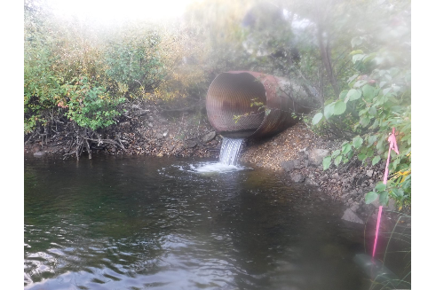

Figure 4: Outlet of PSCIS crossing 57681 (UTM: 10N 533218 6067620).

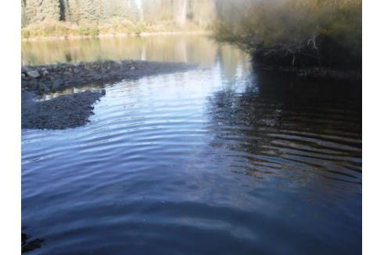

Figure 5: Habitat downstream of PSCIS crossing 57681 (UTM: 10N 533218 6067620).

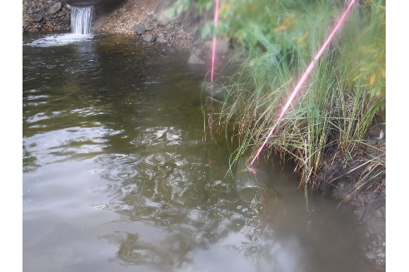

Figure 6: Set minnow traps and habitat downstream of PSCIS crossing 57681 (UTM: 10N 537612 6064559).

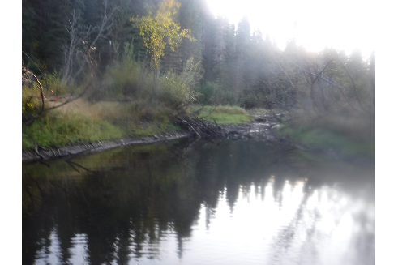

Figure 7: View of habitat upstream of crossing 57681 (UTM: 10N 533202 6067612).

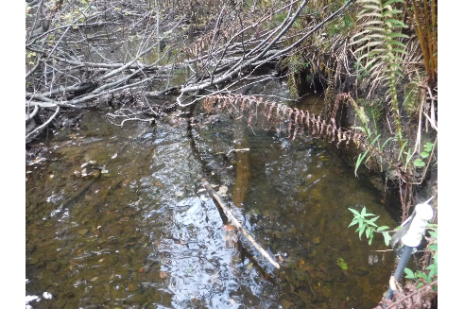

Figure 8: View of habitat upstream of crossing 57681 (UTM: 10N 532803 6067727).

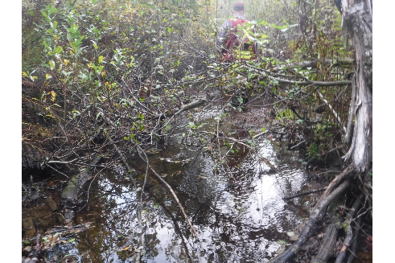

Figure 9: View of habitat upstream of crossing 57681 (UTM: 10N 532816 6067712).

# Appendix - Crossing 57690 - Chuchinka FSR - Trib to Wichcika Creek

##### Site Location

Crossing 57690 is located on an unnamed tributary to Wichcika Creek near the 751km mark of the Chuchinka FSR. The culvert is located 0.3km from the confluence of Wichcika Creek (Table 9). At the time of the field surveys, there was active log hauling on the FSR.

##### Background Information

At the crossing location, the stream is a 3rd order stream with a watershed area upstream of the road of approximatley 10.8km2. The elevation of the watershed ranges from a maximum of 1000m to 800m at the culvert. No other crossings are modeled upstream.

Provincial records indicate that Rainbow Trout, Mountain Whitefish, Sculpin, and Burbot have been captured just downstream in Wichcika Creek near the mouth of the subject stream (MoE 2019b).

Hagen et al. (2015) have identified the upper end of the Wichcika Creek mainstem as containing critical spawning and juvenile rearing habitat for large body Bull Trout with an estimated minimum spawner abundance of less than 50 fish.

Following office review, PSCIS stream crossing 57690 was ranked as a high priority for follow up with habitat confirmation due to the potential for rehabilitation of the crossing to provide access to modeled instream (15.3km) and wetland (13.3ha) habitat with a relatively large channel size (5.2m) and potentially high value habitat as indicated by review of photographs in the PSCIS database (Table 10). The habitat confirmation was completed on September 01, 2019. A map of the watershed including areas surveyed is provided in Attachment 1 – Map [093J115](https://hillcrestgeo.ca/outgoing/forNewGraph/parsnip/maps/FishPassage_093J.115.pdf).

##### Stream Characteristics at Crossing

At the time of the survey, the un-embedded and non-backwatered double (1.8m each) crossing was considered a barrier to upstream fish passage with pipe lengths of 38m, a culvert slope of 5% and an outlet drop of 0.8m (Table 11, Figure 10). Water temperature was 11 $​^{∘}$ C and conductivity was 297uS/cm.

##### Stream Characteristics Downstream

The stream was surveyed downstream from the culvert for 260m to the confluence at Wichcika Creek (Figure 11). Overall, total cover amount was rated as moderate with undercut banks dominant (Figures 12). Cover was also present as small woody debris and overhanging vegetation. Some patches of gravels suitable for spawning were present. The average channel width was 4.2m, the average wetted width was 3.7m and the average gradient was 2% (Table 12). A corrugated culvert pipe was located downstream of the crossing within the stream channel (Figure 13). Habitat value downstream of the crossing was rated as medium as it had moderate rearing potential and few pools present for overwintering.

##### Stream Characteristics Upstream

The stream was surveyed upstream from the culvert for 650m. A Rainbow Trout (~120mm long) was observed approximately 60 m upstream of culvert. The average channel width was 5.6m, the average wetted width was 4.7m and the average gradient was 7.7% (Table 12). Riparian vegetation was comprised of a mature mixed coniferous/deciduous forest and instream cover quantity was rated as moderate. Overall, total cover amount was rated as moderate. The dominant cover form of cover was deep pools with small woody debris, large woody debris, boulders, undercut banks, and overhanging vegetation also available. Some gravels suitable for spawning were present intermittently throughout the area surveyed (Figures 14 - 15). Multiple drops and rock chutes were present in the area surveyed beginning 350 m upstream of the culvert and a 1.4 m high vertical falls was located 650 m upstream of the culvert (Figure 16). Habitat value upstream of the crossing was rated as medium.

##### Conclusion

There is approximately 4km of mainstem habitat and 1.5km of 2nd order tributary modeled as less than 22% gradient upstream of crossing 57690. However, large bodied Bull Trout are likely the only species capable of getting over the 0.8m high falls located 350m upstream of the crossing and may be limited in upstream distribution by the 1.4m falls located at 650m upstream if fish passage was restored at crossing 57690. The relatively low maximum elevation and likely wetland like character of much of the upper watershed (indicated by review of satellite aerial imagery) may not be overly conducive to Bull Trout spawning and rearing although this is unconfirmed. Habitat in the 650m surveyed upstream of the crossing was rated as high value for salmonids with Rainbow Trout presence confirmed upstream of the FSR in this relatively large stream. The forest licensee in the area are Sinclar Group and the road tenure holder is the Ministry of Forests, Lands, Natural Resource Operations & Rural Development. Overall, the crossing located on the Chuchinka FSR was ranked as a high priority for rehabilitation.

Table 9: Overview of stream crossing.

| Site | Stream | Road | Tenure | UTM (10N) | Fish Species | Priority |
| --- | --- | --- | --- | --- | --- | --- |
| 57690 | Trib to Wichcika Creek | Chuchinka FSR | FLNRORD 5506 01 0 | 555027 6046138 | RB | High |

Table 10: Field map, Fish Habitat Model outputs, historic PSCIS details and prioritization for follow up with fish habiat confirmation rank/comments.

| Site | Map 50k | Instream (km) | Lake (ha) | Wetland (ha) | Channel Width (m) | Fish Upstream | Habitat Value | Rank | Comments |
| --- | --- | --- | --- | --- | --- | --- | --- | --- | --- |
| 57690 | 093J115 | 15.3 | - | 13.3 | 5.2 | Yes | Low | High | Large stream. Habitat appears good in photos. |

Table 11: Summary of culvert fish passage assessment.

| Site | Diameter (m) | Length (m) | Embedded | Backwatered | Fill Depth (m) | Outlet Drop (m) | Outlet Pool Depth (m) | Stream Width Ratio | Barrier Result |
| --- | --- | --- | --- | --- | --- | --- | --- | --- | --- |
| 57690 | 1.8 | 38 | no | no | 6 | 0.8 | 0.5 | 2.3 | Barrier |

Table 12: Summary of habitat details

| Site | Location | Length Surveyed (m) | Channel Width (m) | Wetted Width (m) | Pool depth (m) | Gradient (%) | Habitat Value |
| --- | --- | --- | --- | --- | --- | --- | --- |
| 57690 | Upstream | 650 | 5.6 | 4.7 | 0.5 | 7.7 | Medium |
| 57690 | Downstream | 260 | 4.2 | 3.7 | 0.3 | 2 | Medium |

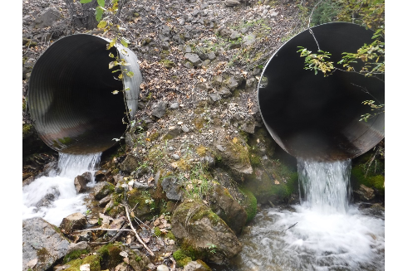

Figure 10: Outlet of PSCIS crossing 57690 (UTM: 10N 555027 6046138).

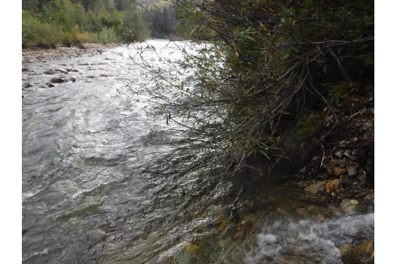

Figure 11: Confluence with Wichcika Creek downstream of PSCIS crossing 57690 (UTM: 10N 555225 6046046).

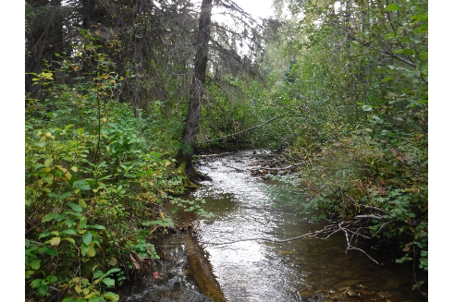

Figure 12: Habitat downstream of PSCIS crossing 57690 (UTM: 10N 555183 6046053).

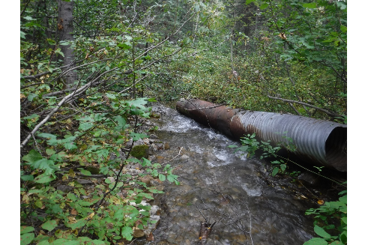

Figure 13: Corrugated culvert structure located downstream of PSCIS crossing 57690 (UTM: 10N 555118 6046103).

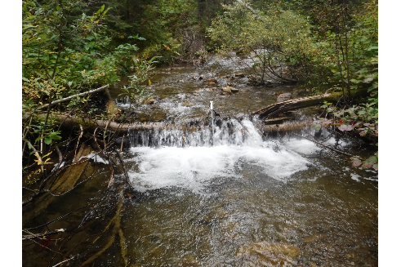

Figure 14: View of habitat upstream of PSCIS crossing 57690 (UTM: 10N 554990 6046171).

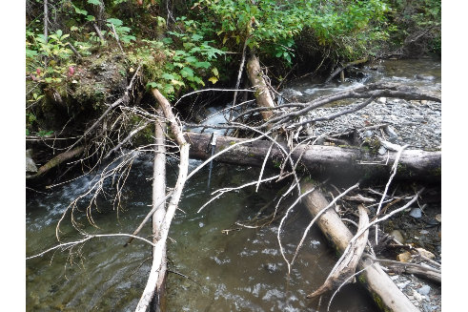

Figure 15: View of habitat upstream of PSCIS crossing 57690 (UTM: 10N 554576 6046307).

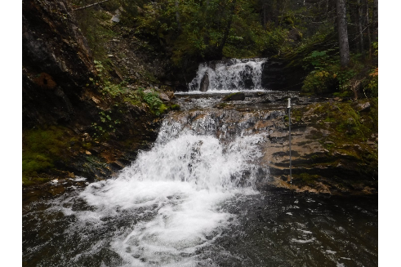

Figure 16: View of 1.4m high falls located approximately 650m upstream of PSCIS crossing 57690 (UTM: 10N 554488 6046241).

# Appendix - Crossing 57695 - Chuchinka-Wichcika FSR - Trib to Wichcika Creek

##### Site Location

Crossing 57695 is located on an unnamed tributary to Wichcika Creek near the 15.5km mark of the Chuchinka-Wichcika FSR. The culvert is located 1.1km from the confluence with Wichcika Creek (Table 13). At the time of the field surveys, there appeared to be no active log hauling on the FSR however their was a mining exploration camp on the road roughly near the 5km mark and some pickup truck traffic was encountered.

##### Background Information

At the crossing location, the stream is 2nd order with a watershed area upstream of the road of approximately 2.8km2. The elevation of the watershed ranges from a maximum of 1500m to 1100m at the culvert. No other crossings are modeled upstream.

Provincial records indicate that Bull Trout were captured downstream of the crossing approximately 400m as well as near the mouth of the stream by DWB in 2016 (MoE 2019b).

Hagen et al. (2015) have identified the upper end of the Wichcika Creek mainstem as containing critical spawning and juvenile rearing habitat for large body Bull Trout with an estimated minimum spawner abundance of less than 50 fish.

Following office review, PSCIS stream crossing 57695 was ranked as a high priority for follow up with habitat confirmation due to the potential for rehabilitation of the crossing to provide access to modeled instream (1.5km) habitat with a relatively large channel size (2.8m) and potentially high value habitat as indicated by contractor habitat value assignment. Additionally, Gollner, Cain, and Russell (2013) prioritized the crossing for follow up (Table 14). The habitat confirmation was completed on September 01, 2019. A map of the watershed including areas surveyed is provided in Attachment 1 – Map [093J115](https://hillcrestgeo.ca/outgoing/forNewGraph/parsnip/maps/FishPassage_093J.115.pdf).

##### Stream Characteristics at Crossing

At the time of the survey, the un-embedded and non-backwatered 1.5m diameter crossing was considered a barrier to upstream fish passage with a pipe length of 20m, a culvert slope of 8% and an outlet drop of 0.95m (Table 15, Figure 17).

##### Stream Characteristics Downstream

The stream was surveyed downstream from the culvert for 520m to below the point where Bull Trout were observed by DWB in 2016. Overall, total cover amount was rated as moderate with deep pools dominant. Cover was also present as small woody debris, large woody debris, boulders, undercut banks, and overhanging vegetation and extensive areas of gravels suitable for spawning present (Figures 18 - 19). The average channel width was 4.2m, the average wetted width was 3.3m and the average gradient was 8.7% (Table 16). The stable, mature channel contained drops up to 0.6m high resulting from large woody debris. Three minnowtraps were set overnight within the 50m of channel directly below the culvert. No fish were captured. Habitat value upstream of the crossing was rated as medium.

##### Stream Characteristics Upstream

The stream was surveyed upstream from the culvert for 920m. The average channel width was 4.4m, the average wetted width was 3.4m and the average gradient was 11.2% (Table 16). Riparian vegetation was comprised of a mature coniferous forest and total cover amount was rated as moderate. The dominant cover form was undercut banks with small woody debris, large woody debris, boulders, and overhanging vegetation also available (Figures 20 - 21). Some gravels suitable for spawning were present. No obstacles to fish passage were observed in the area surveyed with the exception of debris jams ranging from 50 - 100 cm in height (Figure 22). Three minnowtraps were set overnight within the 50m of channel directly above the culvert. No fish were captured. Habitat value upstream of the crossing was rated as medium.

##### Conclusion

There is 1.5km of mainstem habitat modeled as less than 22% gradient upstream of crossing 57695. Habitat in the areas surveyed upstream of the crossing was rated as moderate value for salmonids with Bull Trout presence confirmed downstream of the FSR. Review of Ministry of Forests, Lands, Natural Resource Operations & Rural Development (FLNR) licensee operating areas maps indicate that the forest licensee in the area is Sinclar Group. The road tenure holder is FLNR. As the crossing location appears to be important migration corridor with habitat upstream with moderate rearing potential for Bull Trout the crossing was ranked as a moderate priority for rehabilitation.

Table 13: Overview of stream crossing.

| Site | Stream | Road | Tenure | UTM (10N) | Fish Species | Priority |
| --- | --- | --- | --- | --- | --- | --- |
| 57695 | Trib to Wichcika Creek | Chuchinka-Wichcika FSR | FLNRORD 5506 14 0 | 563257 6038803 | - | Moderate |

Table 14: Field map, Fish Habitat Model outputs, historic PSCIS details and prioritization for follow up with fish habiat confirmation rank/comments.

| Site | Map 50k | Instream (km) | Lake (ha) | Wetland (ha) | Channel Width (m) | Fish Upstream | Habitat Value | Rank | Comments |
| --- | --- | --- | --- | --- | --- | --- | --- | --- | --- |
| 57695 | 093J115 | 1.5 | - | 0.2 | 2.8 | Yes | High | High | Prioritized in Gollner et al. (2013). Larger stream with BT observed downstream. |

Table 15: Summary of culvert fish passage assessment.

| Site | Diameter (m) | Length (m) | Embedded | Backwatered | Fill Depth (m) | Outlet Drop (m) | Outlet Pool Depth (m) | Stream Width Ratio | Barrier Result |
| --- | --- | --- | --- | --- | --- | --- | --- | --- | --- |
| 57695 | 1.5 | 20 | no | no | 1.5 | 1 | 0.6 | 2.8 | Barrier |

Table 16: Summary of habitat details

| Site | Location | Length Surveyed (m) | Channel Width (m) | Wetted Width (m) | Pool depth (m) | Gradient (%) | Habitat Value |
| --- | --- | --- | --- | --- | --- | --- | --- |
| 57695 | Downstream | 520 | 4.2 | 3.3 | 0.4 | 8.7 | Medium |
| 57695 | Upstream | 920 | 4.4 | 3.4 | 0.4 | 11.2 | Medium |

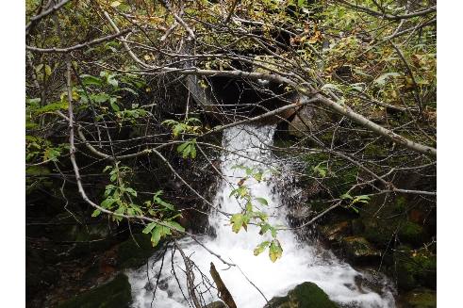

Figure 17: Outlet of PSCIS crossing 57695 (UTM: 10N 563257 6038803).

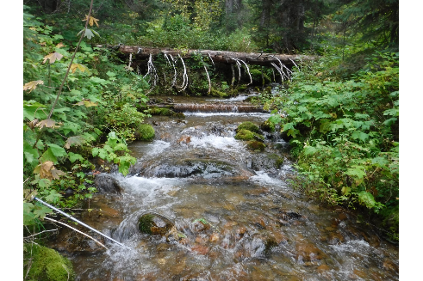

Figure 18: Habitat downstream of PSCIS crossing 57695 (UTM: 10N 563237 6038641).

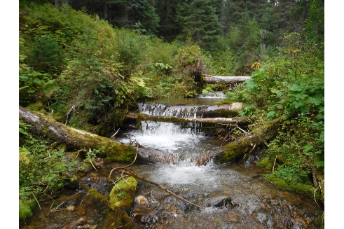

Figure 19: Habitat downstream of PSCIS crossing 57695 (UTM: 10N 563199 6038452).

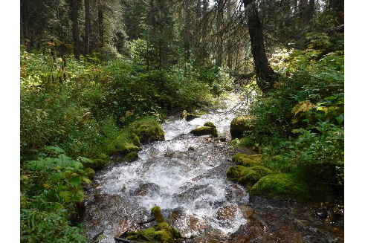

Figure 20: View of habitat upstream of PSCIS crossing 57695 (UTM: 10N 563234 6038882).

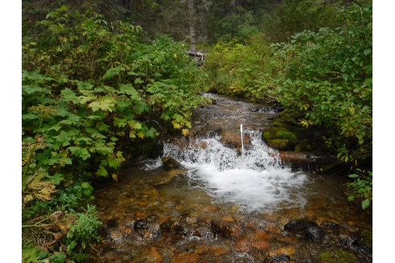

Figure 21: View of habitat upstream of PSCIS crossing 57695 (UTM: 10N 563127 6039030).

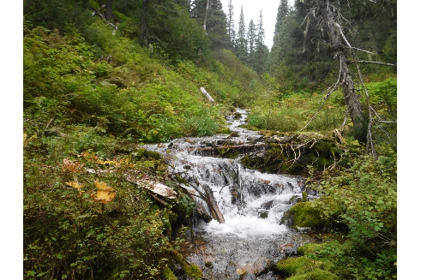

Figure 22: View of habitat upstream of PSCIS crossing 57695 (UTM: 10N 563042 6039289).

# Appendix - Crossing 57696 - Chuchinka-Wichcika FSR - Trib to Wichcika Creek

##### Site Location

Crossing 57696 is located on an unnamed Unnamed tributary to Wichcika Creek near the 17km mark of the Chuchinka-Wichcika FSR. The culvert is located 0.6km from the confluence with Wichcika Creek (Table 17). At the time of the field surveys, there appeared to be no active log hauling on the FSR however their was a mining exploration camp on the road roughly near the 5km mark and some pickup truck traffic was encountered.

##### Background Information

At the crossing location, the stream is 2nd order with a watershed area upstream of the road of approximately 3.2km2. The elevation of the watershed ranges from a maximum of 1500m to 1100m at the culvert. No other crossings are modeled upstream.

Provincial records indicate that Bull Trout were captured within the subject stream downstream of the crossing approximately 450m as well as near the mouth of the stream by DWB in 2016 (MoE 2019b).

Hagen et al. (2015) have identified the upper end of the Wichcika Creek mainstem as containing critical spawning and juvenile rearing habitat for large body Bull Trout with an estimated minimum spawner abundance of less than 50 fish.

Following office review, PSCIS stream crossing 57696 was ranked as a high priority for follow up with habitat confirmation due to the potential for rehabilitation of the crossing to provide access to modeled instream (1.5km) habitat with a relatively large channel size (3.97m) and potentially high value habitat as indicated by contractor habitat value assignment. Additionally, Gollner, Cain, and Russell (2013) prioritized the crossing for follow up (Table 18). The habitat confirmation was completed on August 28, 2019. A map of the watershed including areas surveyed is provided in Attachment 1 – Map [093J115](https://hillcrestgeo.ca/outgoing/forNewGraph/parsnip/maps/FishPassage_093J.115.pdf).

##### Stream Characteristics at Crossing

At the time of the survey, the un-embedded and non-backwatered 0.65m diameter crossing was considered a barrier to upstream fish passage with a pipe length of 20m, a culvert slope of 7% and an outlet drop of 0.6m (Table 19, Figure 23). Water temperature was 7 $​^{∘}$ C and conductivity was 146uS/cm.

##### Stream Characteristics Downstream

The stream was surveyed downstream from the culvert for 700m to the confluence of the stream and Wichcika Creek. A 1.5 m high rock falls was observed approximately 85m downstream of the crossing (Figure 24). Overall, total cover amount was rated as moderate with deep pools dominant. Cover was also present as small woody debris, large woody debris, undercut banks, and overhanging vegetation and there were occasional pockets of gravels suitable for spawning present (Figures 25 - 26). The average channel width was 4.3m, the average wetted width was 3.1m and the average gradient was 11.2% (Table 20). Riparian vegetation was comprised of a mature spruce forest. Three minnowtraps were set overnight within the 50m of channel directly below the culvert. No fish were captured. Habitat value downstream of the crossing was rated as medium.

##### Stream Characteristics Upstream

The stream was surveyed upstream from the culvert for 650m to the location of a 15m long cascade with gradients exceeding 30% (Figure 27). The average channel width was 3.8m, the average wetted width was 3.3m and the average gradient was 14.3% (Table 20). Riparian vegetation was comprised of a mature spruce forest and total cover amount was rated as moderate. The dominant cover form was undercut banks with small woody debris, large woody debris, boulders, and overhanging vegetation also available (Figures 28 - 29). Some pockets of gravels suitable for spawning were present and the mature channel contained frequent drops from 0.3 - 0.5m high resulting from large woody debris jams. Habitat value upstream of the crossing was rated as medium.

##### Conclusion

There is 650m of mainstem habitat upstream of crossing 57696 before a cascade impassable to all fish species at all life stages. Additionally, a 1.5m high falls located 85m downstream of crossing 57696 would limit access to the crossing for all species except potentially large bodied Bull Trout. Habitat in the areas surveyed upstream of the crossing was rated as medium value with moderate rearing potential for Bull Trout which have been confirmed as present downstream of the FSR. Review of Ministry of Forests, Lands, Natural Resource Operations & Rural Development (FLNR) licensee operating areas maps indicate that the forest licensee in the area is Sinclar Group however the road tenure holder is detailed as Carrier Lumber Ltd. within the provincial forest tenure road lines layer (MoE 2019a). The crossing was ranked as a low priority for rehabilitation as habitat upstream was rated as medium value and because the 1.5m high falls located 85m below the falls may hinder access to the crossing location even for large bodied Bull Trout.

Table 17: Overview of stream crossing.

| Site | Stream | Road | Tenure | UTM (10N) | Fish Species | Priority |
| --- | --- | --- | --- | --- | --- | --- |
| 57696 | Trib to Wichcika Creek | Chuchinka-Wichcika FSR | CARRIER LUMBER LTD. R21212 D 0 | 564171 6037942 | - | Low |

Table 18: Field map, Fish Habitat Model outputs, historic PSCIS details and prioritization for follow up with fish habiat confirmation rank/comments.

| Site | Map 50k | Instream (km) | Lake (ha) | Wetland (ha) | Channel Width (m) | Fish Upstream | Habitat Value | Rank | Comments |
| --- | --- | --- | --- | --- | --- | --- | --- | --- | --- |
| 57696 | 093J115 | 1.5 | - | 0.5 | 4 | Yes | High | High | Prioritized in Gollner et al. (2013). Larger stream BT observed downstream. |

Table 19: Summary of culvert fish passage assessment.

| Site | Diameter (m) | Length (m) | Embedded | Backwatered | Fill Depth (m) | Outlet Drop (m) | Outlet Pool Depth (m) | Stream Width Ratio | Barrier Result |
| --- | --- | --- | --- | --- | --- | --- | --- | --- | --- |
| 57696 | 0.6 | 20 | no | no | 1 | 0.6 | 0.3 | 6.6 | Barrier |

Table 20: Summary of habitat details

| Site | Location | Length Surveyed (m) | Channel Width (m) | Wetted Width (m) | Pool depth (m) | Gradient (%) | Habitat Value |
| --- | --- | --- | --- | --- | --- | --- | --- |
| 57696 | Downstream | 700 | 4.3 | 3.1 | 0.4 | 11.2 | Medium |
| 57696 | Upstream | 650 | 3.8 | 3.3 | 0.4 | 14.3 | Medium |

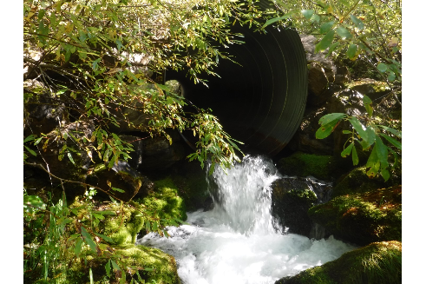

Figure 23: Outlet of PSCIS crossing 57696 (UTM: 10N 564171 6037942).

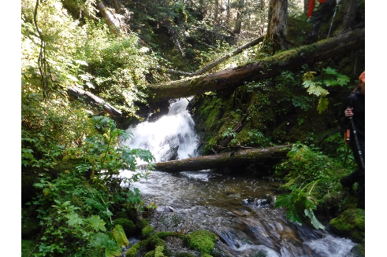

Figure 24: 1.5m high rock drop located 85m downstream of PSCIS crossing 57696 (UTM: 10N 564085 6037947).

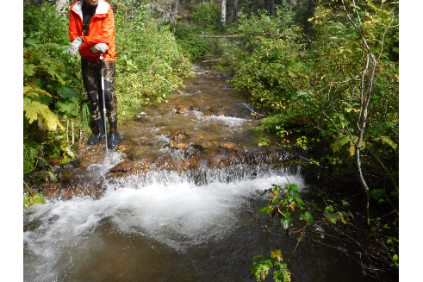

Figure 25: Habitat downstream of PSCIS crossing 57696 (UTM: 10N 563768 6037654).

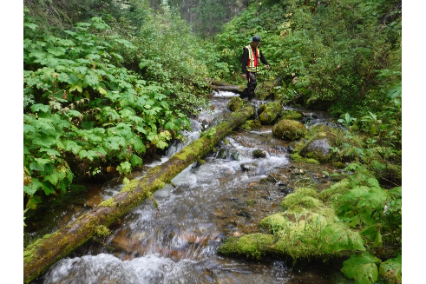

Figure 26: Habitat downstream of PSCIS crossing 57696 (UTM: 10N 563778 6037682).

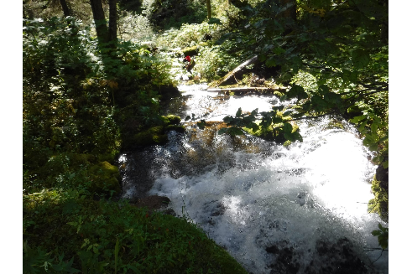

Figure 27: Downstream view of 15m long cascade with gradient of 32% located 650m upstream of PSCIS crossing 57696 (UTM: 10N 564402 6038496).

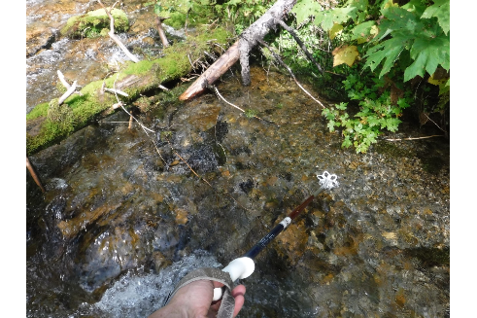

Figure 28: View of habitat upstream of PSCIS crossing 57696 (UTM: 10N 564328 6038150).

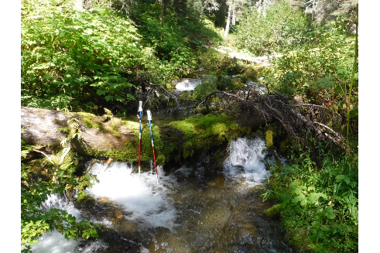

Figure 29: View of habitat upstream of PSCIS crossing 57696 (UTM: 10N 564368 6038257).

# Appendix - Crossing 125000 - Chuchinka-Arctic FSR - Trib to Parsnip River

##### Site Location

Crossing 125000 is located on an unnamed tributary to the Parsnip River under the Chuchinka-Arctic FSR, approximately 2km upstream of the confluence with the Parsnip River and approximately 9km north-west of the outlet of Arctic Lake (Table 21). Arctic Lake is located within Arctic Pacific Lakes Provincial Park which is situated on the north side of the north-south continental divide that separates watersheds flowing north to the Arctic Ocean and the Fraser River watershed that flows south and west to the Pacific Ocean. At the time of the field surveys, a small remote logging camp was located approximately 3.5km to the north-west of the crossing location and active logging was occurring on the east side of the Parsnip River valley adjacent to the camp.

##### Background Information

The unnamed tributary to the Parsnip River is a 3rd order stream with a watershed area upstream of the crossing of 11.2km2. The elevation of the watershed ranges from a maximum of 1600m to 750m at the confluence with the Parsnip River. There are no other stream crossing (culvert) barriers on the stream mainstem upstream of the Chuchinka-Arctic FSR although one crossing was modeled as located on a tributary upstream (crossing 16604087). Provincial records indicate that fish have not previously been recorded in the stream (MoE 2019b). The habitat confirmation was completed on September 02, 2019 and September 8, 2020. A map of the watershed including areas surveyed is provided in Attachment 1 – Map [093I111](https://hillcrestgeo.ca/outgoing/forNewGraph/parsnip/maps/FishPassage_093I.111.pdf).

Although they concede that information adequacy for assessing critical habitats for Bull Trout in the Upper Parsnip sub-basin is poor, Hagen et al. (2015) report that low juvenile Bull Trout density and turbid water conditions indicate that this area is likely of relatively low importance for the Parsnip River population.

Following office review, PSCIS stream crossing 125000 was ranked as a high priority for follow up with habitat confirmation due to the potential for rehabilitation of the crossing to provide access to upstream wetland (5.7ha) and instream (10.5km) habitat. Of note, the crossing was ranked by Hooft (2014) as a high priority for follow up (Table 22).

##### Stream Characteristics at Crossing

At the time of the survey, the culvert was considered a barrier to upstream fish passage with a length of 21m, a culvert slope of 3% and an outlet drop of 0.4m (Table 23). There was a large, deep pool (1.5m) at the outlet of the culvert indicative of a severely confined channel (Figures 30 - 31). Water temperature was 10 $​^{∘}$ C and conductivity was 39uS/cm.

##### Stream Characteristics Downstream

The stream was surveyed downstream from the culvert for 325m. Immediately downstream of the outlet pool the channel substrate was dominated by gravels with large woody debris abundant throughout (Figure 32). Aproximately 60m downstream of the crossing was a 2m high breached historic beaver dam structure. Subsequent beaver dam structures resulted in stream/wetland complex type habitat downstream consisting of glide sections up to 90 cm deep (Figure 33 - 34). The average channel width was 4.5m, the average wetted width was 3.8m and the average gradient was 1.2% (Table 24). There was a 0.7m high beaver dam located at the downstream end of the site (UTM: 10N 577330 6038336).

Based on google earth imagery and modelled gradients, it is likely that there were additional beaver dams between the downstream end of the stream section surveyed and the confluence of the Parsnip River approximately 1.7km downstream. Minnow trapping (3 traps set and left overnight) and electrofishing (70m long site electrofished for 45 seconds) were conducted downstream of the crossing structure. A standardized 100m long electrofishing site was not completed due to equipment malfunction.Four Sculpin ranging from 57 - 61mm long were captured in minnow traps. One Sculpin (57mm) and one Rainbow Trout parr (61mm) were captured by electrofishing (Figure 35).

##### Stream Characteristics Upstream

The stream was surveyed upstream from the culvert continuously for 330m to a beaver influenced wetland area where walking became difficult due to water depth (UTM:10N 577830 6038053). The average channel width was 4.4m, the average wetted width was 3.3m and the average gradient was 4% (Table 24). The stream was accessed again from logging roads at points 1.6km upstream from the crossing then again at approximately 2.5km upstream of the crossing. Undercut banks, large woody debris, overhanging vegetation and gravels suitable for spawning were located within all upstream areas surveyed (Figures 36 - 37). An unmanned aerial vehicle was utilized to capture video footage of upstream habitat and is available [HERE](https://www.youtube.com/watch?v=-foWvX1MSkg). Minnow trapping was conducted upstream of the crossing (3 traps set and left overnight) with no fish captured. One culvert on a small upstream tributary (modeled crossing 16604087) was assessed and determined to be a barrier (Figure - 38).

##### Conclusion

There is an estimated 3.5km of high value mainstem habitat available upstream of crossing 125000. Rainbow Trout and Sculpin were confirmed as present by fish sampling immediately below the crossing. No fish were captured upstream, although habitat appears suitable for not only Rainbow Trout and Sculpin, but also for Bull Trout rearing and spawning. The forest licensee in the area is Sinclar Group and the road tenure holder is the Ministry of Forests, Lands, Natural Resource Operations & Rural Development. Overall, the crossing located on the Chuchinka-Arctic FSR was ranked as a high priority for rehabilitation.

Table 21: Overview of stream crossing.

| Site | Stream | Road | Tenure | UTM (10N) | Fish Species | Priority |
| --- | --- | --- | --- | --- | --- | --- |
| 125000 | Trib to Parsnip River | Chuchinka-Arctic FSR | FLNRORD 5506 10 0 | 577534 6038205 | RB, CC | High |

Table 22: Field map, Fish Habitat Model outputs, historic PSCIS details and prioritization for follow up with fish habiat confirmation rank/comments.

| Site | Map 50k | Instream (km) | Lake (ha) | Wetland (ha) | Channel Width (m) | Fish Upstream | Habitat Value | Rank | Comments |
| --- | --- | --- | --- | --- | --- | --- | --- | --- | --- |
| 125000 | 093I111 | 10.5 | - | 5.7 | 5.5 | Yes | High | High | Large channel in wetland area at top of watershed. |

Table 23: Summary of culvert fish passage assessment.

| Site | Diameter (m) | Length (m) | Embedded | Backwatered | Fill Depth (m) | Outlet Drop (m) | Outlet Pool Depth (m) | Stream Width Ratio | Barrier Result |
| --- | --- | --- | --- | --- | --- | --- | --- | --- | --- |
| 125000 | 1.4 | 21 | no | no | 2 | 0.4 | 1.5 | 3 | Barrier |

Table 24: Summary of habitat details

| Site | Location | Length Surveyed (m) | Channel Width (m) | Wetted Width (m) | Pool depth (m) | Gradient (%) | Habitat Value |
| --- | --- | --- | --- | --- | --- | --- | --- |
| 125000 | Upstream | 350 | 4.4 | 3.3 | 0.4 | 4 | High |
| 125000 | Downstream | 325 | 4.5 | 3.8 | - | 1.2 | High |

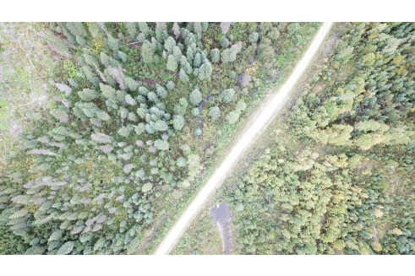

Figure 30: Aerial view of PSCIS crossing 125000 (UTM: 10N 577534 6038205).

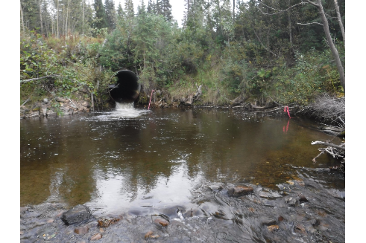

Figure 31: Outlet of PSCIS crossing 125000 (UTM: 10N 577534 6038205).

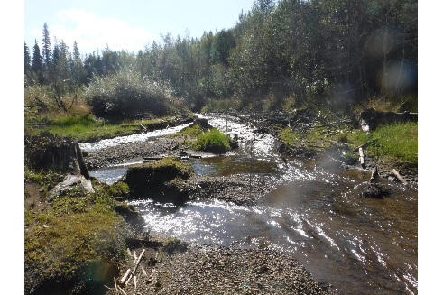

Figure 32: View of habitat immediately downstream of PSCIS crossing 125000 (UTM: 10N 577454 6038254).

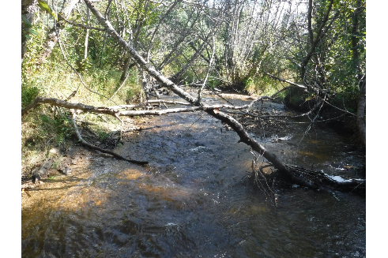

Figure 33: View of habitat downstream of PSCIS crossing 125000 (UTM: 10N 577408 6038313).

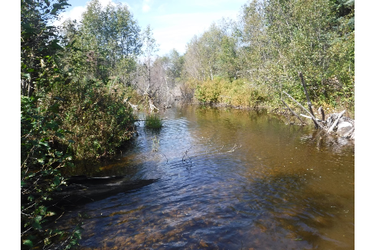

Figure 34: View of habitat downstream of PSCIS crossing 125000 (UTM: 10N 577351 6038341).

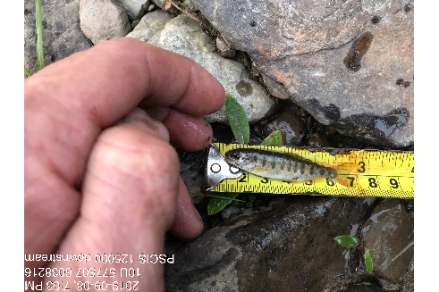

Figure 35: View of Rainbow Trout parr captured downstream of PSCIS crossing 125000 (UTM: 10N 577508 6038217).

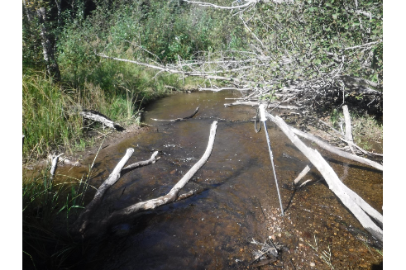

Figure 36: View of habitat upstream of PSCIS crossing 125000 (UTM: 10N 577807 6038068).

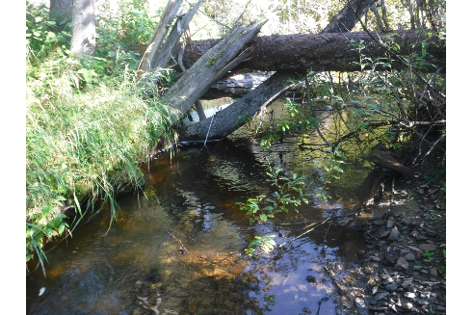

Figure 37: View of habitat upstream of PSCIS crossing 125000 (UTM: 10N 577643 6038097).

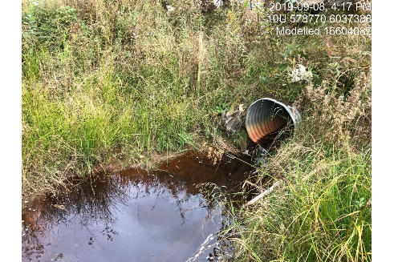

Figure 38: View of crossing 16604087 - located on small tributary upstream of PSCIS crossing 125000 (UTM: 10N 578771 6037388).

# Appendix - Crossing 125098 - Unnamed Road - Trib to Parsnip River

##### Site Location

Crossing 125098 is located on an unnamed tributary to Parsnip River near the 1km mark of an unnamed road (tenure ID R01821B). The road is accessed from the Chuchinka-Arctic FSR. The culvert is located 0.6km upstream from the confluence with the Parsnip River (Table 25). At the time of the field surveys, there appeared to be no active log hauling on the road.

##### Background Information

At the crossing location, the stream is 1st order with watershed elevations ranging from a maximum of 830m to 780m at the culvert. There were no other crossings upstream.

Provincial records indicate that Rainbow Trout were captured upstream of the crossing by DWB in 2017 (MoE 2019b).

Although they concede that information adequacy for assessing critical habitats for Bull Trout in the Upper Parsnip sub-basin is poor, Hagen et al. (2015) report that low juvenile Bull Trout density and turbid water conditions indicate that this area is likely of relatively low importance for the Parsnip River population.

Following office review, PSCIS stream crossing 125098 was ranked as a moderate priority for follow up with habitat confirmation due to the confirmed presence of Rainbow Trout and modeled low gradient habitat upstream (Table 26). The habitat confirmation was completed on September 08, 2019. A map of the watershed including areas surveyed is provided in Attachment 1 – Map [093I111](https://hillcrestgeo.ca/outgoing/forNewGraph/parsnip/maps/FishPassage_093I.111.pdf).

##### Stream Characteristics at Crossing

At the time of the survey, the un-embedded and non-backwatered 1.2m diameter crossing was considered a barrier to upstream fish passage with a pipe length of 10m, a culvert slope of 4% and an outlet drop of 0.4m (Table 27, Figure 39). Water temperature was 11 $​^{∘}$ C and conductivity was 43uS/cm.

##### Stream Characteristics Downstream

The stream was surveyed downstream from the culvert for 215m. Overall, total cover amount was rated as abundant with undercut banks dominant andsmall woody debris, large woody debris, and overhanging vegetation also present. However, the small stream had very minimal flows with moss present mid-channel indicating low flow volumes were typical for the system (Figures 40 - 41). Occasional pockets of gravels suitable for spawning were noted as present. The average channel width was 1.7m, the average wetted width was 1.1m and the average gradient was 4.5% (Table 28). Riparian vegetation was comprised of a mature coniferous forest. Habitat value downstream of the crossing was rated as low due to likely very limited rearing and spawning potential resulting from low flow conditions.

##### Stream Characteristics Upstream

The stream was surveyed upstream from the culvert for 295m. The average channel width was 2m, the average wetted width was 1.6m and the average gradient was 3% (Table 28). Riparian vegetation was comprised of a mature coniferous forest and total cover amount was rated as moderate. The dominant cover form was undercut banks with small woody debris, large woody debris, and overhanging vegetation also available (Figures 42 - 43). Some pockets of gravels suitable for spawning were noted as present. Habitat value downstream of the crossing was rated as low due to likely very limited rearing and spawning potential resulting from low flow conditions.

##### Conclusion

Mapping indicates there is 1km of habitat upstream of crossing 125098. Although Rainbow Trout have been recorded upstream, habitat value was rated as low value due to a lack of significant flow volume. Review of Ministry of Forests, Lands, Natural Resource Operations & Rural Development (FLNR) licensee operating areas maps indicate that the forest licensee in the area is Sinclar Group with the road tenure holder detailed as Winton Global Lumber Ltd. (MoE 2019a). The crossing was ranked as a low priority for rehabilitation.

Table 25: Overview of stream crossing.

| Site | Stream | Road | Tenure | UTM (10N) | Fish Species | Priority |
| --- | --- | --- | --- | --- | --- | --- |
| 125098 | Trib to Parsnip River | Unnamed | WINTON GLOBAL LUMBER LTD. R01821 B | 582902 6035080 | RB | Low |

Table 26: Field map, Fish Habitat Model outputs, historic PSCIS details and prioritization for follow up with fish habiat confirmation rank/comments.

| Site | Map 50k | Instream (km) | Lake (ha) | Wetland (ha) | Channel Width (m) | Fish Upstream | Habitat Value | Rank | Comments |
| --- | --- | --- | --- | --- | --- | --- | --- | --- | --- |
| 125098 | 093I111 | 1 | - | - | 1.4 | Yes | Medium | Mod | Over 1 km of habitat modelled as between 3-5% gradient. First order stream. |

Table 27: Summary of culvert fish passage assessment.

| Site | Diameter (m) | Length (m) | Embedded | Backwatered | Fill Depth (m) | Outlet Drop (m) | Outlet Pool Depth (m) | Stream Width Ratio | Barrier Result |
| --- | --- | --- | --- | --- | --- | --- | --- | --- | --- |
| 125098 | 1.2 | 10 | no | no | 1 | 0.4 | 0.3 | 0.9 | Barrier |

Table 28: Summary of habitat details

| Site | Location | Length Surveyed (m) | Channel Width (m) | Wetted Width (m) | Pool depth (m) | Gradient (%) | Habitat Value |
| --- | --- | --- | --- | --- | --- | --- | --- |
| 125098 | Upstream | 295 | 2 | 1.6 | 0.1 | 3 | Low |
| 125098 | Downstream | 215 | 1.7 | 1.1 | 0.2 | 4.5 | Low |

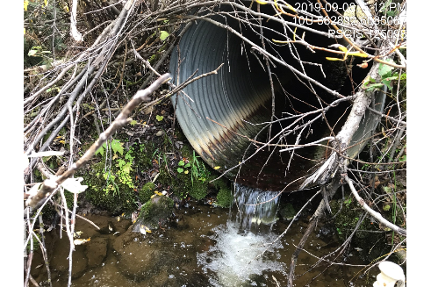

Figure 39: Outlet of PSCIS crossing 125098 (UTM: 10N 582892 6035087).

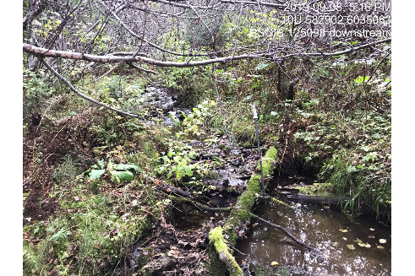

Figure 40: Habitat downstream of PSCIS crossing 125098 (UTM: 10N 582902 6035084).

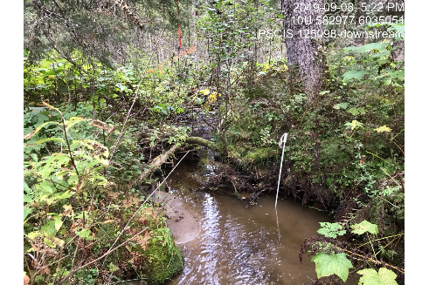

Figure 41: Habitat downstream of PSCIS crossing 125098 (UTM: 10N 582978 6035051).

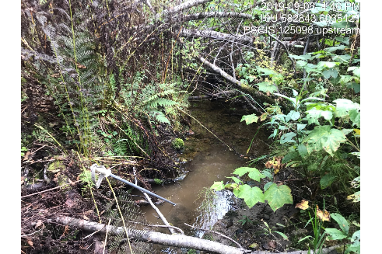

Figure 42: View of habitat upstream of PSCIS crossing 125098 (UTM: 10N 582843 6035121).

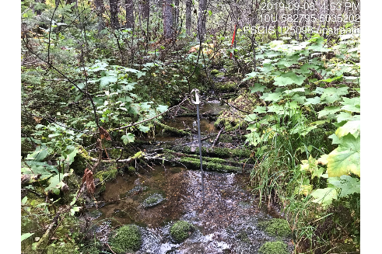

Figure 43: View of habitat upstream of PSCIS crossing 125098 (UTM: 10N 582795 6035202).

# Appendix - Crossing 125128 - Unnamed Road - Trib to Missinka River

##### Site Location

Crossing 125128 is located on an unnamed tributary to the Missinka River near the 1289.2km mark of an unnamed road. The road is accessed from the Chuckinka-Missinka FSR and is located on the south side of the Missinka River. The culvert is located 1.2km from the confluence of the stream and the Missinka River (Table 29). At the time of the field surveys, there appeared to be no active log hauling and extended sections of the road were overgrown with shrubs. The site was accessed by ATV.

##### Background Information

At the crossing location, the stream is a 3rd order stream with a watershed area upstream of the road of approximately 1.6km2. Although upstream tributaries are not mapped below 1000m, the elevation of the watershed ranges from a maximum of 1560m to 920m at the culvert. No other crossings were modeled upstream.

Provincial records indicate that Rainbow Trout, Mountain Whitefish, Sculpin, and Burbot have been captured in the subject stream approximately 400m downstream of the crossing (MoE 2019b; Triton Environmental Consultants Ltd. 1999). Review of Triton Environmental Consultants Ltd. (1999) maps indicates that no fish were captured at a sample site located approximately 700m upstream of the crossing within a small tributary to a wetland area.

Hagen et al. (2015) have identified the Missinka River watershed as containing critical spawning habitat for large body adult Bull Trout with potentially less than 50 spawners utilizing the watershed. Critical juvenile rearing habitat is also noted as present (Hagen et al. 2015). Additionally, the Missinka River watershed is utilized by a possibly genetically distinct, self-sustaining Arctic Grayling population with the mainstem of the river providing critical habitat for fry and adult fish (Shrimpton, Roberts, and Clarke 2012; Hagen et al. 2015).

In 2018, the Missinka River watershed was designated as a fisheries sensitive watershed under the authority of the *Forest and Range Practices Act* due to significant downstream fisheries values and watershed sensitivity (Beaudry 2013b). Special management is required in the crossing’s watershed to protect habitat for Bull Trout and Arctic Grayling and includes measures (among others) to limit equivalent clearcut area, reduce impacts to natural stream channel morphology, retain old growth attributes and maintain fish habitat/movement (Forest and Range Practices Act 2018).

Following office review, PSCIS stream crossing 125128 was ranked as a high priority for follow up with habitat confirmation due to the potential for rehabilitation of the crossing to provide access to modeled instream (1.9km) and wetland (7.1ha) habitat and due to a past habitat value rating assessed as medium by Hooft (2014). Review of historic fisheries information also indicated a 1.9m wide channel located well upstream of the crossing (Table 30). The habitat confirmation was completed on September 02, 2018. A map of the watershed including areas surveyed is provided in Attachment 1 – Map [093I116](https://hillcrestgeo.ca/outgoing/forNewGraph/parsnip/maps/FishPassage_093I.116.pdf).

##### Stream Characteristics at Crossing

At the time of the survey, the un-embedded and non-backwatered 1.2m diameter crossing was considered a barrier to upstream fish passage with a pipe length of 15m and a culvert slope of 2% (Table 31, Figure 44). Water temperature was 14 $​^{∘}$ C and conductivity was 168uS/cm.

##### Stream Characteristics Downstream

The stream was surveyed downstream from the culvert for 75m to below a 5m high cascade (10 m long at 50% gradient) and a subsequent 12m long cascade with gradients of 32% (Figure 45). Overall, total cover amount was rated as moderate with undercut banks dominant (Figures 46). Cover was also present as small woody debris, boulders, and overhanging vegetation. The average channel width was 2.1m, the average wetted width was 2m and the average gradient was 5.3% (Table 32). Habitat downstream of the crossing was rated as medium value with moderate rearing potential for Burbot, Bull Trout, Rainbow Trout and other salmonid species.

##### Stream Characteristics Upstream

The stream was surveyed upstream from the culvert for 50m to where an extensive wetland area began (Figure 47. The average channel width before the wetland was 11.3m, the average wetted width was 11.3m and the average gradient was 0.8% (Table 32). Overall, total cover amount was rated as moderate with the dominant cover form deep pools and overhanging vegetation and instream vegetation also available. Habitat value upstream of the crossing was rated as low as there was no suitable spawning habitat present for salmonids and low rearing potential due to the assumed shallow typical depth of the wetland.

##### Conclusion

There is approximately 0.7km of mainstem habitat within an extensive wetland area upstream of crossing 125128. However, large bodied Bull Trout are likely the only species potentially capable of getting over the steep cascade sections located just downstream of the road. Additionally, the likely shallow depths present in the wetland and a likely absence of habitat suitable for rearing or spawning upstream of the wetland areas (due to the small size of tributary watersheds) are likely not conducive to Bull Trout spawning and rearing. The forest licensee in the area are Sinclar Group and the road tenure holder is the Ministry of Forests, Lands, Natural Resource Operations & Rural Development. Overall, the crossing was ranked as a low priority for rehabilitation.

Table 29: Overview of stream crossing.

| Site | Stream | Road | Tenure | UTM (10N) | Fish Species | Priority |
| --- | --- | --- | --- | --- | --- | --- |
| 125128 | Trib to Missinka River | Unnamed | FLNRORD 5506 25 | 583454 6051827 | - | Low |

Table 30: Field map, Fish Habitat Model outputs, historic PSCIS details and prioritization for follow up with fish habiat confirmation rank/comments.

| Site | Map 50k | Instream (km) | Lake (ha) | Wetland (ha) | Channel Width (m) | Fish Upstream | Habitat Value | Rank | Comments |
| --- | --- | --- | --- | --- | --- | --- | --- | --- | --- |
| 125128 | 093I116 | 1.9 | - | 7.1 | 1.7 | Yes | Medium | High | Assessment comments indicate good habitat upstream. Inventory site well upstream has channel width = 1.9 m. |

Table 31: Summary of culvert fish passage assessment.

| Site | Diameter (m) | Length (m) | Embedded | Backwatered | Fill Depth (m) | Outlet Drop (m) | Outlet Pool Depth (m) | Stream Width Ratio | Barrier Result |
| --- | --- | --- | --- | --- | --- | --- | --- | --- | --- |
| 125128 | 1.2 | 15 | no | no | 1 | 0 | 0.2 | 1.8 | Barrier |

Table 32: Summary of habitat details

| Site | Location | Length Surveyed (m) | Channel Width (m) | Wetted Width (m) | Pool depth (m) | Gradient (%) | Habitat Value |
| --- | --- | --- | --- | --- | --- | --- | --- |
| 125128 | Upstream | 50 | 11.3 | 11.3 | - | 0.8 | Low |
| 125128 | Downstream | 75 | 2.1 | 2 | - | 5.3 | Low |

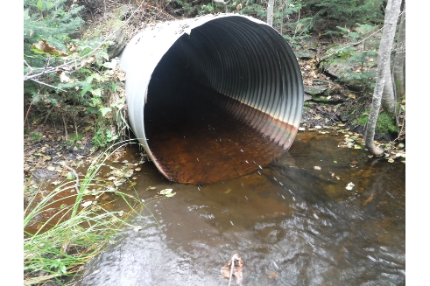

Figure 44: Outlet of PSCIS crossing 125128 (UTM: 10N 583454 6051827).

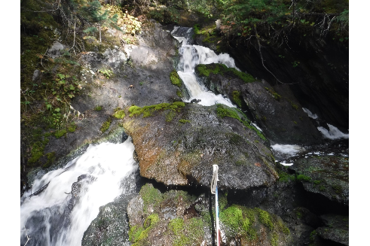

Figure 45: Cascade (32% gradient) downstream of PSCIS crossing 125128 (UTM: 10N 583434 6051814).

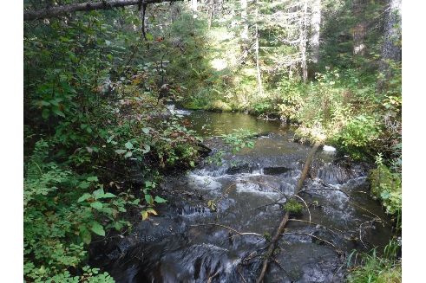

Figure 46: Habitat downstream of PSCIS crossing 125128 (UTM: 10N 583406 6051809).

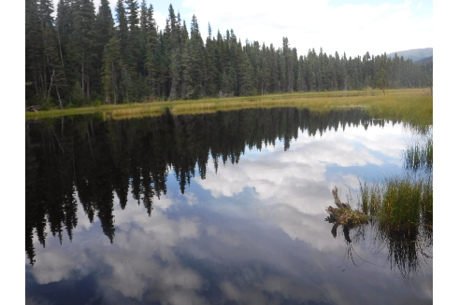

Figure 47: View of habitat upstream of PSCIS crossing 125128 (UTM: 10N 583493 6051822).

# Appendix - Crossing 125175 - Chuchinka-Missinka FSR - Trib to Missinka River

##### Site Location

Crossing 125175 is located on an unnamed tributary to the Missinka River near the 7.5km mark of the Chuchinka-Missinka FSR. The culvert is located approximately 2.4km and 1.7km east of crossings 125180 and 125179 respectively which also were surveyed with habitat confirmation assessments. The stream empties into the Missinka River 0.5km downstream of the crossing (Table 33). At the time of the field surveys, there was very little traffic on the FSR, the road was in disrepair and there appeared to be no active logging in the immediate area.

##### Background Information

At the crossing location, the unnamed tributary to the Missinka River is a 2nd order stream with a watershed area upstream of the road of approximately 1.2km2. The elevation of the watershed ranges from a maximum of 1400m to 800m at the culvert. One crossing is modeled as present on a tributary (16602407) at a location approximately 1km upstream of crossing 125175.

Provincial records indicate that in 1998 there were Rainbow Trout captured in multiple locations upstream of the crossing (MoE 2019b; Triton Environmental Consultants Ltd. 1999). Hagen et al. (2015) have identified the Missinka River watershed as containing critical spawning habitat for large body adult Bull Trout with potentially less than 50 spawners utilizing the watershed. Additionally, they note that critical juvenile Bull Trout rearing habitat is also present. The Missinka River watershed is also utilized by a possibly genetically distinct, self-sustaining Arctic Grayling population with the mainstem of the river providing critical habitat for fry and adult life stages (Shrimpton, Roberts, and Clarke 2012; Hagen et al. 2015).

In 2018, the Missinka River watershed was designated as a fisheries sensitive watershed under the authority of the *Forest and Range Practices Act* due to significant downstream fisheries values and watershed sensitivity (Beaudry 2013b). Special management is required in the crossing’s watershed to protect habitat for Bull Trout and Arctic Grayling and includes measures (among others) to limit equivalent clearcut area, reduce impacts to natural stream channel morphology, retain old growth attributes and maintain fish habitat/movement (Forest and Range Practices Act 2018).

Following office review, PSCIS stream crossing 125175 was ranked as a high priority for follow up with habitat confirmation due to the potential for rehabilitation of the crossing to provide access to instream (2.3km) habitat with a relatively large channel size (2.9m) and Rainbow Trout documented upstream (Table 34). Of note, Hooft (2014) had prioritized this crossing for rehabilitation ranking it 12th of 18 priorities identified. The habitat confirmation was completed on August 29, 2019. A map of the watershed including areas surveyed is provided in Attachment 1 – Map [093I116](https://hillcrestgeo.ca/outgoing/forNewGraph/parsnip/maps/FishPassage_093I.116.pdf).

##### Stream Characteristics at Crossing

At the time of the survey, the un-embedded culvert and un-backwatered double pipe structure (1.2m diameter each) was considered a barrier to upstream fish passage with a length of 15m, a culvert slope of 4% and an outlet drop of 0.1m (Table 35, Figure 48). Water temperature was 7 $​^{∘}$ C, pH was 7.8 and conductivity was 43uS/cm.

##### Stream Characteristics Downstream

The stream was surveyed downstream from the culvert for 400m. The channel contained abundant gravels suitable for spawning. Overall, total cover amount was rated as moderate with overhanging vegetation dominant and small woody debris and undercut banks also available (Figures 49 - 50). The average channel width was 2.8m, the average wetted width was 2.4m and the average gradient was 4.2% (Table 36). Habitat value downstream of the crossing was rated as high due to extensive sections of gravels suitable for salmonid spawning.

##### Stream Characteristics Upstream

The stream was surveyed upstream from the culvert for 565m. The average channel width was 2.5m, the average wetted width was 2m and the average gradient was 9% (Table 36, Figure 51). Riparian vegetation was comprised of a young coniferous forest and instream cover quantity was rated as moderate. The dominant form of cover was overhanging vegetation with small woody debris and undercut banks also available. Approximately 300m upstream of the crossing the stream split into three small tributaries with the western most tributary containing the greatest quantity of flow (Figure 52). Although there were extensive sections of gravels present suitable for resident salmonid spawning above the split, there was a lack of pool habitat suitable for overwintering and rearing. Modeled crossing 16602407, located upstream of the crossing 125175 approximately 1km on the eastern most tributary, could not be inventoried as the road to the location was overgrown and not passable by ATV. Habitat value upstream of the crossing was rated as medium due to the presence of suitable spawning habitat.

##### Conclusion

There is approximately 0.3km of mainstem habitat upstream of crossing 125175 before the stream splits into three small tributaries. Habitat surveyed was rated as medium value for Rainbow Trout, Bull Trout and Burbot with Rainbow Trout presence confirmed 120m upstream of the split within the eastern most tributary (Triton Environmental Consultants Ltd. 1999). The watershed is designated as Fisheries Sensitive with critical habitat for Bull Trout and Arctic Grayling spawning as well as critical rearing habitat for Bull Trout juveniles and Arctic Grayling fry known in the Missinka River system. The forest licensee operating in the area was Sinclar Group Forest Products Ltd. and the road tenure holder was the Ministry of Forests, Lands, Natural Resource Operations & Rural Development. Overall, the crossing located on the Chuchinka-Missinka FSR was ranked as a moderate priority for rehabilitation.

Table 33: Overview of stream crossing.

| Site | Stream | Road | Tenure | UTM (10N) | Fish Species | Priority |
| --- | --- | --- | --- | --- | --- | --- |
| 125175 | Trib to Missinka River | Chuchinka-Missinka FSR | FLNRORD 5506 11 0 | 571772 6051998 | RB | Moderate |

Table 34: Field map, Fish Habitat Model outputs, historic PSCIS details and prioritization for follow up with fish habiat confirmation rank/comments.

| Site | Map 50k | Instream (km) | Lake (ha) | Wetland (ha) | Channel Width (m) | Fish Upstream | Habitat Value | Rank | Comments |
| --- | --- | --- | --- | --- | --- | --- | --- | --- | --- |
| 125175 | 093I116 | 2.3 | - | - | 2.9 | Yes | Medium | High | Larger stream. Potential access at modelled crossing 16602407. |

Table 35: Summary of culvert fish passage assessment.

| Site | Diameter (m) | Length (m) | Embedded | Backwatered | Fill Depth (m) | Outlet Drop (m) | Outlet Pool Depth (m) | Stream Width Ratio | Barrier Result |
| --- | --- | --- | --- | --- | --- | --- | --- | --- | --- |
| 125175 | 1.2 | 15 | no | no | 1 | 0.1 | 0.1 | 2.3 | Barrier |

Table 36: Summary of habitat details

| Site | Location | Length Surveyed (m) | Channel Width (m) | Wetted Width (m) | Pool depth (m) | Gradient (%) | Habitat Value |
| --- | --- | --- | --- | --- | --- | --- | --- |
| 125175 | Upstream | 565 | 2.5 | 2 | - | 9 | Medium |
| 125175 | Downstream | 400 | 2.8 | 2.4 | 0.3 | 4.2 | High |

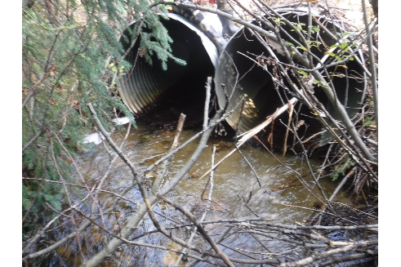

Figure 48: Outlet of PSCIS crossing 125175 (UTM: 10N 571772 6051998).

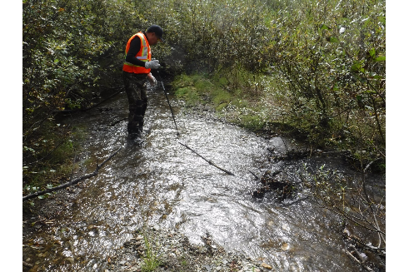

Figure 49: Habitat downstream of PSCIS crossing 125175 (UTM: 10N 571716 6051853).

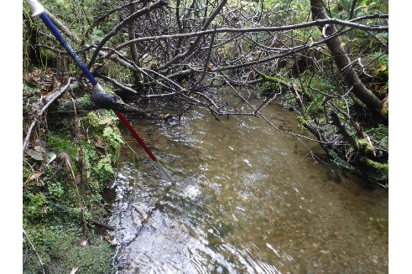

Figure 50: Habitat downstream of PSCIS crossing 125175 (UTM: 10N 571603 6051832).

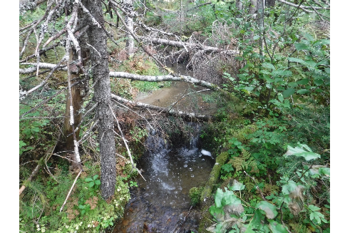

Figure 51: View of habitat upstream of crossing 125175 (UTM: 10N 572161 6052205).

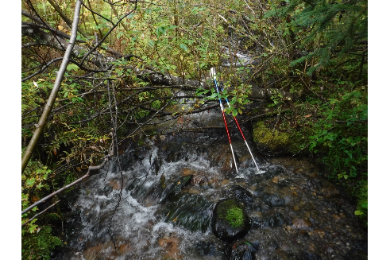

Figure 52: View of habitat upstream of crossing 125175 (UTM: 10N 572059 6052383).

# Appendix - Crossing 125179 - Chuchinka-Missinka FSR Road - Trib to Missinka River

##### Site Location

Crossing 125179 is located on an unnamed tributary to the Missinka River near the 12km mark of the Chuchinka-Missinka FSR. The culvert is located approximately 660m east of surveyed crossing 125180 and joins this adjacent stream just before emptying into the Missinka River 1km downstream of the crossing (Table 37). At the time of the field surveys, there was very little traffic on the FSR and it appeared as though there was no active logging. The forest licensee in the area is Canfor Forest Products and the road tenure holder is the Ministry of Forests, Lands, Natural Resource Operations & Rural Development.

##### Background Information

The unnamed tributary to the Missinka River is a 2nd order stream with a watershed area upstream of the crossing of 4.3km2. The elevation of the watershed ranges from a maximum of 1700m to 800m at the culvert. There are no other stream crossing (culvert) barriers upstream of the crossing.

Provincial records indicate that in 1998 there were Rainbow Trout captured upstream (MoE 2019b; Triton Environmental Consultants Ltd. 1999). Hagen et al. (2015) have identified the Missinka River watershed as containing critical spawning habitat for large body adult Bull Trout with potentially less than 50 spawners utilizing the watershed. Critical juvenile rearing habitat is also noted as present in the Missinka River watershed (Hagen et al. 2015). The Missinka River watershed is utilized by a possibly genetically distinct, self-sustaining Arctic Grayling population with the mainstem of the river providing critical habitat for fry and adult fish (Shrimpton, Roberts, and Clarke 2012; Hagen et al. 2015).

In 2018, the Missinka River watershed was designated as a fisheries sensitive watershed under the authority of the *Forest and Range Practices Act* due to significant downstream fisheries values and watershed sensitivity (Beaudry 2013b). Special management is required in the crossing’s watershed to protect habitat for Bull Trout and Arctic Grayling and includes measures (among others) to limit equivalent clearcut area, reduce impacts to natural stream channel morphology, retain old growth attributes and maintain fish habitat/movement (Forest and Range Practices Act 2018).

Following office review, PSCIS stream crossing 125179 was ranked as a high priority for follow up with habitat confirmation due to the potential for rehabilitation of the crossing to provide access to instream (2.1km) habitat with a relatively large channel size (4.2m) and Bull Trout documented upstream (Table 38). The crossing was also ranked by Hooft (2014) as a high priority for follow up. The habitat confirmation was completed on August 29, 2019. A map of the watershed including areas surveyed is provided in Attachment 1 – Map [093I116](https://hillcrestgeo.ca/outgoing/forNewGraph/parsnip/maps/FishPassage_093I.116.pdf).

##### Stream Characteristics at Crossing

At the time of the survey, the double culvert (1.2m diameter each) was considered a barrier to upstream fish passage with a length of 10m, a culvert slope of 5% and an outlet drop of 0.3m (Table 39, Figure 53). Water temperature was 8 $​^{∘}$ C and conductivity was 32uS/cm.

##### Stream Characteristics Downstream

The stream was surveyed downstream from the culvert for 360m. Abundant large woody debris and overhanging vegetation was available for cover and there were large areas of gravels suitable for salmonid spawning present (Figures 54 - 55). The stream had good flow with an average channel width of 2.8m, an average wetted width of 2.4m and an average gradient of 6.3% (Table 40). No barriers were observed and none were likely located downstream of the area surveyed due to low gradients and significant flow volume. Habitat value downstream of the crossing was rated as high

##### Stream Characteristics Upstream

The stream was surveyed upstream from the culvert for 520m. The average channel width was 3.8m, the average wetted width was 2.5m and the average gradient was 8.7% (Table 40). Large woody debris and undercut banks were present for cover throughout. There were sections of gravel suitable for spawning and deep pools noted (Figures 56 - 57). Habitat value upstream of the crossing was rated as high

##### Conclusion

There is approximately 2km of mainstem habitat upstream of crossing 125179 modeled as less than 22% gradient. The majority of this habitat is likely of high value with Rainbow Trout presence confirmed up to 1.5km upstream of the crossing (Triton Environmental Consultants Ltd. 1999). Bull Trout has also been confirmed upstream of the crossing and the watershed is designated as Fisheries Sensitive with critical habitat for the species known nearby. The forest licensee in the area is Sinclar Group and the road tenure holder is the Ministry of Forests, Lands, Natural Resource Operations & Rural Development. Overall, the crossing located on the Chuchinka-Missinka FSR was ranked as a high priority for rehabilitation.

Table 37: Overview of stream crossing.

| Site | Stream | Road | Tenure | UTM (10N) | Fish Species | Priority |
| --- | --- | --- | --- | --- | --- | --- |
| 125179 | Trib to Missinka River | Chuchinka-Missinka FSR | FLNRORD 5506 11 0 | 570308 6052835 | BT, RB | High |

Table 38: Field map, Fish Habitat Model outputs, historic PSCIS details and prioritization for follow up with fish habiat confirmation rank/comments.

| Site | Map 50k | Instream (km) | Lake (ha) | Wetland (ha) | Channel Width (m) | Fish Upstream | Habitat Value | Rank | Comments |
| --- | --- | --- | --- | --- | --- | --- | --- | --- | --- |
| 125179 | 093I116 | 2.1 | - | - | 4.2 | Yes | Medium | High | Larger stream with BT upstream. |

Table 39: Summary of culvert fish passage assessment.

| Site | Diameter (m) | Length (m) | Embedded | Backwatered | Fill Depth (m) | Outlet Drop (m) | Outlet Pool Depth (m) | Stream Width Ratio | Barrier Result |
| --- | --- | --- | --- | --- | --- | --- | --- | --- | --- |
| 125179 | 1.2 | 10 | no | no | 2 | 0.3 | 0.3 | 2.3 | Barrier |

Table 40: Summary of habitat details

| Site | Location | Length Surveyed (m) | Channel Width (m) | Wetted Width (m) | Pool depth (m) | Gradient (%) | Habitat Value |
| --- | --- | --- | --- | --- | --- | --- | --- |
| 125179 | Upstream | 520 | 3.8 | 2.5 | 0.4 | 8.7 | High |
| 125179 | Downstream | 360 | 2.8 | 2.4 | 0.7 | 6.3 | High |

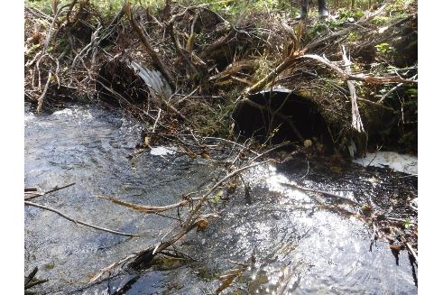

Figure 53: Inlet of PSCIS crossing 125179 (UTM: 10N 570308 6052835).

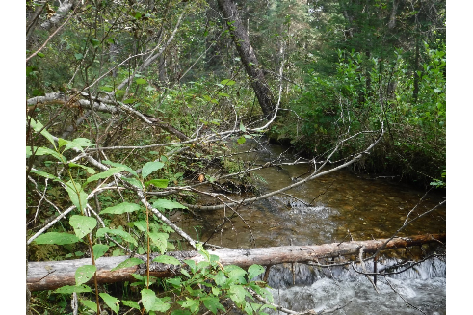

Figure 54: Habitat downstream of PSCIS crossing 125179 (UTM: 10N 570061 6052726).

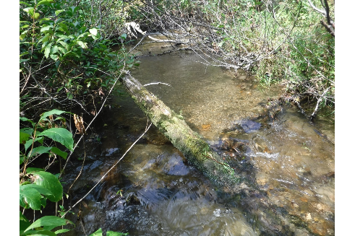

Figure 55: Habitat downstream of PSCIS crossing 125179 (UTM: 10N 570017 6052685).

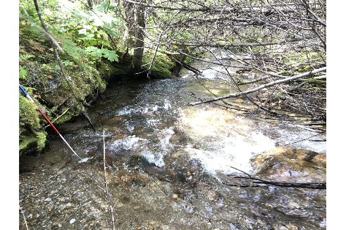

Figure 56: View of habitat upstream of crossing 125179 (UTM: 10N 570255 6052822).

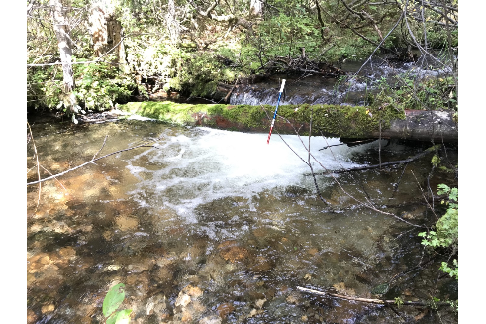

Figure 57: View of habitat upstream of crossing 125179 (UTM: 10N 570228 6052811).

# Appendix - Crossing 125180 - Chuchinka-Missinka FSR - Trib to Missinka River

##### Site Location

Crossing 125180 is located on an unnamed tributary to the Missinka River near the 11km mark of the Chuchinka-Missinka FSR. The culvert is located approximately 660m west of surveyed crossing 125179 and joins this adjacent stream before emptying into the Missinka River 0.9km downstream of the crossing (Table 41). At the time of the field surveys, there was very little traffic on the FSR, the road was in disrepair and there appeared to be no active logging in the immediate area.

##### Background Information

The unnamed tributary to the Missinka River is a 2nd order stream with a watershed area upstream of the crossing of 4km2. The elevation of the watershed ranges from a maximum of 1600m to 800m at the culvert. There are no other stream crossing (culvert) barriers on the mainstem of the stream upstream of the Chuchinka-Missinka FSR.

Provincial records indicate that in 1998 there were Rainbow Trout captured upstream (MoE 2019b; Triton Environmental Consultants Ltd. 1999). Hagen et al. (2015) have identified the Missinka River watershed as containing critical spawning habitat for large body adult Bull Trout with potentially less than 50 spawners utilizing the watershed. Critical juvenile rearing habitat is also noted as present (Hagen et al. 2015). The Missinka River watershed is utilized by a possibly genetically distinct, self-sustaining Arctic Grayling population with the mainstem of the river providing critical habitat for fry and adult fish (Shrimpton, Roberts, and Clarke 2012; Hagen et al. 2015).

In 2018, the Missinka River watershed was designated as a fisheries sensitive watershed under the authority of the *Forest and Range Practices Act* due to significant downstream fisheries values and watershed sensitivity (Beaudry 2013b). Special management is required in the crossing’s watershed to protect habitat for Bull Trout and Arctic Grayling and includes measures (among others) to limit equivalent clearcut area, reduce impacts to natural stream channel morphology, retain old growth attributes and maintain fish habitat/movement (Forest and Range Practices Act 2018).

Following office review, PSCIS stream crossing 125180 was ranked as a high priority for follow up with habitat confirmation due to the potential for rehabilitation of the crossing to provide access to instream (2.1km) habitat with a relatively large channel size (3.9m), Rainbow Trout documented upstream and low average gradients modeled for a significant length (~1km) upstream (Table 42). The habitat confirmation was completed on September 08, 2019. A map of the watershed including areas surveyed is provided in Attachment 1 – Map [093I116](https://hillcrestgeo.ca/outgoing/forNewGraph/parsnip/maps/FishPassage_093I.116.pdf).

##### Stream Characteristics at Crossing

At the time of the survey, the un-embedded double culvert (1.2m each) was considered a barrier to upstream fish passage with a length of 20m and a culvert slope of 3% (Table 43, Figure 58). Water temperature was 10 $​^{∘}$ C and conductivity was 38uS/cm.

##### Stream Characteristics Downstream

The stream was surveyed downstream from the culvert for 600m. Overhanging vegetation was the dominant form of cover and there were abundant gravels present suitable for salmonid spawning (Figures 59 - 60). The stream had good flow with an average channel width of 3.9m, an average wetted width of 2.8m and an average gradient of 5% (Table 44). No barriers were observed and none were likely located downstream of the surveyed area due to low gradients and significant flow volume. Habitat value downstream of the crossing was rated as high

##### Stream Characteristics Upstream

The stream was surveyed upstream from the culvert for 530m. The average channel width was 4.3m, the average wetted width was 3.2m and the average gradient was 6.5% (Table 44). Frequent pockets of gravel suitable for spawning were present at pool tailouts and behind large woody debris (Figures 61 - 62). Although no obstacles to fish passage were noted during 2019 surveys, historic fisheries information indicates that multiple potential obstacles to fish passage (log jam, a cascade and multiple falls) were located near the top end of the surveyed section of stream in 1998. However, it should also be noted that in 1998, Rainbow Trout were captured in the mainstem of the system 800m upstream of the top end of the 2019 site (MoE 2019b; Triton Environmental Consultants Ltd. 1999). Habitat value upstream of the crossing was rated as high

##### Conclusion

There is approximately 2km of mainstem habitat upstream of crossing 125180 modeled as less than 22% gradient. The majority of this habitat is likely of high value with Rainbow Trout presence confirmed up to 1.5km upstream of the crossing (Triton Environmental Consultants Ltd. 1999). Bull Trout is known to utilize the adjacent stream of similiar size and topography and the watershed is designated as Fisheries Sensitive with critical habitat for spawning and juvenile rearing known in the Missinka River system. The forest licensee in the area is Sinclar Group and the road tenure holder is the Ministry of Forests, Lands, Natural Resource Operations & Rural Development. Overall, the crossing located on the Chuchinka-Missinka FSR was ranked as a high priority for rehabilitation.

Table 41: Overview of stream crossing.

| Site | Stream | Road | Tenure | UTM (10N) | Fish Species | Priority |
| --- | --- | --- | --- | --- | --- | --- |
| 125180 | Trib to Missinka River | Chuchinka-Missinka FSR | FLNRORD 5506 11 0 | 569649 6053047 | RB | High |

Table 42: Field map, Fish Habitat Model outputs, historic PSCIS details and prioritization for follow up with fish habiat confirmation rank/comments.

| Site | Map 50k | Instream (km) | Lake (ha) | Wetland (ha) | Channel Width (m) | Fish Upstream | Habitat Value | Rank | Comments |
| --- | --- | --- | --- | --- | --- | --- | --- | --- | --- |
| 125180 | 093I116 | 2.1 | - | - | 3.9 | Yes | Medium | High | Larger stream with near 1 km habitat modelled <5% average slope. |

Table 43: Summary of culvert fish passage assessment.

| Site | Diameter (m) | Length (m) | Embedded | Backwatered | Fill Depth (m) | Outlet Drop (m) | Outlet Pool Depth (m) | Stream Width Ratio | Barrier Result |
| --- | --- | --- | --- | --- | --- | --- | --- | --- | --- |
| 125180 | 1.2 | 20 | no | no | 1 | 0 | 0.2 | 3.6 | Barrier |

Table 44: Summary of habitat details

| Site | Location | Length Surveyed (m) | Channel Width (m) | Wetted Width (m) | Pool depth (m) | Gradient (%) | Habitat Value |
| --- | --- | --- | --- | --- | --- | --- | --- |
| 125180 | Upstream | 530 | 4.3 | 3.2 | 0.5 | 6.5 | High |
| 125180 | Downstream | 600 | 3.9 | 2.8 | 0.4 | 5 | High |

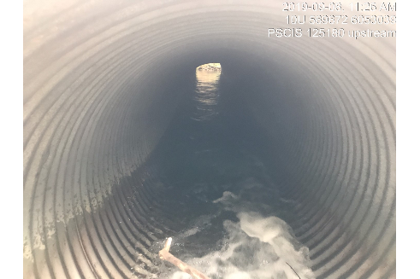

Figure 58: Inlet of PSCIS crossing 125180 (UTM: 10N 569673 6053040).

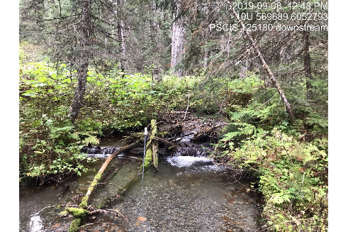

Figure 59: Habitat downstream of PSCIS crossing 125180 (UTM: 10N 569689 6052793).

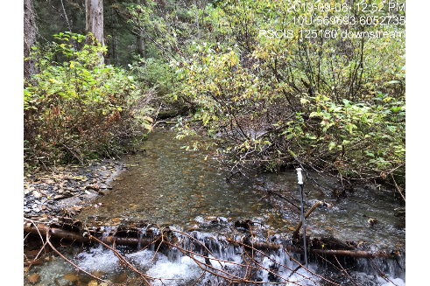

Figure 60: Habitat downstream of PSCIS crossing 125180 (UTM: 10N 569694 6052736).

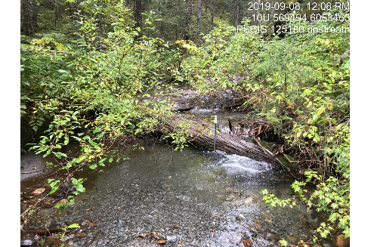

Figure 61: View of habitat upstream of crossing 125180 (UTM: 10N 569495 6053464).

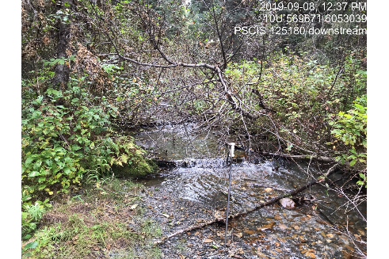

Figure 62: View of habitat upstream of crossing 125180 (UTM: 10N 569672 6053040).

# Appendix - Crossing 125186 - Chuchinka-Missinka FSR - Trib to Missinka River

##### Site Location

Crossing 125186 is located on an unnamed tributary to the Missinka River near the 7.5km mark of the Chuchinka-Missinka FSR. The culvert is located approximately 4.1km and 5.1km west of crossings 125180 and 125179 which also were surveyed with habitat confirmation assessments. The stream empties into the Missinka River 0.4km downstream of crossing 125186 (Table 45). At the time of the field surveys, there was very little traffic on the FSR, the road was in disrepair and there appeared to be no active logging in the immediate area.

##### Background Information

At the crossing location, the unnamed tributary to the Missinka River is a 3rd order stream with a watershed area upstream of the road of approximatley 4.7km2. The elevation of the watershed ranges from a maximum of 1400m to 800m at the culvert. There are no other stream crossing (culvert) barriers upstream of the Chuchinka-Missinka FSR.

Provincial records indicate that in 1998 there were Rainbow Trout captured near the crossing location as well as 460m upstream (MoE 2019b; Triton Environmental Consultants Ltd. 1999). Hagen et al. (2015) have identified the Missinka River watershed as containing critical spawning habitat for large body adult Bull Trout with potentially less than 50 spawners utilizing the watershed. Additionally, they note that critical juvenile Bull Trout rearing habitat is also present. The Missinka River watershed is also utilized by a possibly genetically distinct, self-sustaining Arctic Grayling population with the mainstem of the river providing critical habitat for fry and adult life stages (Shrimpton, Roberts, and Clarke 2012; Hagen et al. 2015).

In 2018, the Missinka River watershed was designated as a fisheries sensitive watershed under the authority of the *Forest and Range Practices Act* due to significant downstream fisheries values and watershed sensitivity (Beaudry 2013b). Special management is required in the crossing’s watershed to protect habitat for Bull Trout and Arctic Grayling and includes measures (among others) to limit equivalent clearcut area, reduce impacts to natural stream channel morphology, retain old growth attributes and maintain fish habitat/movement (Forest and Range Practices Act 2018).

Following office review, PSCIS stream crossing 125186 was ranked as a high priority for follow up with habitat confirmation due to the potential for rehabilitation of the crossing to provide access to instream (1.4km) habitat with a relatively large channel size (4.2m) and Rainbow Trout documented upstream (Table 46). The habitat confirmation was completed on September 08, 2019. A map of the watershed including areas surveyed is provided in Attachment 1 – Map [093I116](https://hillcrestgeo.ca/outgoing/forNewGraph/parsnip/maps/FishPassage_093I.116.pdf).

##### Stream Characteristics at Crossing

At the time of the survey, the un-embedded culvert was considered a barrier to upstream fish passage with a length of 20m, a culvert slope of 4% and an outlet drop of 0.5m (Table 47, Figure 63). Water temperature was 10 $​^{∘}$ C and conductivity was 30uS/cm.

##### Stream Characteristics Downstream

The stream was surveyed downstream from the culvert for 525m. The channel contained abundant gravels suitable for spawning and young of year salmonids were observed approximately 100 m downstream of crossing. Undercut banks comprised the dominant form of cover with overhanging vegetation, large woody debris and small woody debris also present and contributing to high habitat complexity (Figures 64 - 65). The average channel width was 3.8m, the average wetted width was 2.7m and the average gradient was 2.8% (Table 48). There were sections of abandoned dry channel at the bottom of the area surveyed and although the watered channel could not immediately be located during the survey, it is not likely disconnected from the Missinka River mainstem for much of the year (or at all) based the quantity of flow upstream. Following post-survey review of satellite imagery, it appears the channel may meander west of the mapped stream location, joining a wetland complex before flowing into the Missinka River. Habitat value downstream of the crossing was rated as high.

##### Stream Characteristics Upstream

The stream was surveyed upstream from the culvert for 400m. The average channel width was 3.3m, the average wetted width was 2.7m and the average gradient was 7.8% (Table 48). Riparian vegetation was comprised of a mature mixed forest and instream cover was abundant. The dominant cover form was large woody debris with boulders, undercut banks, overhanging vegetation, small woody debris, pools to 0.6m deep and gravels suitable for spawning present (Figures 66 - 67). Habitat value upstream of the crossing was rated as high.

##### Conclusion

There is approximately 1.4km of mainstem habitat upstream of crossing 125186 modeled as less than 22% gradient. Habitat surveyed was rated as high value for salmonids with Rainbow Trout presence confirmed up to 450m upstream of the crossing (Triton Environmental Consultants Ltd. 1999). Bull Trout is known to utilize adjacent streams of similiar size and topography within the vicinity of this stream and the watershed is designated as Fisheries Sensitive with critical habitat for Bull Trout and Arctic Grayling spawning as well as critical rearing habitat for Bull Trout juveniles and Arctic Grayling fry known in the Missinka River system. The forest licensee operating in the area was Sinclar Group Forest Products Ltd. and the road tenure holder was the Ministry of Forests, Lands, Natural Resource Operations & Rural Development. Overall, the crossing located on the Chuchinka-Missinka FSR was ranked as a high priority for rehabilitation.

Table 45: Overview of stream crossing.

| Site | Stream | Road | Tenure | UTM (10N) | Fish Species | Priority |
| --- | --- | --- | --- | --- | --- | --- |
| 125186 | Trib to Missinka River | Chuchinka-Missinka FSR | FLNRORD 5506 11 0 | 565417 6052678 | RB | High |

Table 46: Field map, Fish Habitat Model outputs, historic PSCIS details and prioritization for follow up with fish habiat confirmation rank/comments.

| Site | Map 50k | Instream (km) | Lake (ha) | Wetland (ha) | Channel Width (m) | Fish Upstream | Habitat Value | Rank | Comments |
| --- | --- | --- | --- | --- | --- | --- | --- | --- | --- |
| 125186 | 093I116 | 1.4 | - | - | 4.2 | Yes | High | High | Larger stream. |

Table 47: Summary of culvert fish passage assessment.

| Site | Diameter (m) | Length (m) | Embedded | Backwatered | Fill Depth (m) | Outlet Drop (m) | Outlet Pool Depth (m) | Stream Width Ratio | Barrier Result |
| --- | --- | --- | --- | --- | --- | --- | --- | --- | --- |
| 125186 | 1.2 | 20 | no | no | 1.5 | 0.5 | 0.4 | 2.8 | Barrier |

Table 48: Summary of habitat details

| Site | Location | Length Surveyed (m) | Channel Width (m) | Wetted Width (m) | Pool depth (m) | Gradient (%) | Habitat Value |
| --- | --- | --- | --- | --- | --- | --- | --- |
| 125186 | Upstream | 400 | 3.3 | 2.7 | 0.4 | 7.8 | High |
| 125186 | Downstream | 525 | 3.8 | 2.7 | 0.4 | 2.8 | High |

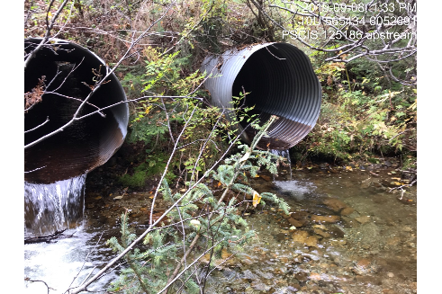

Figure 63: Inlet of PSCIS crossing 125186 (UTM: 10N 565434 6052677).

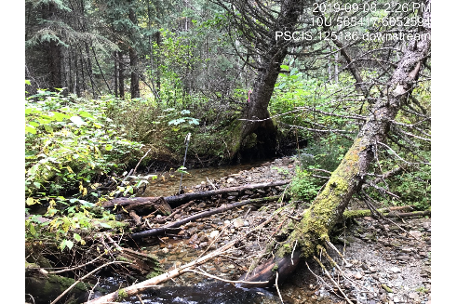

Figure 64: Habitat downstream of PSCIS crossing 125186 (UTM: 10N 565417 6052594).

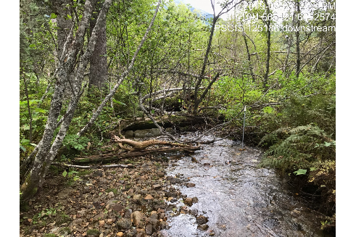

Figure 65: Habitat downstream of PSCIS crossing 125186 (UTM: 10N 565421 6052574).

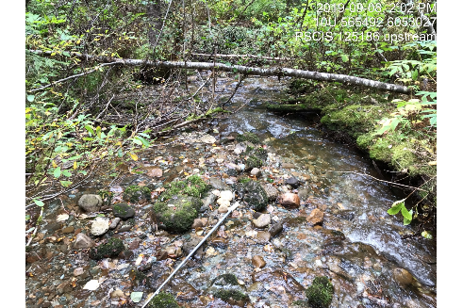

Figure 66: View of habitat upstream of crossing 125186 (UTM: 10N 565456 6053159).

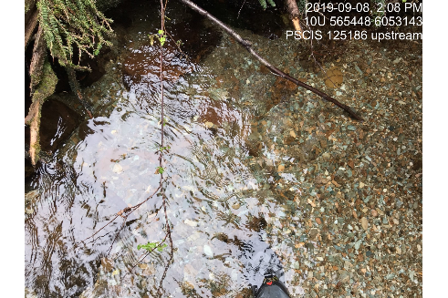

Figure 67: View of habitat upstream of crossing 125186 (UTM: 10N 565448 6053144).

# Appendix - Crossing 125231 - Chuchinka-Table FSR - Trib to Table River

##### Site Location

Crossing 125231 is located on an unnamed tributary to the Table River near the 20km mark of the Chuchinka-Table FSR. The culvert is located 0.7km from the confluence of the Table River on the upstream side of the CN Railway (Table 49). At the time of the field surveys, there was active log hauling on the FSR.

##### Background Information

At the crossing location, the stream is a 3rd order stream with a watershed area upstream of the road of 4km2. The elevation of the watershed ranges from a maximum of 1400m to 760m at the culvert. One previously unassessed crossing (16603641) is located upstream (450m) and previously unassessed crossing (16603278) is located downstream 210m under the CN Railway.

Provincial records indicate that Rainbow Trout have been captured just upstream of the crossing and Rainbow Trout and Sucker species have captured downstream (MoE 2019b; Zemlak and Langston 1995).

Hagen et al. (2015) have identified the Table River watershed and several tributaries as containing critical spawning and juvenile rearing habitat for large body Bull Trout with an estimated minimum spawner abundance of 100 fish.

The Table River (along with the Anzac River) is identified as the primary core of post-Williston Arctic Grayling distribution in the Parsnip River watershed with life history, migration behaviours and critical habitats summarized in Hagen et al. (2015). The mainstem of the Table River contains critical habitats for all life stages of Arctic Grayling with adults observed moving among mainstem locations and tributaries during summer (Hagen et al. 2015).

In 2018, the Table River watershed was designated as a fisheries sensitive watershed under the authority of the *Forest and Range Practices Act* (FSW identifier f-7-022) due to significant downstream fisheries values and watershed sensitivity (Beaudry 2014b). Special management is required in the crossing’s watershed to protect habitat for Bull Trout and Arctic Grayling and includes measures (among others) to limit equivalent clearcut area, reduce impacts to natural stream channel morphology, retain old growth attributes and maintain fish habitat/movement (Forest and Range Practices Act 2018).

Following office review, PSCIS stream crossing 125231 was ranked as a high priority for follow up with habitat confirmation due to the potential for rehabilitation of the crossing to provide access to modeled instream habitat (2.4km) with a relatively large channel size (3.3m) and Rainbow Trout documented upstream (Table 50). The habitat confirmation was completed on September 4, 2019 (downstream) and September 05, 2019 (upstream). A map of the watershed including areas surveyed is provided in Attachment 1 – Map [093J120](https://hillcrestgeo.ca/outgoing/forNewGraph/parsnip/maps/FishPassage_093J.120.pdf).

##### Stream Characteristics at Crossing

At the time of the survey, the un-embedded and non-backwatered double (1.2m each) crossing was considered a barrier to upstream fish passage with pipe lengths of 13.5m, a culvert slope of 3.5% and an outlet drop of 0.65m (Table 51, Figure 68). Water temperature was 9 $​^{∘}$ C and conductivity was 43uS/cm.

##### Stream Characteristics Downstream

The stream was surveyed downstream from the culvert for 350m to within the floodplain of the Table River. Overall, total cover amount was rated as moderate with overhanging vegetation dominant (Figures 69 - 70). Cover was also present as small woody debris and undercut banks. Gravels suitable for spawning were abundant throughout the area surveyed. The average channel width was 3.1m, the average wetted width was 2.5m and the average gradient was 5.2% (Table 52). Habitat value downstream of the crossing was rated as high.

##### Stream Characteristics Upstream

The stream was surveyed upstream from the culvert for 600m to 100m above the location of a newly installed bridge (modeled crossing 16603641, Figure 72). The average channel width was 4m, the average wetted width was 3.5m and the average gradient was 6.3% (Table 52). Riparian vegetation was comprised of a mature coniferous forest and instream cover quantity was rated as moderate. The dominant cover form of cover was deep pools with small woody debris, large woody debris, boulders, undercut banks, and overhanging vegetation also available. Gravels suitable for spawning were present intermittently throughout the area surveyed (Figures 73 - 74). Although there were no permanent barriers, some debris steps from 30 - 70 cms high were located throughout. Habitat value upstream of the crossing was rated as high.

##### Conclusion

There is approximately 2.2km of mainstem habitat upstream of crossing 125231 modeled as less than 22% gradient. Habitat surveyed was rated as high value for salmonids with Rainbow Trout presence confirmed upstream of the crossing (Triton Environmental Consultants Ltd. 1999). Bull Trout is known to utilize adjacent streams of similiar size and topography within the vicinity of this stream and the watershed is designated as Fisheries Sensitive with critical habitat for Bull Trout and Arctic Grayling spawning as well as critical rearing habitat for Bull Trout juveniles and Arctic Grayling fry known in the Table River system. The forest licensees in the area are Sinclar Group and Canfor and the road tenure holder is the Ministry of Forests, Lands, Natural Resource Operations & Rural Development. Overall, the crossing located on the Chuchinka-Table FSR was ranked as a high priority for rehabilitation.

Table 49: Overview of stream crossing.

| Site | Stream | Road | Tenure | UTM (10N) | Fish Species | Priority |
| --- | --- | --- | --- | --- | --- | --- |
| 125231 | Trib to Table River | Chuchinka-Table FSR | FLNRORD 5506 08 0 | 549976 6065139 | RB | High |

Table 50: Field map, Fish Habitat Model outputs, historic PSCIS details and prioritization for follow up with fish habiat confirmation rank/comments.

| Site | Map 50k | Instream (km) | Lake (ha) | Wetland (ha) | Channel Width (m) | Fish Upstream | Habitat Value | Rank | Comments |
| --- | --- | --- | --- | --- | --- | --- | --- | --- | --- |
| 125231 | 093J120 | 2.4 | - | - | 3.3 | Yes | Low | High | Larger stream with fish present upstream. Assess upstream modelled crossing 16603641. |

Table 51: Summary of culvert fish passage assessment.

| Site | Diameter (m) | Length (m) | Embedded | Backwatered | Fill Depth (m) | Outlet Drop (m) | Outlet Pool Depth (m) | Stream Width Ratio | Barrier Result |
| --- | --- | --- | --- | --- | --- | --- | --- | --- | --- |
| 125231 | 1.2 | 13.5 | no | no | 1 | 0.6 | 0.4 | 3.8 | Barrier |

Table 52: Summary of habitat details

| Site | Location | Length Surveyed (m) | Channel Width (m) | Wetted Width (m) | Pool depth (m) | Gradient (%) | Habitat Value |
| --- | --- | --- | --- | --- | --- | --- | --- |
| 125231 | Downstream | 350 | 3.1 | 2.5 | 0.4 | 5.2 | High |
| 125231 | Upstream | 600 | 4 | 3.5 | 0.4 | 6.3 | High |

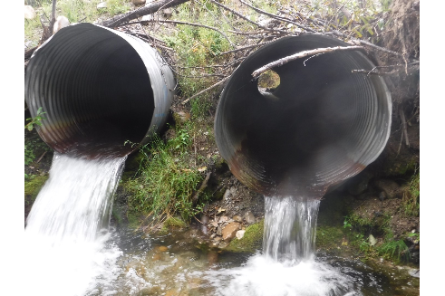

Figure 68: Outlet of PSCIS crossing 125231 (UTM: 10N 549976 6065139).

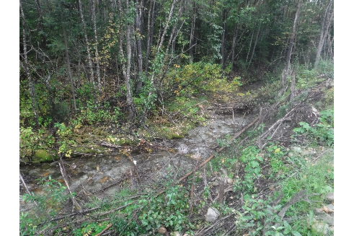

Figure 69: Habitat downstream of PSCIS crossing 125231 (UTM: 10N 549976 6065139).

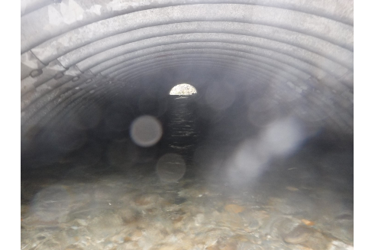

Figure 70: Passable railway culvert (modeled crossing 16603278) located downstream of PSCIS crossing 125231 (UTM: 10N 549788 6065094).

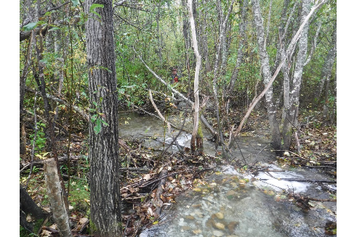

Figure 71: Habitat downstream of PSCIS crossing 125231 (UTM: 10N 549786 6065066).

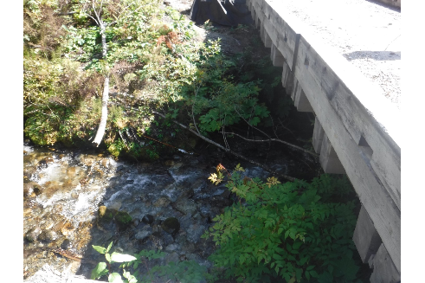

Figure 72: View of bridge (modeled crossing 16603641) located upstream of crossing 125231 (UTM: 10N 550099 6065555).

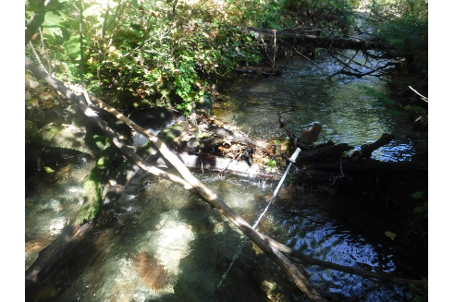

Figure 73: View of habitat upstream of crossing 125231 (UTM: 10N 549975 6065209).

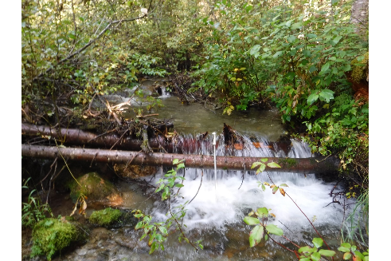

Figure 74: View of habitat upstream of crossing 125231 (UTM: 10N 550041 6065348).

# Appendix - Crossing 125247 - Chuchinka-Table FSR and CN Railway - Trib to Parsnip River

##### Site Location

Crossing 125247 is located on an unnamed tributary to the Parsnip River near the 12.8km mark of the Chuchinka-Table FSR. The culvert is located 0.2km from the confluence of the Parsnip River which is located approximately 3km downstream of where the Table River flows into the Parsnip River (Table 53). At the time of the field surveys, there was active logging on the FSR.

##### Background Information

At the crossing location, the stream is considered 3rd order with a watershed area upstream of the road of 9.9km2. The elevation of the watershed ranges from a maximum of 1400m to 760m at the culvert. One previously unassessed crossing (16603287) is located approximately 200m upstream under the CN Railway. Representatives from Canfor’s engineering team report that this crossing is undersized, the culvert is damaged and that water has backed up and overflowed onto the road on two occasions since 2017.

Provincial records indicate that Rainbow Trout have been captured just upstream of the crossing (MoE 2019b).

Hagen et al. (2015) have identified the upstream Table River watershed and several tributaries to the Table as containing critical spawning and juvenile rearing habitat for large body Bull Trout with an estimated minimum spawner abundance of 100 fish.

The Parsnip River mainstem has been identified as containing critical habitat for juvenile and fry Arctic Grayling. Additionally, the Table River (along with the Anzac River) just south of the crossing is identified as the primary core of post-Williston Arctic Grayling distribution in the Parsnip River watershed with life history, migration behaviours and critical habitats summarized in Hagen et al. (2015). The mainstem of the Table River contains critical habitats for all life stages of Arctic Grayling with adults observed moving among mainstem locations and tributaries during summer (Hagen et al. 2015).

Following office review, PSCIS stream crossing 125247 was ranked as a high priority for follow up with habitat confirmation due to the potential for rehabilitation of the crossing to provide access to modeled instream habitat (17.7km) with a relatively large channel size (2.9m) and Rainbow Trout documented upstream (Table 54). The habitat confirmation was completed on September 06, 2019. A map of the watershed including areas surveyed is provided in Attachment 1 – Map [093J120](https://hillcrestgeo.ca/outgoing/forNewGraph/parsnip/maps/FishPassage_093J.120.pdf).

##### Stream Characteristics at Crossing

At the time of the survey, the un-embedded and backwatered (0.9m each) crossing was considered a barrier to upstream fish passage with a pipe length of 12m and a culvert slope of 2% (Table 55, Figure 75). Water temperature was 11 $​^{∘}$ C and conductivity was 163uS/cm.

##### Stream Characteristics Downstream

The stream was surveyed downstream from the culvert for 190m to the confluence with the Parsnip River. Overall, total cover amount was rated as abundant with small woody debris, undercut banks dominant (Figures 76 - 77). Cover was also present as overhanging vegetation. Gravels suitable for spawning were abundant throughout the area surveyed. The average channel width was 3.5m, the average wetted width was 2.9m and the average gradient was 2.5% (Table 56). Habitat value downstream of the crossing was rated as medium with moderate potential for rearing and overwintering.

##### Stream Characteristics Upstream

The stream was surveyed upstream from the culvert for 755m. Modeled crossing 16603287 was located upstream of the FSR approximately 200m and under the railway (Figure 78). The crossing under the railway was assessed as a barrier with a length of 92m, a diameter of 3m and a slope of 0%. The average channel width was 3.8m, the average wetted width was 3.5m and the average gradient was 3% (Table 56). Riparian vegetation was comprised of a mature coniferous forest and instream cover quantity was rated as abundant. The dominant cover form was deep pools with small woody debris, large woody debris, undercut banks, and overhanging vegetation also available. Gravels suitable for spawning were present intermittently throughout the area surveyed and the channel morphology was riffle-pool (Figures 79 - 80). Although there were no permanent barriers, a beaver impounded area was located at the top end of the site (Figure 81). Habitat value upstream of the crossing was rated as medium.

##### Conclusion

Although there is approximately 4.5km of mainstem habitat upstream of crossing 125247 modeled as less than 22% gradient, there is only 200m of stream between the FSR and the upstream CN Railway culvert barrier. Habitat surveyed was rated as medium value for salmonids between the FSR and the railway as well as between the railway and the top end of the site surveyed. At the time of the survey, the forest licensees in the area were Sinclar Group and Canadian Forest Products Ltd. The road tenure holder was the Ministry of Forests, Lands, Natural Resource Operations & Rural Development. Overall, the crossing was ranked as a high priority for rehabilitation. Fish passage restoration at the crossing upstream under the CN Railway would also be required to achieve habitat gains greater than 200m.

Table 53: Overview of stream crossing.

| Site | Stream | Road | Tenure | UTM (10N) | Fish Species | Priority |
| --- | --- | --- | --- | --- | --- | --- |
| 125247 | Trib to Parsnip River | Chuchinka-Table FSR and CN Railway | FLNRORD 5506 08 0 | 542959 6062815 | RB | High |

Table 54: Field map, Fish Habitat Model outputs, historic PSCIS details and prioritization for follow up with fish habiat confirmation rank/comments.

| Site | Map 50k | Instream (km) | Lake (ha) | Wetland (ha) | Channel Width (m) | Fish Upstream | Habitat Value | Rank | Comments |
| --- | --- | --- | --- | --- | --- | --- | --- | --- | --- |
| 125247 | 093J120 | 17.7 | - | 18.6 | 2.9 | Yes | Low | High | Larger watershed with fish noted at crossing in FISS system. Railway crossing (16603287) upstream to be assessed. |

Table 55: Summary of culvert fish passage assessment.

| Site | Diameter (m) | Length (m) | Embedded | Backwatered | Fill Depth (m) | Outlet Drop (m) | Outlet Pool Depth (m) | Stream Width Ratio | Barrier Result |
| --- | --- | --- | --- | --- | --- | --- | --- | --- | --- |
| 125247 | 0.9 | 12 | no | 100 | 1 | 0 | 0.5 | 3.9 | Barrier |

Table 56: Summary of habitat details

| Site | Location | Length Surveyed (m) | Channel Width (m) | Wetted Width (m) | Pool depth (m) | Gradient (%) | Habitat Value |
| --- | --- | --- | --- | --- | --- | --- | --- |
| 125247 | Upstream | 755 | 3.8 | 3.5 | 0.4 | 3 | Medium |
| 125247 | Downstream | 190 | 3.5 | 2.9 | 0.4 | 2.5 | Medium |

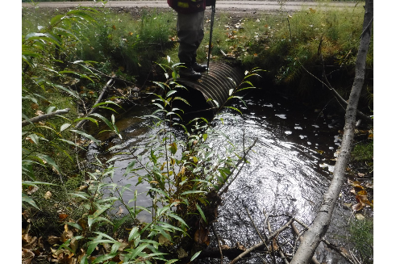

Figure 75: Inlet of PSCIS crossing 125247 (UTM: 10N 542959 6062815).

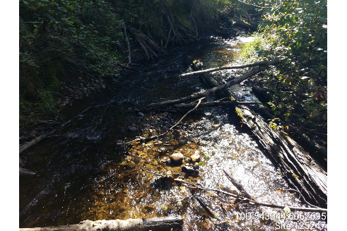

Figure 76: Habitat downstream of PSCIS crossing 125247 (UTM: 10N 543044 6062695).

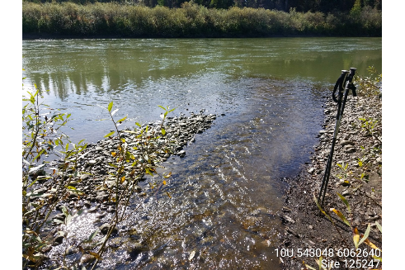

Figure 77: Confluence with Parsnip River downstream of PSCIS crossing 125247 (UTM: 10N 543048 6062640).

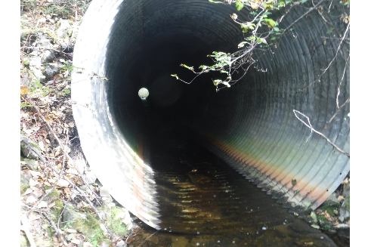

Figure 78: Railway crossing (modeled crossing 16603287) located 200 m upstream of PSCIS crossing 125247 (UTM: 10N 542901 6062899).

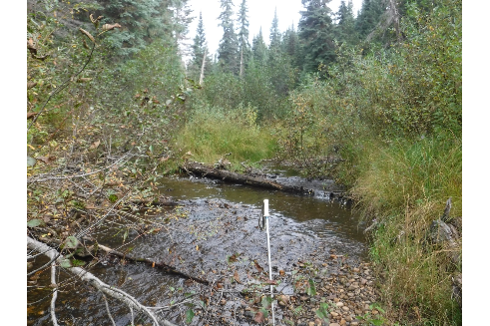

Figure 79: View of habitat upstream of crossing 125247 (UTM: 10N 542807 6063148).

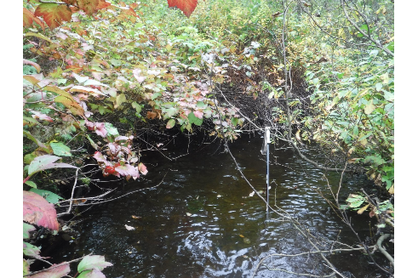

Figure 80: View of habitat upstream of crossing 125247 (UTM: 10N 542788 6063196).

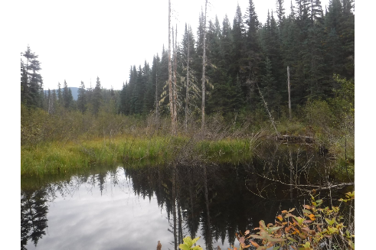

Figure 81: View of habitat upstream of crossing 125247 (UTM: 10N 542648 6063450).

# Appendix - Crossing 125253 - Chuchinka-Table FSR - Trib to Parsnip River

##### Site Location

Crossing 125253 is located on an unnamed tributary to the Parsnip River near the 6.8km mark of the Chuchinka-Table FSR. The culvert is 1km upstream from the confluence of the Parsnip River which in turn is located approximately 3km downstream of where the Table River flows into the Parsnip River (Table 57). At the time of the field surveys, there was active logging on the FSR.

##### Background Information

At the crossing location, the stream is 3rd order with a watershed area upstream of the road of approximately 7km2. The elevation of the watershed ranges from a maximum of approximately 1000m to 750m at the culvert. One previously unassessed crossing (16603267) is located approximately 60m downstream of the FSR under the CN Railway. Representatives from Canfor’s engineering team report that crossing 125253 is undersized for accommodating flow volumes and that water has backed up and overflowed onto the road on two occasions since 2017 (pers comm. Janine Gervais, Forestry Superintendent, Canadian Forest Products). Provincial records indicate that Rainbow Trout have been captured just downstream of the crossing (MoE 2019b).

Following office review, PSCIS stream crossing 125253 was ranked as a moderate priority for follow up with habitat confirmation due to the potential for rehabilitation of the crossing to provide access to modeled instream (11.2km) and wetland (7.1854382ha) habitat (Table 58). Review of a historic FISS sample site indicated that the channel width upstream was 2.2m as apposed to the 1.2m recorded within the PSCIS system (MoE 2019c). The habitat confirmation was completed on September 06, 2019. A map of the watershed including areas surveyed is provided in Attachment 1 – Map [093J119](https://hillcrestgeo.ca/outgoing/forNewGraph/parsnip/maps/FishPassage_093J.119.pdf).

##### Stream Characteristics at Crossing

At the time of the survey, the un-embedded and non-backwatered double (0.8m each) culvert was considered a barrier to upstream fish passage with a pipe length of 16m and a culvert slope of 2% (Table 59, Figure 82). Water temperature was 12 $​^{∘}$ C and conductivity was 174uS/cm.

##### Stream Characteristics Downstream

The stream was surveyed downstream from the culvert for 240m to within the floodplain of the Parsnip River. Modeled crossing 16603267 was located downstream of the FSR approximately 60m and was assessed as a barrier (Figure 83). Overall, total cover amount was rated as moderate with undercut banks dominant (Figures 84 - 85). Cover was also present as small woody debris and overhanging vegetation. The average channel width was 4m, the average wetted width was 3.5m and the average gradient was 1.6% (Table 60). Habitat value downstream of the crossing was rated as high.

##### Stream Characteristics Upstream

The stream was surveyed upstream from the culvert for 800m. The average channel width was 4.2m, the average wetted width was 3.3m and the average gradient was 3% (Table 60). Riparian vegetation was comprised of a mature coniferous forest and instream cover quantity was rated as moderate. The dominant cover form was deep pools with small woody debris, large woody debris, undercut banks, and overhanging vegetation also available. Gravels suitable for spawning were present intermittently throughout the area surveyed and the channel morphology was riffle-pool (Figures 86 - 87). Although there were no permanent barriers, a beaver impounded area was located at the top end of the site (UTM:10 U 538462 6064926, Figure 88). Habitat value upstream of the crossing was rated as high.

##### Conclusion

Although there is approximately 4.5km of mainstem habitat upstream of crossing 125253 modeled as less than 22% gradient, the CN Railway culvert barrier located 60m downstream is also a barrier to fish passage and will require remediation for fish habitat gains upstream of the FSR to be realized. Habitat surveyed was rated as high value for salmonids between the railway and the FSR as well as between the FSR and the top end of the site surveyed. At the time of the survey, the forest licensees in the area were Sinclar Group and Canadian Forest Products Ltd. The road tenure holder was the Ministry of Forests, Lands, Natural Resource Operations & Rural Development. Overall, the crossing was ranked as a moderate priority for rehabilitation. Fish passage restoration at the crossing downstream under the CN Railway would also be required to realize habitat gains above the FSR.

Table 57: Overview of stream crossing.

| Site | Stream | Road | Tenure | UTM (10N) | Fish Species | Priority |
| --- | --- | --- | --- | --- | --- | --- |
| 125253 | Trib to Parsnip River | Chuchinka-Table FSR | FLNRORD 5506 08 0 | 537735 6064732 | - | Moderate |

Table 58: Field map, Fish Habitat Model outputs, historic PSCIS details and prioritization for follow up with fish habiat confirmation rank/comments.

| Site | Map 50k | Instream (km) | Lake (ha) | Wetland (ha) | Channel Width (m) | Fish Upstream | Habitat Value | Rank | Comments |
| --- | --- | --- | --- | --- | --- | --- | --- | --- | --- |
| 125253 | 093J119 | 11.2 | - | 7.2 | 1.4 | Yes | Low | Mod | Appears passable to larger fish. Railway (16603267) to assess downstream. |

Table 59: Summary of culvert fish passage assessment.

| Site | Diameter (m) | Length (m) | Embedded | Backwatered | Fill Depth (m) | Outlet Drop (m) | Outlet Pool Depth (m) | Stream Width Ratio | Barrier Result |
| --- | --- | --- | --- | --- | --- | --- | --- | --- | --- |
| 125253 | 0.8 | 16 | no | no | 1 | 0 | 0 | 5 | Barrier |

Table 60: Summary of habitat details

| Site | Location | Length Surveyed (m) | Channel Width (m) | Wetted Width (m) | Pool depth (m) | Gradient (%) | Habitat Value |
| --- | --- | --- | --- | --- | --- | --- | --- |
| 125253 | Downstream | 240 | 4 | 3.5 | 0.5 | 1.6 | High |
| 125253 | Upstream | 800 | 4.2 | 3.3 | 0.5 | 3 | High |

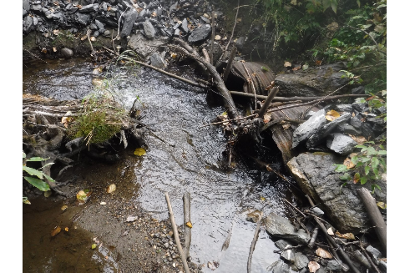

Figure 82: Inlet of PSCIS crossing 125253 (UTM: 10N 537735 6064732).

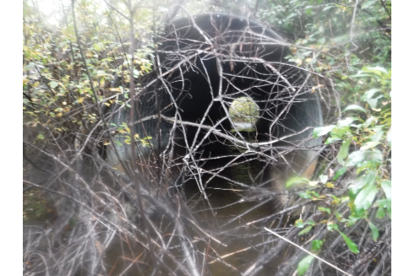

Figure 83: Railway crossing (modeled crossing 16603267) located 60 m downstream of PSCIS crossing 125253 (UTM: 10N 537694 6064698).

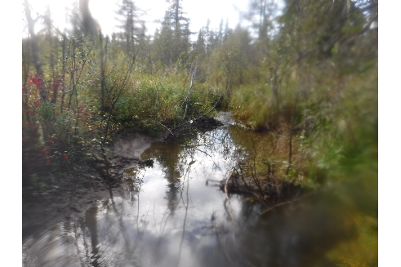

Figure 84: Habitat downstream of PSCIS crossing 125253 (UTM: 10N 537633 6064566).

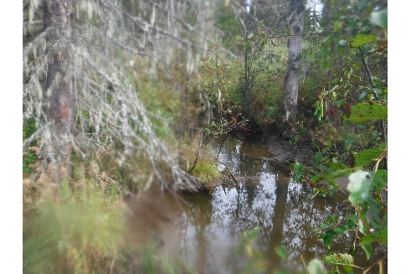

Figure 85: Confluence with Parsnip River downstream of PSCIS crossing 125253 (UTM: 10N 537621 6064553).

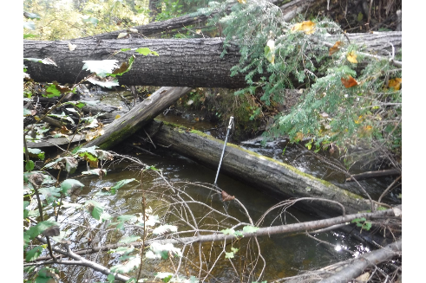

Figure 86: View of habitat upstream of crossing 125253 (UTM: 10N 537971 6064788).

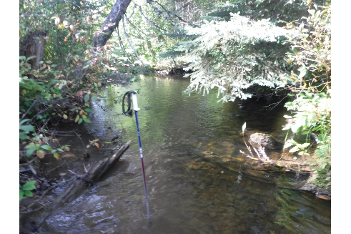

Figure 87: View of habitat upstream of crossing 125253 (UTM: 10N 538393 6064876).

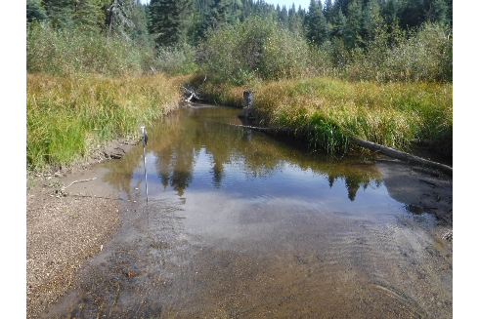

Figure 88: View of habitat upstream of crossing 125253 (UTM: 10N 538439 6064910).

# Appendix - Crossings 125345 and 57687 - Chuchinka-Colbourne FSR and CN Railway - Trib to Parsnip River

##### Site Location

Crossing 125345 is located on an unnamed tributary to the Parsnip River just south-east of Reynolds Creek near the 13km mark of the Chuchinka-Colbourne FSR. The culvert is located 0.2km upstream from the confluence of the stream and the Parsnip River (Table 61). PSCIS crossing 57687 is located immediately upstream of the FSR under the CN Railway. At the time of the field surveys, there was very little activity on the FSR and the road was in disrepair. Less than 1km south of the crossing location, there was a washout on the FSR that had narrowed the road to a width just barely passable by 4 x 4 pickup.

##### Background Information

At the crossing location, the stream is 4th order with a watershed area upstream of the road estimated at 16.2km2. The elevation of the watershed ranges from a maximum of 900m to 730m at the culvert. Although, there are several modeled crossings located on tributary streams upstream of the FSR and railway crossings (modeled crossings 16601006, 16601673, 16601173, 16601175, 16600094 and 16601726), there is not significant amounts of habitat modeled upstream of their mapped locations.

There are no stream sample sites or fish observations for the subject stream recorded within the provincial fisheries information summary system (MoE 2019c, 2019b).

Following office review, PSCIS stream crossing 125345 was ranked as a high priority for follow up with habitat confirmation due to the potential for rehabilitation of the crossing to provide access to modeled instream habitat (35.6km), wetland habitat (58.5ha) and a relatively large channel size of 3.5m (Table 62). The habitat confirmation was completed on September 06, 2019. A map of the watershed including areas surveyed is provided in Attachment 1 – Map [093J124](https://hillcrestgeo.ca/outgoing/forNewGraph/parsnip/maps/FishPassage_093J.124.pdf).

##### Stream Characteristics at Crossing

At the time of the survey, crossing 125345 was un-embedded and non-backwatered. The double pipe culvert (1.2m each) was considered a barrier to upstream fish passage with pipe lengths of 13m and a culvert slope of 1% (Table 63, Figure 89). Crossing 57687 under the railway was also a double pipe structure and was considered a barrier as it was un-embedded and non-backwatered with pipe lengths of 18m, diameters of 1.2m each and a culvert slope of 2% (Figure 90). Water temperature was 10 $​^{∘}$ C and conductivity was recorded as 180uS/cm.

##### Stream Characteristics Downstream

The stream was surveyed downstream from the culvert for 220m to the confluence of the Parsnip River (Figure 91). Overall, total cover amount was rated as moderate with undercut banks dominant (Figures 92 - 93). Cover was also present as small woody debris, large woody debris, and overhanging vegetation. Gravels suitable for spawning were abundant throughout the area surveyed. The average channel width was 4.2m, the average wetted width was 3.3m and the average gradient was 2.8% (Table 64). Habitat value downstream of the crossing was rated as high with salmonid fry and cyprinids observed downstream throughout the area surveyed. At the time of the survey, trailers were present at a hunting and fishing camp located near the confluence of the stream and the Parsnip River.

##### Stream Characteristics Upstream

The stream was surveyed upstream from the culvert for 680m. Beaver activity was present in the area surveyed with a 0.6 m high structure noted approximately 180m upstream from crossing 125345 (Figure 94). The average channel width was 4.7m, the average wetted width was 3.9m and the average gradient was 3.2% (Table 64). Riparian vegetation was comprised of a mature coniferous forest and instream cover quantity was rated as moderate. The dominant form of cover was deep pools with small woody debris, large woody debris, undercut banks, and overhanging vegetation also available. Gravels suitable for spawning were abundant throughout the area surveyed (Figures 95 - 96). There were no barriers to upstream fish migration observed. Habitat value upstream of the crossing was rated as high.

##### Conclusion

There is approximately 4.7km of mainstem habitat upstream of crossing 125345 modeled as less than 22% gradient with several large tributaries also present likely providing additional high value fish habitat. Habitat surveyed was rated as high value for salmonids with fish presence confirmed immediately downstream of the crossings. The forest licensees in the area are BC Timber Sales and Sinclar Group. The road tenure holder is the Ministry of Forests, Lands, Natural Resource Operations & Rural Development (FLNR). Overall, crossing 125345 and 57687 were ranked as high priorities for rehabilitation. Works on this stream will require coordination between CN Rail and FLNR to remediate fish passage at both crossings.

Table 61: Overview of stream crossing.

| Site | Stream | Road | Tenure | UTM (10N) | Fish Species | Priority |
| --- | --- | --- | --- | --- | --- | --- |
| 125345 | Trib to Parsnip River | Chuchinka-Colbourne FSR | FLNRORD 5506 04 0 | 522549 6083674 | (RB), CC | High |

Table 62: Field map, Fish Habitat Model outputs, historic PSCIS details and prioritization for follow up with fish habiat confirmation rank/comments.

| Site | Map 50k | Instream (km) | Lake (ha) | Wetland (ha) | Channel Width (m) | Fish Upstream | Habitat Value | Rank | Comments |
| --- | --- | --- | --- | --- | --- | --- | --- | --- | --- |
| 125345 | 093J124 | 35.6 | - | 58.5 | 3.5 | Yes | Low | High | Larger stream. Railway just upstream (57687) with habitat rated as high value. |

Table 63: Summary of culvert fish passage assessment.

| Site | Diameter (m) | Length (m) | Embedded | Backwatered | Fill Depth (m) | Outlet Drop (m) | Outlet Pool Depth (m) | Stream Width Ratio | Barrier Result |
| --- | --- | --- | --- | --- | --- | --- | --- | --- | --- |
| 57687 | 1.2 | 18 | no | no | 2 | 0 | 0.3 | 3.5 | Barrier |
| 125345 | 1.2 | 13 | no | no | 1 | 0 | 0.6 | 3.5 | Barrier |

Table 64: Summary of habitat details

| Site | Location | Length Surveyed (m) | Channel Width (m) | Wetted Width (m) | Pool depth (m) | Gradient (%) | Habitat Value |
| --- | --- | --- | --- | --- | --- | --- | --- |
| 125345 | Upstream | 680 | 4.7 | 3.9 | 0.4 | 3.2 | High |
| 125345 | Downstream | 220 | 4.2 | 3.3 | 0.5 | 2.8 | High |

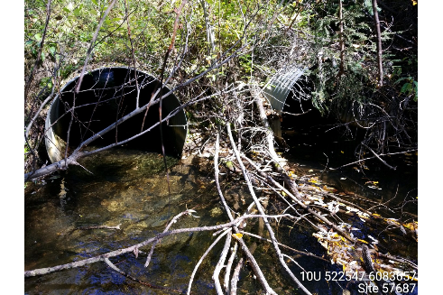

Figure 89: Outlet of PSCIS crossing 125345 (UTM: 10N 522547 6083657).

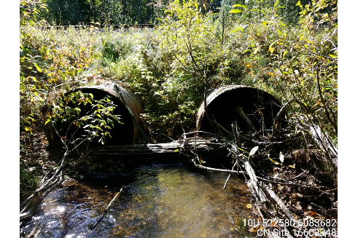

Figure 90: Inlet of PSCIS crossing 57687 (UTM: 10N 522580 6083682).

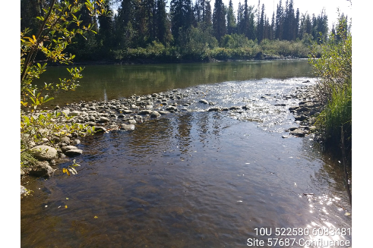

Figure 91: Confluence with Parsnip River downstream of PSCIS crossing 125345 (UTM: 10N 522580 6083481).

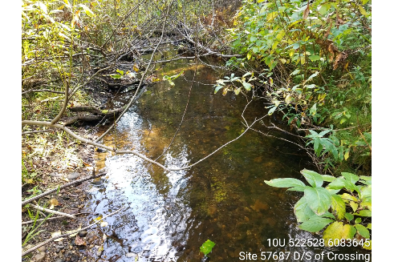

Figure 92: Habitat downstream of PSCIS crossing 125345 ().

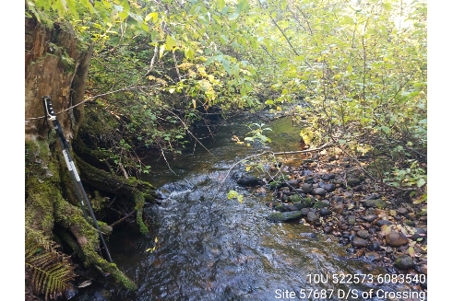

Figure 93: Habitat downstream of PSCIS crossing 125345 (UTM: 10N 522573 6083540).

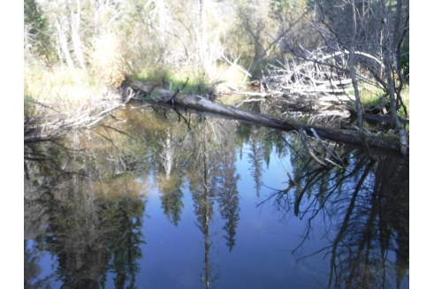

Figure 94: View of habitat upstream of crossing 125345 (UTM: 10N 522713 6083740).

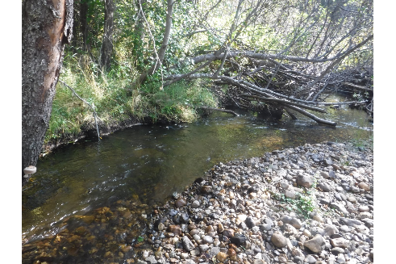

Figure 95: View of habitat upstream of crossing 125345 (UTM: 10N 522770 6083776).

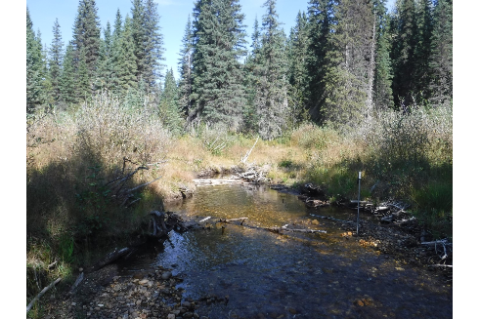

Figure 96: View of habitat upstream of crossing 125345 (UTM: 10N 522922 6084045).

# Appendix - Crossing 125403 - Hodda Lake FSR - Trib to Parsnip River

##### Site Location

Crossing 125403 is located on an unnamed tributary to Parsnip River near the 17.3km mark of the Hodda Lake FSR. The culvert is also recorded in the PSCIS database as crossing 57606. The culvert is located 0.4km upstream from the confluence of the stream and the Parsnip River (Table 65). At the time of the field surveys, there appeared to be no active log hauling on the FSR.

##### Background Information

At the crossing location, the stream is 2nd order with a watershed area upstream of the road of approximately 4km2. The elevation of the watershed ranges from a maximum of 900m to 750m at the culvert. One PSCIS crossing (57608) and several modeled crossings (79706, 189512, 190084, 79707, 7289, 6472) are located upstream on small tributaries to the mainstem of the subject stream. Provincial records indicate that there is no fisheries information available for the stream (**???**; MoE 2019c).

Following office review, PSCIS stream crossing 125403 was ranked as a high priority for follow up with habitat confirmation due to the potential for rehabilitation of the crossing to provide access to modeled instream (6.1km) habitat with a relatively large channel size (3.1m) and potentially high value habitat as indicated by contractor habitat value assignment (Table 66). Of note, Hooft (2014) had prioritized this crossing for rehabilitation ranking it 13th of 18 priorities identified. The habitat confirmation was completed on August 30, 2019. A map of the watershed including areas surveyed is provided in Attachment 1 – Map [093J124](https://hillcrestgeo.ca/outgoing/forNewGraph/parsnip/maps/FishPassage_093J.124.pdf).

##### Stream Characteristics at Crossing

At the time of the survey, the un-embedded and non-backwatered 0.8m diameter crossing was considered a barrier to upstream fish passage with a pipe length of 20m, a culvert slope of 8% and an outlet drop of 0.48m (Table 67, Figure 97). Water temperature was 7 $​^{∘}$ C, pH was 8.3 and conductivity was 230uS/cm.

##### Stream Characteristics Downstream

The stream was surveyed downstream from the culvert for 120m to within the floodplain of the Parsnip River. Overall, total cover amount was rated as abundant with undercut banks dominant. Cover was also present as small woody debris, large woody debris, boulders, deep pools, overhanging vegetation, and instream vegetation (Figures 98 - 99). The average channel width was 2.2m, the average wetted width was 2.1m and the average gradient was 2.5% (Table 68). Riparian vegetation was primarily shrubs and streambed substrates were dominated by fines. One salmonid parr (suspected Rainbow Trout - 120mm fork length) was observed in a small pool area located approximately 20m downstream of the culvert.

##### Stream Characteristics Upstream

The stream was surveyed upstream from the culvert for 350m. The initial 50m of habitat upstream of the crossing was shallow beaver influenced wetland with a section of small channel flowing for approximately 150m from an extensive beaver influenced wetland complex located upstream (Figures 100 - 101). The average channel width was 2.1m, the average wetted width was 1.9m and the average gradient was 1.1% (Table 68). Riparian vegetation was comprised of a young coniferous forest. Total cover amount was rated as abundant with the dominant form as undercut banks and small woody debris, large woody debris, deep pools, and overhanging vegetation also available. Upstream of the crossing, habitat was rated as low value due to a lack of areas suitable for spawning, and the apparently shallow depths of the majority of upstream wetland habitat present.

##### Conclusion

There is an estimated 2.4km of mainstem habitat upstream of crossing 125403 within a beaver influenced plateau. Habitat in the areas surveyed upstream of the crossing was rated as low value. Review of Ministry of Forests, Lands, Natural Resource Operations & Rural Development (FLNR) licensee operating areas maps indicate that the forest licensees in the area were BCTS and Canfor Forest Products Ltd. and the road tenure holder was the Ministry of Forests, Lands, Natural Resource Operations & Rural Development (MoE 2019a). The crossing was ranked as a low priority for rehabilitation due to a lack of suitable spawning habitat and likely shallow depths of upstream wetland habitat present.

Table 65: Overview of stream crossing.

| Site | Stream | Road | Tenure | UTM (10N) | Fish Species | Priority |
| --- | --- | --- | --- | --- | --- | --- |
| 125403 | Trib to Parsnip River | Hodda Lake FSR | FLNRORD 7698 01 0 | 520140 6084908 | - | Low |

Table 66: Field map, Fish Habitat Model outputs, historic PSCIS details and prioritization for follow up with fish habiat confirmation rank/comments.

| Site | Map 50k | Instream (km) | Lake (ha) | Wetland (ha) | Channel Width (m) | Fish Upstream | Habitat Value | Rank | Comments |
| --- | --- | --- | --- | --- | --- | --- | --- | --- | --- |
| 125403 | 093J124 | 6.1 | - | - | 3.1 | Yes | Medium | High | Same as crossing 57606. Rated by Marlim as high habitat value. Close to Parsnip R. |

Table 67: Summary of culvert fish passage assessment.

| Site | Diameter (m) | Length (m) | Embedded | Backwatered | Fill Depth (m) | Outlet Drop (m) | Outlet Pool Depth (m) | Stream Width Ratio | Barrier Result |
| --- | --- | --- | --- | --- | --- | --- | --- | --- | --- |
| 125403 | 0.8 | 20 | no | no | 3 | 0.5 | 0.5 | 2.9 | Barrier |

Table 68: Summary of habitat details

| Site | Location | Length Surveyed (m) | Channel Width (m) | Wetted Width (m) | Pool depth (m) | Gradient (%) | Habitat Value |
| --- | --- | --- | --- | --- | --- | --- | --- |
| 125403 | Upstream | 350 | 2.1 | 1.9 | 0.5 | 1.1 | Low |
| 125403 | Downstream | 120 | 2.2 | 2.1 | 0.4 | 2.5 | Low |

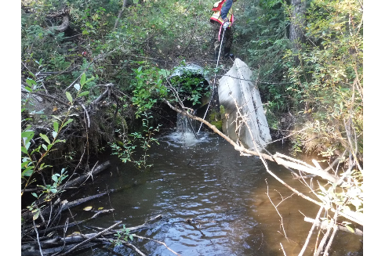

Figure 97: Outlet of PSCIS crossing 125403 (UTM: 10N 520140 6084908).

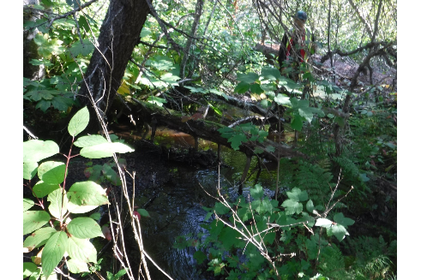

Figure 98: Habitat downstream of PSCIS crossing 125403 (UTM: 10N 520173 6084926).

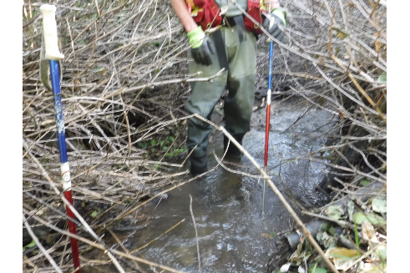

Figure 99: Habitat downstream of PSCIS crossing 125403 (UTM: 10N 520221 6084886).

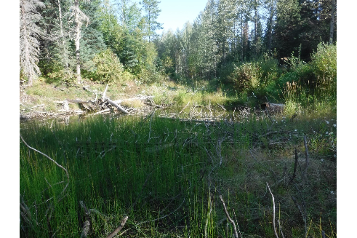

Figure 100: View of habitat upstream of PSCIS crossing 125403 (UTM: 10N 520133 6084912).

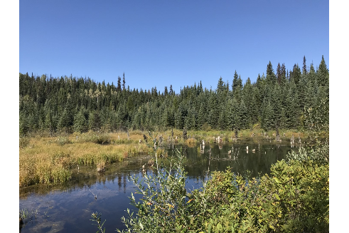

Figure 101: View of habitat upstream of PSCIS crossing 125403 (UTM: 10N 520004 6084647).

# Appendix - Crossing CV1 - CN Railway - Trib to Table River

##### Site Location

Crossing CV1 is located on an unnamed tributary to the Table River under the CN Railway near the 17km mark of the Chuchinka-Table FSR. The culvert is located approximately 230m upstream from the FSR and 0.3km upstream from the confluence of the Table River (Table 69). At the time of the field surveys, there was active log hauling on the FSR.

##### Background Information

At the crossing location, the stream is 3rd order with a watershed area upstream of the road of km2. The elevation of the watershed ranges from a maximum of approximately 1600m to 780m at the culvert. A newly installed bridge is located just upstream of CV1 on a forestry road as well as downstream on the Chuchinka-Table FSR.

Provincial records indicate that Rainbow Trout have been captured downstream of the crossing near the confluence of the stream by DWB in 2017 (MoE 2019b).

Hagen et al. (2015) have identified the Table River watershed and several of it’s tributaries as containing critical spawning and juvenile rearing habitat for large body Bull Trout with an estimated minimum spawner abundance of 100 fish.

The Table River (along with the Anzac River) is identified as the primary core of post-Williston Arctic Grayling distribution in the Parsnip River watershed with life history, migration behaviours and critical habitats summarized in Hagen et al. (2015). The mainstem of the Table River contains critical habitats for all life stages of Arctic Grayling with adults observed moving among mainstem locations and tributaries during summer (Hagen et al. 2015).

In 2018, the Table River watershed was designated as a fisheries sensitive watershed under the authority of the *Forest and Range Practices Act* (FSW identifier f-7-022) due to significant downstream fisheries values and watershed sensitivity (Beaudry 2014b). Special management is required in the crossing’s watershed to protect habitat for Bull Trout and Arctic Grayling and includes measures (among others) to limit equivalent clearcut area, reduce impacts to natural stream channel morphology, retain old growth attributes and maintain fish habitat/movement (Forest and Range Practices Act 2018).

The stream associated with crossing CV1 is situated in a location approximately 230m to the west of the location mapped in the provincial freshwater atlas stream layer. There was no data available for the crossing in the PSCIS system however potential habitat gains for the site are likely similiar to those associated with modeled crossing 16603266 which provides access to approximately 6.6km of modeled instream habitat. The habitat confirmation was completed on September 05, 2019. A map of the watershed including areas surveyed is provided in Attachment 1 – Map [093J120](https://hillcrestgeo.ca/outgoing/forNewGraph/parsnip/maps/FishPassage_093J.120.pdf).

##### Stream Characteristics at Crossing

At the time of the survey, the un-embedded and non-backwatered culvert (3m diameter) was considered a barrier to upstream fish passage with a pipe length of 28m and a culvert slope of 5% (Table 70, Figure 102). Water temperature was 9 $​^{∘}$ C and conductivity was 61uS/cm.

##### Stream Characteristics Downstream

The stream was surveyed downstream from the culvert for 310m to within the floodplain of the Table River. The bridge located downstream 235m on the Chuchinka-Table FSR had a span of 9m and a width of 5m (Figure 103). Overall, total cover amount was rated as moderate with undercut banks dominant (Figures 104 - 105). Cover was also present as small woody debris, large woody debris, deep pools, and overhanging vegetation. The average channel width was 4.2m, the average wetted width was 3.8m and the average gradient was 2.5% (Table 71). Three minnow traps were set downstream of the crossing and left to soak overnight. One Rainbow Trout (102mm fork length) was captured. A 1.4m high beaver dam was located downstream of the crossing approximately 120m (UTM 10N 547419 6063849). Habitat value downstream of the crossing was rated as high.

##### Stream Characteristics Upstream

The stream was surveyed upstream from the culvert for 425m. The average channel width was 3.8m, the average wetted width was 3.5m and the average gradient was 3.5% (Table 71). Riparian vegetation was comprised of a mature coniferous forest and instream cover quantity was rated as abundant. The dominant cover form was large woody debris with small woody debris, undercut banks, deep pools, and overhanging vegetation also available (Figure 106. Gravels suitable for spawning were present throughout the area surveyed and a suspected Bull Trout spawning redd (40 - 50cm diameter gravel “egg nest”) was observed (Figure 107- 108). A 20cm long salmonid (suspect Bull Trout) and young of year salmonids were also observed. Channel morphology was riffle-pool. An open span bridge was located upstream of the culvert approximately 100m (Figure 109). Three minnow traps were set upstream of the crossing and left to soak overnight. One Rainbow Trout (48mm fork length) was captured (Figure 110). Habitat value upstream of the crossing was rated as high.

##### Conclusion

There is approximately 3.4km of mainstem habitat upstream of crossing CV1 modeled as less than 22% gradient. Habitat surveyed was rated as high value for salmonids with confirmed Rainbow Trout and suspected Bull Trout presence upstream. Bull Trout in the Parsnip River watershed are provincially and federally listed as a species of special concern. There are newly installed open span structures located both upstream and downstream of the crossing with no obstacles other than beaver dams structures and CV1 obstructing fish passage in the lower sections of the watershed. At the time of the survey CN Rail was responsible for this crossing and the structure was ranked as a high priority for rehabilitation.

Table 69: Overview of stream crossing.

| Site | Stream | Road | Tenure | UTM (10N) | Fish Species | Priority |
| --- | --- | --- | --- | --- | --- | --- |
| CV1 | Trib to Table River | CN Railway | CN Rail | 547303 6063955 | RB, (BT) | High |

Table 70: Summary of culvert fish passage assessment.

| Site | Diameter (m) | Length (m) | Embedded | Backwatered | Fill Depth (m) | Outlet Drop (m) | Outlet Pool Depth (m) | Stream Width Ratio | Barrier Result |
| --- | --- | --- | --- | --- | --- | --- | --- | --- | --- |
| CV1 | 3 | 28 | no | no | 2 | 0.2 | 0.2 | 1.4 | Barrier |

Table 71: Summary of habitat details

| Site | Location | Length Surveyed (m) | Channel Width (m) | Wetted Width (m) | Pool depth (m) | Gradient (%) | Habitat Value |
| --- | --- | --- | --- | --- | --- | --- | --- |
| CV1 | Downstream | 310 | 4.2 | 3.8 | 0.4 | 2.5 | High |
| CV1 | Upstream | 425 | 3.8 | 3.5 | 0.3 | 3.5 | High |

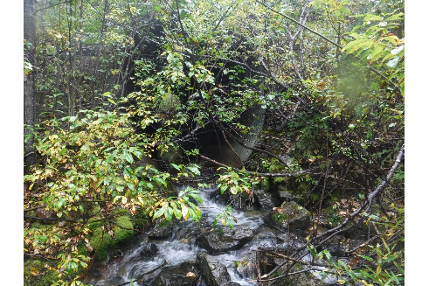

Figure 102: Outlet of crossing CV1 (UTM: 10N 547303 6063955).

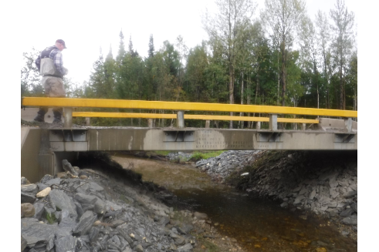

Figure 103: Newly installed bridge located downstream of crossing CV1 (UTM: 10N 547474 6063810).

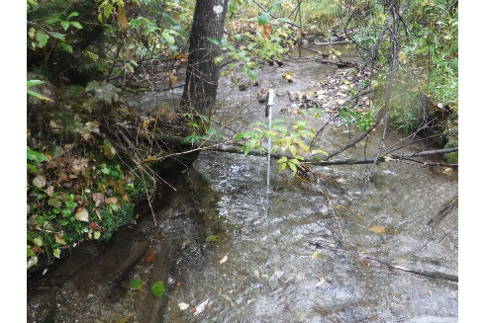

Figure 104: Habitat downstream of crossing CV1 (UTM: 10N 547344 6063925).

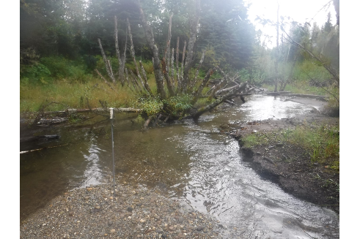

Figure 105: Habitat downstream of crossing CV1 (UTM: 10N 547394 6063890).

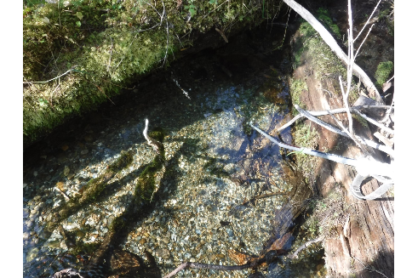

Figure 106: View of 40 - 50cm diameter redd (suspect Bull Trout) located upstream of crossing CV1 (UTM: 10N 547159 6064093).

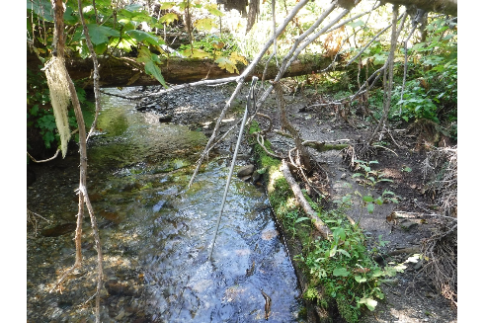

Figure 107: View of habitat upstream of crossing CV1 (UTM: 10N 547192 6064075).

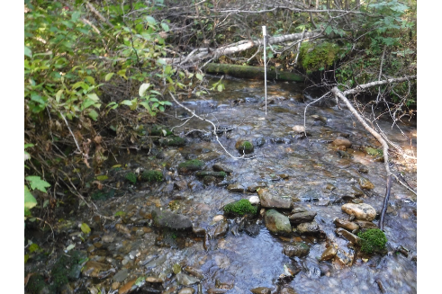

Figure 108: View of habitat upstream of crossing CV1 (UTM: 10N 547076 6064120).

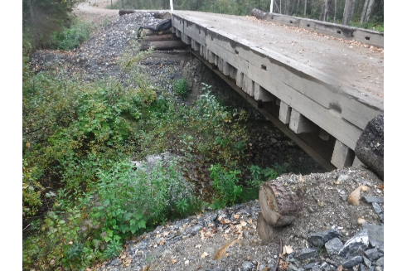

Figure 109: View of bridge located upstream of crossing CV1 (UTM: 10N 549707 6064989).

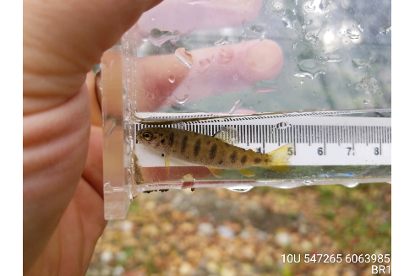

Figure 110: Rainbow Trout captured upstream of crossing CV1 (UTM: 10N 547265 6063985).

## References

BC Fisheries Information Services Branch. 2001. “Reconnaissance (1:20 000) Fish and Fish Habitat Inventory: Standards and Procedures. Version 2.0.” Resources Inventory Committee.

BC Ministry of Environment. 2011. *Field Assessment for Determining Fish Passage Status of Closed Bottom Structures*. Victoria, British Columbia: BC Ministry of Environment. <https://www2.gov.bc.ca/assets/gov/environment/natural-resource-stewardship/land-based-investment/forests-for-tomorrow/field-assessment-for-determining-fish-passage-status-of-cbs.pdf>.

BC Species & Ecosystem Explorer. 2020. “Salvelinus Confluentus Pop. 10 (Bull Trout - Western Arctic Populations).” http://a100.gov.bc.ca/pub/eswp/reports.do?elcode=AFCHA05122.

Beaudry, Pierre G. 2013a. “Assessment and Assignment of Sensitivity Ratings to Sub-Basins of the Anzac Watershed in Parsnip Drainage – Ominieca Region. Contract Number: GS14823018.” Report. <http://a100.gov.bc.ca/pub/acat/public/viewReport.do?reportId=51630>.

———. 2013b. “Assessment and Assignment of Sensitivity Ratings to Sub-Basins of the Missinka Watershed in Parsnp Drainage – Ominieca Region. Contract Number: GS14FWH-006.” Report. P. Beaudry; Associates Ltd. <http://a100.gov.bc.ca/pub/acat/public/viewReport.do?reportId=51631>.

———. 2014a. “Assessment and Assignment of Sensitivity Ratings to Sub-Basins of the Hominka Watershed in Parsnip Drainage – Ominieca Region. Contract Number: GS15823011.” Report. <http://a100.gov.bc.ca/pub/acat/public/viewReport.do?reportId=51633>.

———. 2014b. “Assessment and Assignment of Sensitivity Ratings to Sub-Basins of the Table Watershed in Parsnip Drainage – Ominieca Region. Contract Number: GS15823011.” Report. <http://a100.gov.bc.ca/pub/acat/public/viewReport.do?reportId=51634>.

Bramblett, Robert, Mason Bryant, Brenda Wright, and Robert White. 2002. “Seasonal Use of Small Tributary and Main-Stem Habitats by Juvenile Steelhead, Coho Salmon, and Dolly Varden in a Southeastern Alaska Drainage Basin.” *Transactions of the American Fisheries Society* 131 (May): 498–506. [https://doi.org/10.1577/1548-8659(2002)131<0498:SUOSTA>2.0.CO;2](https://doi.org/10.1577/1548-8659(2002)131%3C0498:SUOSTA%3E2.0.CO;2).

Clarke, A. 2005. “Omineca Region Stocked Lake Assessment Report - Goose Lake,” 7.

Comittee on the Status of Endangered Wildlife in Canada. 2012. “COSEWIC Assessment and Status Report on the Bull Trout Salvelinus Confluentus.” Report. <https://www.sararegistry.gc.ca/virtual_sara/files/cosewic/sr_omble_tete_plat_bull_trout_1113_e.pdf>.

Fish, and ildlife Compensation Program. 2014. “Peace Basin Streams Action Plan,” 30.

“Fish Inventories Data Queries.” 2020. *BC Ministry of Environment Fish Inventories Data Queries*. http://a100.gov.bc.ca/pub/fidq/welcome.do.

Fish Passage Technical Working Group. 2011. *A Checklist for Fish Habitat Confirmation Prior to the Rehabilitation of a Stream Crossing.* <https://www2.gov.bc.ca/gov/content/environment/natural-resource-stewardship/land-based-investment/investment-categories/fish-passage/habitat-confirmation-projects>.

———. 2014. “Fish Passage Strategic Approach: Protocol for Prioritizing Sites for Fish Passage Remediation.” <https://www2.gov.bc.ca/assets/gov/environment/plants-animals-and-ecosystems/fish-fish-habitat/fish-passage/strategic20approach20july202014.pdf>.

Forest and Range Practices Act. 2018. “Order - Fisheries Sensitive Watershed Prince George Forest District.” <http://www.env.gov.bc.ca/wld/frpa/fsw/approved.html>.

Gollner, M C, Robijn Cain, and Krista Russell. 2013. “FISH PASSAGE CULVERT INVESTIGATIONS - Prince George Timber Sales Business Area - CONTRACT # PD13TGB001.” MarLim Ecological Consulting Ltd.

Hagen, John, Ray Pillipow, and Nikolaus Gantner. 2018. “Trend in Abundance of Arctic Grayling (Thymallus Arcticus) in Index Sites of the Parsnip River Watershed, 1995-2018.” 37.

Hagen, John, and Susanne Weber. 2019. “Limiting Factors, Enhancement Potential, Critical Habitats, and Conservation Status for Bull Trout of the Williston Reservoir Watershed: Information Synthesis and Recommended Monitoring Framework.” Report. <http://fwcp.ca/app/uploads/2019/08/Bull-Trout-Info-Synthesis-Monitoring-Framework-_FINAL29Aug2019.pdf>.

Hagen, John, Susanne Williamson, Mike Stamford, and Ray Pillipow. 2015. “Critical Habitats for Bull Trout and Arctic Grayling Within the Parsnip River and Pack River Watersheds.”

Hirst, S. M. 1991. “Impacts of the Operations of Existing Hydroelectric Developments on Fishery Resources in British Columbia.” <https://waves-vagues.dfo-mpo.gc.ca/Library/124832main.pdf>.

“History - Who We Are.” n.d. *McLeod Lake Indian Band*. https://www.mlib.ca/about/History.

Hooft, Jason. 2014. “Prince George Forest District: Parsnip Watershed 468 Locations Contract: PD14TGB003,” 25.

MoE. 2019a. “Forest Tenure Road Segment Lines - Data Catalogue.” https://catalogue.data.gov.bc.ca/dataset/forest-tenure-road-segment-lines.

———. 2019b. “Known Bc Fish Observations and Bc Fish Distributions.” Ministry of Environment and Climate Change Strategy - Knowledge Management. <https://catalogue.data.gov.bc.ca/dataset/known-bc-fish-observations-and-bc-fish-distributions>.

———. 2019c. “Stream Inventory Sample Sites.” Ministry of Environment and Climate Change Strategy - Knowledge Management. <https://catalogue.data.gov.bc.ca/dataset/stream-inventory-sample-sites>.

Norris, Simon, and Craig Mount. 2016. “Fish Passage Gis Analysis Version 2.2 – Methodology and Output Data Specifications.” <https://data.skeenasalmon.info/dataset/bc-fish-passage-program>.

Pearce, Dr Tristan. 2019. “First Nations Information Gathering on Kokanee, Bull Trout and Arctic Grayling: TSE’KHENE FIRST NATIONS - McLEOD LAKE INDIAN BAND,” 31.

Seliger, Carina, and Bernhard Zeiringer. 2018. “River Connectivity, Habitat Fragmentation and Related Restoration Measures.” In *Riverine Ecosystem Management*, edited by Stefan Schmutz and Jan Sendzimir, 171–86. Cham: Springer International Publishing. <https://doi.org/10.1007/978-3-319-73250-3_9>.

Shrimpton, J. M., S. L. Roberts, and A. D. Clarke. 2012. “Genetic Analysis of Arctic Grayling Population Structure in the Williston Watershedcfe3011493.Pdf.” http://a100.gov.bc.ca/appsdata/acat/documents/r38246/Report_311_GR_genetics_2012_1379090176074_c3e946726980918f9466d47b59978ad28ded2b969041dd7fe53b83cfe3011493.pdf.

Species Registry Canada. 2020. “Bull Trout (Salvelinus Confluentus), Western Arctic Populations - Species Search - Species at Risk Registry.” https://species-registry.canada.ca/index-en.html#/species/1202-869.

Stamford, Mike, John Hagen, and Susanne Williamson. 2017. “FWCP Arctic Grayling Synthesis Report,” 148.

Stewart, D B, N J Mochnacz, J D Reist, T J Carmichael, and C D Sawatzky. 2007. “Fish Life History and Habitat Use in the Northwest Territories: Arctic Grayling (Thymallus Arcticus).” *Canadian Manuscript Report of Fisheries and Aquatic Sciences 2797*, 64.

Swales, Stephen, and C. Levings. 1989. “Role of Off-Channel Ponds in the Life Cycle of Coho Salmon ( Oncorhynchus Kisutch ) and Other Juvenile Salmonids in the Coldwater River, British Columbia.” *Canadian Journal of Fisheries and Aquatic Sciences - CAN J FISHERIES AQUAT SCI* 46 (February): 232–42. <https://doi.org/10.1139/f89-032>.

Triton Environmental Consultants Ltd. 1999. “Reconnaissance (1:20,000) Fish and Fish Habitat Inventory of the Missinka River Watershed WSC: 236-614900.”

Whyte, Ian, Scott Babakaiff, Mark A. Adam, and Paul A. Giroux. 1997. “Restoring Fish Access and Rehabilitation of Spawning Sites.” In *Fish Habitat Rehabilitation Procedures. Watershed Restoration Technical Circular No. 9*, edited by P. A. Slaney and D. Zaldokas, 5–1–5–13. Canadian Cataloguing in Publication Data. <https://www.for.gov.bc.ca/hfd/library/FFIP/Slaney_PA1997_A.pdf>.

Williamson, S. A, and J. T. Zimmerman. 2005. “Region 7a, Omineca Arctic Grayling (Thymallus Arcticus): Data Consolidation Review and Gap Analysis.” B.C. Ministry of Water, Land,; Air Protection.

Zemlak, R. J., and A. R. Langston. 1995. “Fish Species Presence and Abundance of the Table River, 1995.” Peace/Williston Fish and Wildlife Compensation Program.